


FDA BAA Year 2 | September 2024

In Vitro Diagnostic Encoded Test Result Data Validation and Quality Improvement
  - Proof of Concept and Analysis Normal Form Evaluation
  - Final Report – FDABAA #75F40122C00179

Prime Author: The College of American Pathologists

College of American Pathologists | 325 Waukegan Rd. | Northfield, IL 60093 | 800-323-4040 | cap.org

TABLE OF CONTENTS
1. Executive Summary 4
2. Introduction 5
2.1 Data Accuracy and Transparency in the Laboratory 7
3. In Vitro Diagnostic (IVD) Test Data Coding Quality Assurance Program Proof of Concept (POC) 9
3.1 Background and Overview 9
3.2 Environment Development 10
3.2.1 Required Environment Set-Up of System Components 12
3.3 Implement LIDR Subset in Laboratory Information System 21
3.4 Simulate Test Submission 26
3.5 Testing and Validation Process 31
3.6 QA Analysis Reporting 32
3.6.1 LIDR Test Compendium Error Check QA Analysis Reports 32
3.6.2 Instance Error Check QA Analysis Reports 36
3.6.3 Future Plans for QA Analysis Reporting 40
3.7 Gap Analysis 41
3.7.1 Gaps Related to LIDR 44
3.7.2 Gaps Related to LIS Build 47
3.7.3 Gaps Related to Entering Results in Epic Beaker 52
3.7.4 Gaps Related to LIS Result Interface 52
3.7.5 Gaps Related to the LIDR Test Compendium Report 55
3.7.6 Gaps Related to the Instance Error Check 57
3.7.7 Gaps Related to Training and Education 57
3.7.8 Gaps Related to QA Analysis Reporting 58
3.7.9 Gaps Related to Laboratory Analyst Availability 58
3.8 Successes and Challenges of Implementing the POC 59
3.9 Lessons Learned 62
3.9.1 CAP Perspective 62
3.9.2 Duke Laboratory Perspective 63
3.9.3 Vendor Collaboration Feedback 65
4. Training and Education Materials 66
4.1 Development Process and Overview 66
4.2 Training and Education Material Prototypes 67
4.3 Training and Education Recommended Next Steps 70
5. Analysis Normal Form (ANF) 71
5.1 ANF Background and Overview 71
5.2 ANF Process and Outcomes 72
5.3 Development of Clinical Narratives 84
5.3.1 Clinical Narrative 1: Serum Albumin Test 85
5.3.2 Clinical Narrative 2: Renal Biopsy 85
5.3.3 Clinical Narrative 3: Complete Blood Count 88
5.3.4 Clinical Narrative 4: Lymph Node Biopsy 91
5.3.5 Clinical Narrative 5: Breast Resection for Cancer 93
5.3.6 Clinical Narrative 6: Self-Administered Syphilis Test 94
5.3.7 Clinical Narrative 7: Toxicology 96
5.3.8 Clinical Narrative 8: Blood Culture 96
5.4 ANF Lessons Learned 101
5.4.1 Recommended Next Steps 101
6. References 102
7. Appendix 103
7.1 Success Metrics 103
7.2 Terminology Glossary 104
7.3 Supplemental Materials 112
7.3.1 Proof of Concept Supplemental Materials 112
7.3.2 Training and Education Supplemental Materials 122
7.3.3 ANF Supplemental Materials 122

EXECUTIVE SUMMARY
The transformative role of data interoperability in the in vitro diagnostics (IVD) domain is the central theme of this document. Interoperability is the seamless ability of diverse systems to exchange and collaboratively use data. This report outlines the implementation and quality analysis of the structural and semantic interoperability essential for the format, understanding, and organization of data exchanges.
The Systemic Harmonization and Interoperability Enhancement for Laboratory Data (SHIELD) initiative serves as a foundation in this space. SHIELD aims to collaborate with organizations to build, implement, and support a comprehensive solution addressing clinical and semantic device interoperability of IVD data nationwide. A noteworthy facet of this initiative is Laboratory Interoperability Data Repository (LIDR) — a centralized repository tailored to streamline both structural and semantic encoding of laboratory results data.
This document, created by the College of American Pathologists (CAP), is a continuation of the Year 1 IVD Test Data Coding Quality Assurance Program (the QA Program) design and aligns with the FDA’s priority to leverage real-world data. The emphasis lies on utilizing data standards to enhance reliability, interoperability, and overall value of real-world data.
The primary objectives of this report are to describe the findings and outcomes of:
1. Proof of Concept (POC) Implementation:
- Conducted POC with Duke University Health System Clinical Laboratory to understand if test results could be encoded and transmitted with simulated LIDR elements
- Identified potential gaps in the design and evaluated whether the encoded test data met necessary data transmission standards
2. Development of Training and Education Material Prototypes:
- Created a framework to offer training and education to inform laboratories about system changes required to implement the proof of concept
- Developed training and educational tools including instructional materials, online tutorials, and educational videos
3. Analysis Normal Form (ANF)
- Developed clinical narratives focused on laboratory workflows involving IVD tests to support and enhance ANF statement development
- Applied existing ANF data elements to clinical narratives and identified modification or additional data elements to enhance the model’s relevance to anatomic and clinical pathology
This document reviews the processes and challenges related to implementing an IVD test data encoding quality assurance program. The quality assurance program proof of concept experience offers insights and strategies into both the needs of implementing the program and the needs of a national laboratory test results interoperability solution.

INTRODUCTION
Improving interoperability within the in vitro diagnostics (IVD)* space has been a focus of the Food and Drug Administration (FDA), as well as other federal agencies, as seen through the creation of the SHIELD collaboration. Interoperability, as defined by the Healthcare Information and Management Systems Society (HIMSS), is the ability of different information systems, devices, and applications to access, exchange, integrate, and cooperatively use data in a coordinated manner, within and across organizational, regional, and national boundaries, to provide timely and seamless portability of information.
SHIELD aims to collaborate with organizations to build, implement, and support a comprehensive solution that addresses clinical and semantic device interoperability of IVD data across the nation. As a part of the solution, SHIELD aims to introduce a centralized reference database of standardized test data elements, LIDR, that will assist in the facilitation of structural and semantic interoperability.
This document was created by the CAP in support of SHIELD and as a continuation of efforts that were completed in Year 1, which established a strategic design for quality organizations to leverage standardized coding, such as LIDR, enabling semantic transmission of test results by laboratories. Year 1 outlined a high-level design for a QA program to assess accuracy and completeness of laboratory-encoded data. This document aligns to the FDA research interest in “leveraging existing and future data” by developing standards for data quality and data sources that increase the quality, interoperability, and usability of real-world data. There are three primary objectives accomplished through the content below.
The first objective was to perform a POC with the selected laboratory, Duke University Health System Clinical Laboratory, to understand if test results could be encoded and transmitted with the LIDR elements and to identify potential gaps with the design. As LIDR is still in the conceptual stage, the CAP developed and utilized a simulated LIDR in the POC. The submitted data were consumed and analyzed through the CAP quality assurance program POC. Analysis was performed to ascertain whether the encoded test data conformed to HL7® messaging standards. This objective highlighted challenges and gaps faced by the laboratory when trying to use their systems native capabilities to form a fully encoded laboratory test results message.
The second objective was to develop training and educational materials for the POC. The CAP has been successful in creating and providing tools such as for training and educational support, instructional materials, computer-based tutorials, and remote hands-on learning. The CAP developed proposed training, education, and necessary tools to inform laboratories about system changes required to implement the IVD Test Data Coding Quality Assurance Program (the QA Program) utilizing LIDR.
The final objective was to develop clinical narratives focused on laboratory workflows involving IVD tests to support and enhance Analysis Normal Form (ANF) statement development. This project leveraged the CAP’s extensive expertise in laboratory medicine to further advance the ANF framework by incorporating laboratory use cases. The clinical narratives depicted orders sent to laboratories that necessitate the use of IVD instruments and their resulting outputs. An additional goal was to apply the existing ANF data elements to the clinical narratives and identify any modifications or additions that could enhance the model’s relevance to pathology to help ensure that ANF is an understandable, reproducible, and useful framework incorporating these domains.
The overarching goal of this initiative is to explore and design ongoing quality assessment systems that will be used by quality organizations such as the CAP to evaluate laboratory IVD test result coding. To support efficient and enhanced laboratory interoperability, IVD results should be encoded with the proper standardized terminology. LIDR fulfills the goal to improve data quality, real-world evidence, and patient safety. The contents of this document contain the materials created to accomplish the above-mentioned objectives.
To gain a comprehensive understanding of the objectives for the Year 2 project, the following section provides an overview of the industry background and historical context as detailed in the Year 1 Final Report.
Clinical laboratories generate laboratory test results on thousands of patient samples on a daily basis, which are utilized to diagnose, monitor, and indicate treatment for any given illness. Each laboratory determines which tests are offered to ordering providers (clinicians). These are compiled into each individual laboratory test compendium, which may include only a few tests (small laboratories) to a full array of thousands of tests (large institutions and commercial clinical laboratories). The tests typically measure an analyte, such as glucose, white blood cells, presence of a virus or bacteria, presence of a drug or other chemical, among many other analytes. The types of specimens collected (blood, urine, bodily fluids, tissues, etc.) to perform these tests, also vary per test, however there are times when it is clinically indicated to perform the same test on different types of specimens. Understanding which test, which analyte, and which specimen type the test results are referring to, is critical for correct interpretation by a clinician. In addition, there are multitudes of laboratory instruments, IVD devices, which perform the tests and each may have a unique chemical reaction or test method in use that varies between IVD vendors. This information is captured within the electronic health record (EHR) or laboratory information system (LIS) of the specific laboratory that performs the test and presents the test results to the clinician and patient. When results are reviewed within that health system EHR, they can be interpreted safely, knowing the same methods are always in use and the information associated with that test result is accurate.
In today’s electronic world of healthcare, there are a myriad of interfaces which share the patient test results with external entities such as physician practice EHRs, departments of public health, as well as Health Information Exchanges (HIE). Often, the test results from one laboratory are integrated with a display of the same test analyte from a different lab, allowing them to trend together. While the names of the analyte may be the same, the type of sample used, the units the result is reported in, and the testing system used may be different. These differences make it very challenging to compare results from one laboratory from a sample taken at a point in time, to another result for the same analyte, performed at a different laboratory from a sample taken at a different point in time. Laboratories need the ability to share and safely aggregate and trend test results with other healthcare organizations. To work toward resolving this issue, IVD vendors have developed a standardized format, known as the LOINC® in vitro diagnostic (LIVD) codes, to provide the appropriate standardized codes (LOINC, SNOMED CT®) for their test offerings. These codes are specific to the methods of the IVD vendor. In some instances, the coding is incomplete, inaccurate, or not kept up to date with the most recent versions of LIVD. While the LIVD files are a step forward, they lack other data elements (e.g., specimen source, instrument unique device identifier [UDI], test kit UDI) that could potentially define a specific test’s unique “digital fingerprint”, a combination of data elements which define unique attributes of a test that aid in accurate interpretation and comparability determination. The digital fingerprint can be used to represent the test results throughout the healthcare ecosystem. A key challenge is also ensuring the correct codes are easily identified and associated with the indicated test and corresponding result within the LIS of an individual laboratory. LIDR is a proposed repository which will be an accessible database of all the LIVD codes by manufacturer, test, method, and specimen type that includes other data elements, beyond traditional LIVD elements, to enhance and augment the repository. This readily accessible database will help laboratories define their test compendium and results with codes that would allow for more accurate data sharing.

2.1 Data Accuracy and Transparency in the Laboratory
Until the widespread adoption of the EHR, laboratory test results were communicated by phone, fax, or paper. While clinical laboratories adopted information and automation technologies to deliver test results more efficiently to clinicians beginning in the 1970‘s, the model of patient care remained a single institution-centric model. Most patients could be expected to receive care from a single institution through long periods of their life. Physical copies of laboratory results and notes moved with a patient between facilities if they required care from more than one institution. In the past decade, the electronic transfer of patient history, diagnoses, and laboratory results has never been technologically easier, but this process has been far from seamless and fraught with risk. Individual laboratories develop and select local test codes, tests names, normal range values, and formats of test results and associated units. While the lack of data standardization may work well in a single institution healthcare model and does not impact the daily operations of individual laboratories, it does pose a significant barrier when data are compared or aggregated across institutions and creates inefficiencies and ambiguity for secondary data users.
Accurate mapping of local laboratory codes to standardized terminologies would enable semantic interoperability in data sharing and aggregation across systems for a variety of purposes. In the case of laboratory data, accuracy does not simply mean successfully transmitting the test and result value without error, it also means successfully transmitting the data elements that allow for meaningful interpretation and use of the laboratory result. Laboratory test results require additional data elements besides the result (e.g., units of measure, reference range values, specimen type, methodology) to be correctly interpreted and to meet interoperability standards and requirements. The analytical techniques, reagents, and equipment calibration of IVD vendor products vary between IVD platforms and testing kits. These methodological differences can produce significant variation in results for similar laboratory tests across different IVD vendor platforms. Data necessary (e.g., instrument and test kit information) to determine equivalence and interpret results originating from differing locations or performed on differing IVD platforms are currently not communicated to and/or are suppressed in the EHRs which can impact patient care and safety.
Figure 1 below illustrates the touch points outside of the laboratory that produce risk for data quality degradation. Accurate interpretation and equivalence determination of tests and a shared understanding of the laboratory data as they move across the healthcare ecosystem require a standardized digital representation of laboratory tests. Enhanced laboratory data accuracy holds the potential to improve patient care transfers, reduce redundant laboratory testing, implement automated clinical decision support, aid in the monitoring of infectious disease outbreaks, and accelerate translational research based on real-world evidence. To realize the full potential of interoperable laboratory data, we must abandon the single institution model of healthcare and evaluate laboratory data in their role in the healthcare ecosystem through the lens of systems safety.
Figure 1: Current Laboratory Data Ecosystem and Workflow
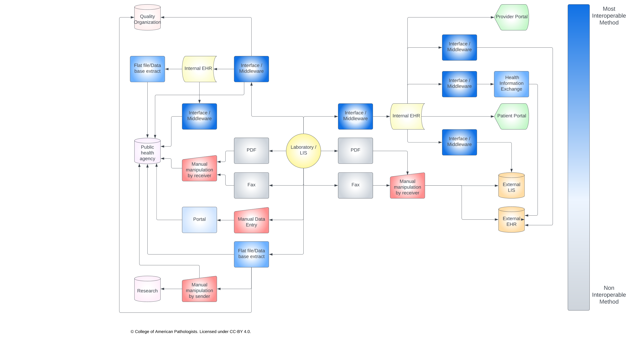

3. IN VITRO DIAGNOSTIC (IVD) TEST DATA CODING QUALITY ASSURANCE PROGRAM PROOF OF CONCEPT (POC)

3.1 Background and Overview
The CAP’s proposed IVD Test Data Coding QA Program (the QA Program) was designed to monitor the appropriate coding of laboratory test results compared to LIDR. The full LIDR design and specifications are still under development as part of the government supported SHIELD initiative. The QA Program workflow is intended to utilize test result transmissions and test compendium reports to evaluate the quality of the encoded laboratory tests, validate correct coding, and identify any gaps in the design.
The envisioned data flow for the QA Program would be expected to follow these important steps:
- IVD vendor provides test coding: The IVD vendors provide specific and unique coding for any test being performed in a clinical laboratory to the LIDR Administrator. LIDR is curated and serves as a resource, storing the data elements for all clinical laboratory tests. It is based on the input from the IVD manufacturers who are experts on their tests and methods.
- Laboratory encodes LIDR data elements: The laboratory applies LIDR data element coding to the LIS so when any test results are entered into the LIS and are electronically transferred to an outside system, unique data elements exist and are present within the HL7 message.
- Laboratory performs the LIDR Test Compendium Error Check process: The laboratory must compile a report from their LIS that includes all LIDR data elements for every test performed and conduct a self-assessment, ensuring the encoding is correct for each test on the report. This report is then submitted to the CAP for external evaluation and comparison to the LIDR records for those tests and methods.
- Laboratory performs the Instance Error Check: Working in the test environment of the LIS, the laboratory orders and results a test simulating a proficiency test (PT) sample. Once the result is entered in the LIS, the encoded results are sent from the LIS to the laboratory transmit interface.
- Laboratory transports results to quality organization: The laboratory interface engine transmits the encoded results to the quality organization interface engine.
- Quality organization checks encoding accuracy: The quality organization checks the accurate encoding of tests by receiving HL7 messages and test compendium reports from the laboratory, which are validated for accuracy by comparison to LIDR. Validation will identify any issues and return an error to the performing laboratory that will include any of the elements that do not match what is expected.
The QA Program design (Figure 2) demonstrates how laboratory results encoded with LIDR will flow through the QA Program. This ensures that with each test result transmission, whether it be for proficiency or actual patient results, the same data elements are present in the transmitted HL7 message and can be received by an external entity in a meaningful and comparable manner.
Figure 2: Quality Assurance Program Design
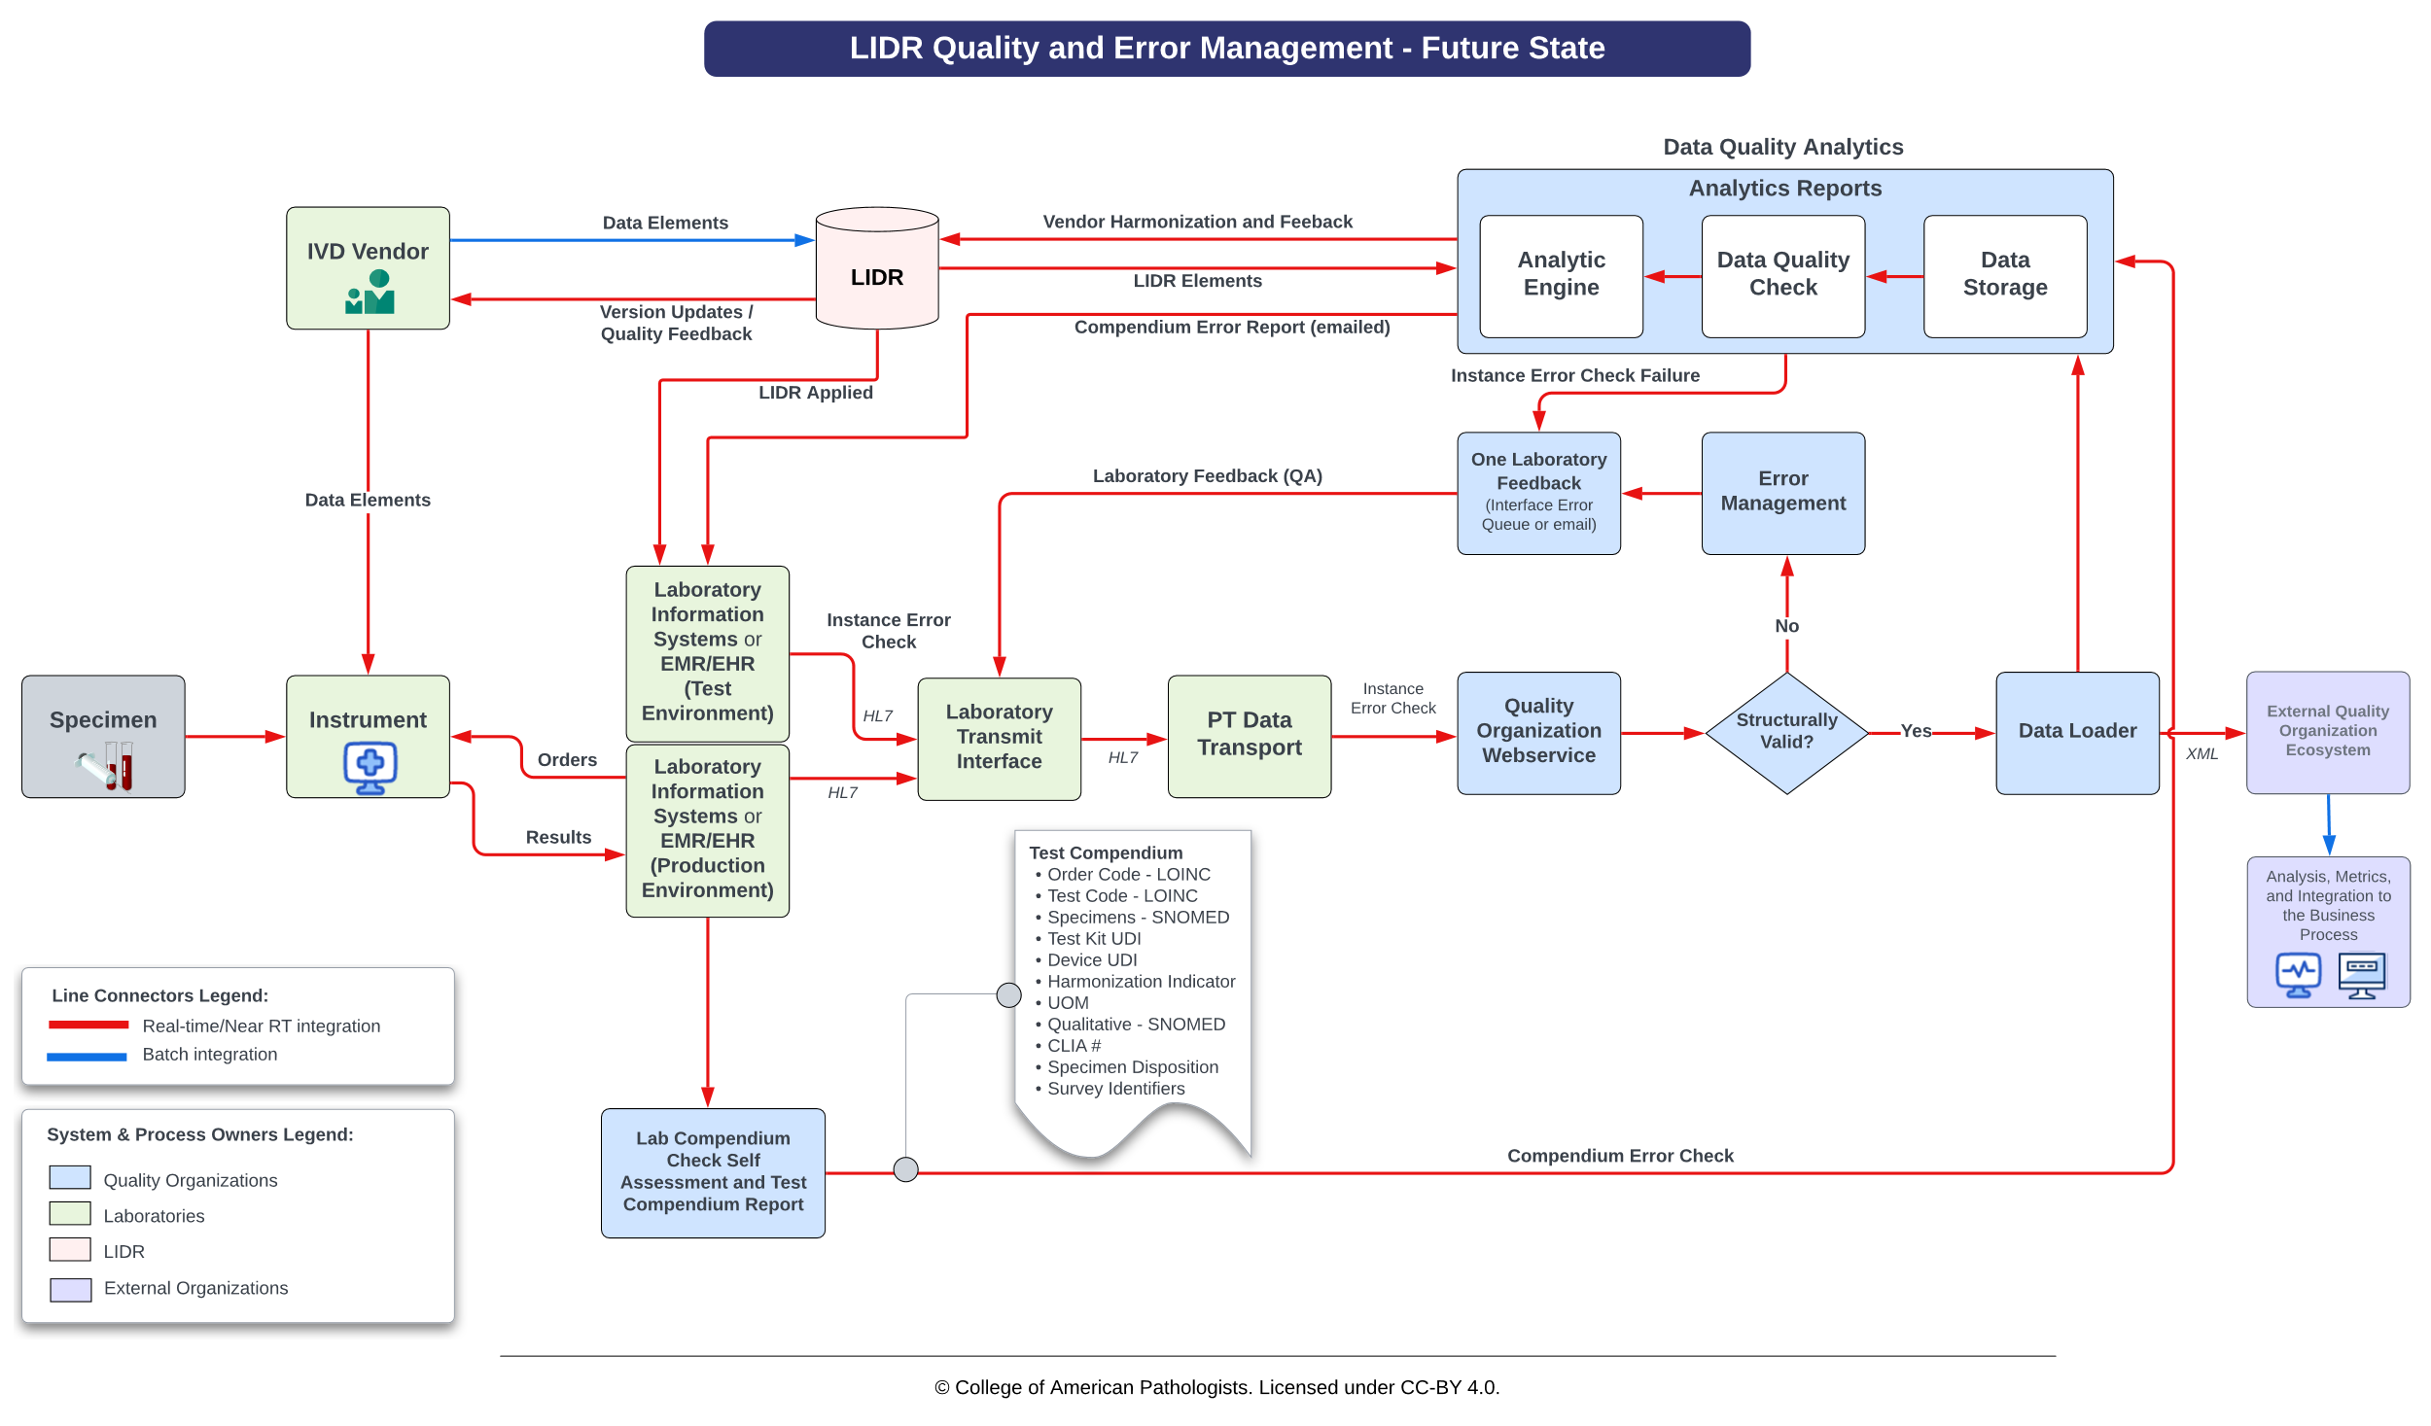

The QA Program is envisioned to use an HL7 interface to connect the LIS to the CAP. To create a POC for the QA Program described above, the CAP partnered with a representative laboratory, Duke University Health System Clinical Laboratory. Duke was selected because of its existing proficiency testing enrollment and history of assisting the CAP with research and development projects.

3.2 Environment Development
In the context of the POC with Duke, the environment refers to the technical and operational components required to facilitate the transmission and processing of laboratory test result data. This includes hardware, software, network configurations, and other infrastructure. Environment development is necessary for the sending laboratory, the receiving entity, and any intermediary interface engines between the two. Table 1 demonstrates the components necessary for environment development, as well as the specific vendor or tool used in the POC. Other vendors and tools may be utilized dependent on the QA Program needs for a given site and quality organization.

Table 1: POC Technical Components Requiring Environment Development
System Component | Ownership | Vendor | Role in Data Transmission
LIS | Duke | Epic/Beaker® | - Encoding of LIDR data elements into the test compendium of the laboratory  - Test ordering and resulting system  - Updates the result interface for outbound test results with the ability to send the encoded test results in standard HL7 messaging format with the expected LIDR elements present
Interface Engine | Duke | InterSystems HealthShare® | - Connects the LIS interface to external systems often allowing for additional modifications to match the required HL7 structure specified by the interface specifications
Interface Engine | ELLKAY | LKOrbit® | - Intake interface for the CAP utilized to transmit data received
VPN Port Connection | ELLKAY | VPN Tunnel | - Specific endpoint in a network where data are sent and received  - In the POC, the port connection already existed between Duke and ELLKAY from a previous initiative
Simulated LIDR | CAP (Future state will be LIDR Administrator) | Data Warehouse | - The POC used a subset of tests (Table 2) with curated LIDR elements accessible in the CAP environment
Intake Interface | CAP | Application  Programming  Interface (API) | - Receiving system for the CAP for POC test result submissions  - Evaluates the submission for structural validation of the HL7 result message
Data Storage | CAP | Postgres-SQL | - Messages received by the CAP are parsed and stored for evaluation of the submitted LIDR elements
Data Warehouse | CAP | Redshift® | - HL7 messages are transformed and stored in a data warehouse solution for consumption by the analytics tool used in the POC (Tableau)
Data Analysis | CAP | Tableau® | - Evaluates data and compares to LIDR to produce analysis reports of the laboratory’s ability to encode their test compendium with the correct LIDR elements  - Provides feedback reports to the subscribed laboratory

3.2.1 Required Environment Set-Up of System Components
Laboratory Information System
Test Build Requirements: Duke utilizes the Epic Beaker system for its LIS. Duke agreed to build out a subset of its test compendium with the LIDR elements. The subset of tests can be found in Table 2.
The system defines laboratory tests utilizing multiple dictionaries, but updates are necessary to align with LIDR elements. Epic Beaker accommodates many LIDR elements, but some new ones pose challenges that were found to require unscalable workarounds in the POC.
Inherent gaps and limitations (Section 3.7) were identified through the proof of concept. The details of the environment development and QA Program design evolved as the QA process was tested and refined. In the POC, consideration was given to any test or test build changes that could potentially impact the Duke production environment for live patient and proficiency testing. It was recommended to maintain all changes within the testing environments where interfacing to an external receiving system could occur without initially moving these changes to the production environment. Many records required edits. To prevent production impact, some elements of the test build required a new record to contain the updated data elements. This was accomplished by duplicating the original record (a feature commonly available within Epic) and uniquely naming it to prevent utilization in other builds for the production environment.

Table 2: Subset of Tests for the POC
Test Ordered | Test Performed | Test Scale | Test Ordered | Test Performed | Test Scale
Basic Metabolic Panel | Glucose | Quantitative | Complete Urinalysis with Microscopic analysis | Color | Nominal
 | Sodium | Quantitative |  | Clarity | Nominal
 | Potassium | Quantitative |  | pH | Semi Quant
 | Chloride | Quantitative |  | Specific Gravity | Quantitative
 | CO2 | Quantitative |  | Glucose | Ordinal
 | Calcium | Quantitative |  | Protein | Ordinal
 | Creatinine | Quantitative |  | Bilirubin | Ordinal
 | BUN | Quantitative |  | Hemoglobin | Ordinal
 | Anion Gap | Quantitative |  | Ketones | Ordinal
 | Bun/Creatinine Ratio | Quantitative |  | Leukocyte Esterase | Ordinal
 | Estimated Glomerular Filtration Rate (eGFR) | Quantitative |  | Nitrite | Ordinal
Blood Culture | Microorganism preliminary growth | Ordinal |  | Urobilinogen | Semi Quant
 | Gram Stain | Nominal |  | Erythrocytes | Quantitative
 | Bacteria Identification | Nominal |  | Leukocytes | Quantitative
AST (Antimicrobial Susceptibility Test) | Cefoxitin | Ordinal |  | Casts | Quantitative
 | Ciprofloxacin | Ordinal | Respiratory Viral Panel | Influenza virus A RNA | Ordinal
 | Daptomycin | Ordinal |  | Influenza virus B RNA | Ordinal
 | Erythromycin | Ordinal |  | Respiratory Syncytial Virus RNA | Ordinal
 | Gentamicin | Ordinal |  | SARS-related coronavirus RNA | Ordinal
 | Levofloxacin | Ordinal | Serum/Plasma Creatinine | Creatinine | Quantitative
 | Linezolid | Ordinal
 | Nitrofurantoin | Ordinal
 | Oxacillin | Ordinal
 | Rifampin | Ordinal
 | Tetracycline | Ordinal
 | Tigecycline | Ordinal
 | Trimethoprim & Sulfamethoxazole | Ordinal
 | Vancomycin | Ordinal
Result Interface Build Requirements: There is a need to be able to send proficiency testing results from the LIS to participate in the proposed QA program.
In Epic Beaker, the initial build requires the creation of a record known as a “non-participating submitter”. Submitters in the system may be considered “clients” of the laboratory, where tests are ordered on specimens submitted by an external provider who is not considered part of the healthcare system (in this case, the CAP). They are accessioned into the LIS for identification, ordering, and testing workflows. The term “non-participating” indicates a particular “patient” type, where the orders and test results for the specimen do not transfer into a regular Epic chart but remain accessible only within the Beaker LIS. In the Epic system, such patient types are known as Requisition Grouper (RQG) types. They are created using the laboratory function “requisition entry” with a non-participating submitter within the Beaker LIS.
The alternate patient type in Epic is an Enterprise Patient (EPT), which is a patient whose registration, test results, and other patient records are stored in the Epic EHR. The interface requires the creation of a proficiency testing submitter used solely for proficiency testing as a non-participating submitter. The Epic interface specifications indicate that the PID 3.6 field of the HL7 result message can identify the type of patient result being sent (EPT or RQG). The Duke result interface did not transmit this information and did not require it for their laboratory result interface (LRI). However, some laboratories utilize this field to indicate the type of patient record being transmitted with the transaction. If the interface indicates the result is an RQG patient type, it can assist the quality organization system’s ability to identify an accidental patient result. However, it was not implemented for this POC. Below is an example of a PID HL7 segment for a non-patient test result that clearly indicates it is an RQG patient type:
PID|1||97^^^RQG^||STUDY^125^^^^^||19820105|F||||||||||12363||||||||||||N
In addition to creating the non-participating submitter for proficiency testing use, the submitter record must allow for custom fields required by the CAP and other quality organizations. These custom fields were used in the POC to capture the CAP Number, the CAP Kit ID, and the CAP Specimen ID, which identified the laboratory and mock proficiency testing survey sample result being sent to the CAP. The result interface sending the test result data to the quality organization must also include this information within the HL7 message. See Table 3 below for the HL7 segments utilized for this purpose.
The Epic result interface, used to send results from Beaker, is an HL7 v2.5.1 LRI which requires specific settings to allow the electronic transmission of results from an RQG sample, as well as the custom fields required by the quality organization. Additionally, there are several other attributes which must be sent with the test results that contain additional LIDR elements. The result interface utilizes Epic profile variables, which control what results are transmitted and how. The LIDR elements specified to be sent in the HL7 segments are indicated in Table 3 below.
Because the interface settings are complex and require the system analysts to be certified in Epic, Epic customers can obtain access to the instructions utilizing the Sherlock Checklist Template 1904. Epic customers can follow this link to make a copy that is specific to their site: Epic Sherlock Checklist Template 1904.

Table 3: HL7 Segment for LIDR Elements and Final Segments From the Duke Interface Engine
LIDR Data Element / Requirement | HL7 Field Utilized by the LIS | HL7 Field Post -Transform by Engine
Test Ordered LOINC | OBR-4 | OBR-4
Test Performed LOINC | OBX-3 | OBX-3
Specimen Type SNOMED CT | SPM-4 | SPM-4
Specimen Source Site SNOMED CT | SPM-8 | SPM-8
Specimen Collection Method SNOMED CT | SPM-7 | SPM-7
Test Kit UDI | OBX-17 | OBX-18
Device UDI | OBX-17 | OBX-18
Numeric result UOM | OBX-6 | OBX-6
Qualitative Result SNOMED CT | OBX-5 | OBX-5
CLIA Identifier | OBX-23 | OBX-23
Specimen Disposition SNOMED CT | SPM-24 | SPM-24
CAP Number | ZRQ-5 | MSH-4
CAP Kit ID | ZRQ-5 | ORC-4
CAP Specimen ID | ZRQ-5 | SPM-2.1
This table displays the HL7 fields for each of the LIDR elements as they were transmitted from the LIS, and how they appeared after they were transformed by the interface engine prior to sending to the CAP. The transformation by the interface engine was necessary because the LIS could not send all of the LIDR elements as required by the developed interface specification.
Figure 3: Format of HL7 Result Message After Transformation to be Sent to the CAP
MSH|^~\&|12300002560|1400801|ELLKAY|CAP|20240614094614|LABBACKGROUND|ORU^R01^ORU_R01|526||2.5.1|||||||||LRI_NG_RN_Profile^Profile Component^2.16.840.1.113883.9.20^ISO
PID|1||30^^^^||CAPFDA^TESTFOUR^^^^^||19780526|F||||||||||1834||||||||||||N
PV1|1|102
ORC|RE|1396909|1396909|23423|||^^^^^T||20240614094407|JP398^POLING^JEREMY^^||279259^DASH^RAJESH^CHANDRA^^^^^DM^^^^DPID||(919)668-3352^^^^^919^6683352|20240614094407|||CLISUP^EPIC SUPPORT||||||2301 Erwin Road^^DURHAM^NC^27705^USA^C^^DURHAM
OBR|1|1396909|1396909|^FDA CREATININE^^2160-0^Creat SerPl-mCnc^LN^^2.77^FDA CREATININE|||20240614094400|||JP398^POLING^JEREMY^^|Lab Collect||R10.84^Generalized abdominal pain^I10^^^^^^Generalized abdominal pain|20240614094432|119361006&Blood, Arterial^^^87612001&Plasma|279259^DASH^RAJESH^CHANDRA^^^^^DM^^^^DPID|(919)668-3352^^^^^919^6683352|||||20240614094605||LAB|F||^^^^^T|||||&Poling&Jeremy&&||||20240614094400
OBX|1|NM|12316566^FDA CREATININE (BKR)^BEAKERLRR^2160-0^Creat SerPl-mCnc^LN^^2.77^FDA CREATININE (BKR)||0.8|mg/dL|0.4-1.0||||F|||20240614094400|||15099590233525^FDA DRAH DXC860I 2^BEAKERFDA^(01)15099590280994(21)7275^FDA DRAH DXC860I 2^BEAKERFDATK|15099590233525^FDA DRAH DXC860I 2^BEAKERFDA^(01)15099590280994(21)7275^FDA DRAH DXC860I 2^BEAKERFDATK|20240614094605||||34D0240734|DUKE RALEIGH CLINICAL LABORATORY
OBX|2|NM|12316574^FDA EGFR (BKR)^BEAKERLRR^62238-1^GFR/BSA.pred SerPlBld CKD-EPI-ArVRat^LN^^2.77^FDA EGFR (BKR)||82|mL/min/1.73sq m|||||F|||20240614094400|||15099590233525^FDA DRAH DXC860I 2^BEAKERFDA^(01)15099590280994(21)7275^FDA DRAH DXC860I 2^BEAKERFDATK|15099590233525^FDA DRAH DXC860I 2^BEAKERFDA^(01)15099590280994(21)7275^FDA DRAH DXC860I 2^BEAKERFDATK|20240614094605||||34D0240734|DUKE RALEIGH CLINICAL LABORATORY
SPM|1|||119361006^Blood, Arterial^^^^^^^Blood, Arterial|||16631761000119104|87612001^Plasma^^^^^^^Plasma|||||||||20240614094400|20240614094432
The above message is an HL7 result message format based on the interface specifications developed for the POC. The LIDR elements are highlighted yellow in Figure 3 and appear in the following locations:
- Test Ordered analyte/observable (LOINC): OBR-4.
- Test Performed analyte/observable (LOINC): OBX-3.
- Specimen type SNOMED CT (at minimum): SPM-4.
- Specimen source site SNOMED CT (topography inferred): SPM-8.
- Specimen collection method SNOMED CT (container / additive inferred): SPM-7.
- Test Kit UDI: OBX-18 Subfield or a future designated field.
- Device UDI: OBX-18 Subfield or a future designated field.
- Numeric Result Units of Measure (UCUM®): OBX-6.
- Qualitative Result (SNOMED CT): Map the SNOMED CT OBX-5.
- CLIA Identifier of the Result Laboratory: OBX-23.
- Specimen Disposition: SPM-24. This is an element that typically would not be utilized for proficiency testing sample submissions and may or may not be sent with the result transmission.
CAP Identifiers:
- CAP Number: MSH-4
- CAP Kit number: ORC-4
- CAP Specimen ID: SPM-2.1
Interface Specification for the QA Program:
The interface specification provided for this project includes the typical segments utilized in an LRI HL7 message and aligns with the proposed IHE PaLM PT Profile (Integrating the Healthcare Enterprise Pathology and Laboratory Medicine Proficiency Testing Profile) (Figure 4). In addition, the headers in Figure 4 indicate the required locations of the various components of the electronic message that the Duke Epic System sent through their interface engine (InterSystems HealthShare) to the CAP.

Seq | Type | Required by Receiving System? | Element Name | Maestro Care Notes | Formatting Notes |  |  |  | Testing Status | Comments
 |  |  |  |  | Maestro Care |  | CAP | Interface Broker
 |  |  |  |  | Format | Sample
MSH – Message Header
4 | HD | Required | Sending Facility |  | Sending lab identifier |  | { CLIENT#} | set to cap # |  | To match IHE PaLM PT profile
SFT – Software
PID - Patient Identification
NTE - Notes Following PID
PV1 - Patient Visit
ORC - Common Order
4 | EI | No | Placer Group Number |  |  |  | CAP KIT # |  |  | To match IHE PaLM PT profile
OBR - Observation Request
Figure 4: Portion of the Interface Specifications for the Laboratory Result Interface (LRI)
Note: For full interface specifications see details in Section 7.3.1.1.

Interface Engine (Duke)
Duke utilized InterSystems HealthShare as its interface engine. The engine formatted the received data into the required interface specifications, as the result messages from Epic could not be configured to send all data elements in the requested HL7 fields. The transformation to the required fields, if necessary, were summarized in Table 3.
Interface Engine (CAP)
ELLKAY’s LKOrbit system was the interface engine for receiving the HL7 messages from Duke and passing through to the CAP. The CAP utilized the LIDR elements instead of custom codes for this proof of concept. There was no mapping or transformation of the information sent in the HL7 message by the LKOrbit system.
VPN Port Connection
This section outlines the process and steps involved in establishing a VPN connection between the laboratory and interface vendor, specifically for the purpose of data transfer related to the POC.
    - VPN Connection Establishment:
To facilitate secure data exchange between Duke and the interface vendor (ELLKAY), a VPN tunnel was established. This involved collaborative efforts between the network teams at both institutions. The connection was configured to allow for secure file transfer, specifically using a VPN-based method.
    - Data Filtering and Transfer:
ELLKAY employed a data filtering process based on specific identifiers associated with the FDA project. Data matching the criteria (MSH3=12300002560 [FDA]) were extracted and prepared for transfer. The filtered data were then transmitted to the CAP via the API.
  - API Integration:
An API-based mechanism was implemented to ensure efficient and automated data exchange. ELLKAY utilized a push method which automatically sends data or updates as they are available to transmit HL7 data, leveraging CAP's API endpoint.
- Onboarding a New Laboratory:
The process of integrating a new laboratory into the data exchange framework will depend on the specific technical capabilities of the laboratory and the quality organization. Key steps typically include:
- Assessment of Network Infrastructure: Evaluating the laboratory network setup to determine the most suitable connection method (SFTP, VPN, API, etc.).
- Establishment of Secure Connection: Collaborating with the laboratory IT team to establish a secure connection, similar to the process followed for the POC.
- Data Filtering Configuration (if applicable): Implementing appropriate data filtering mechanisms based on the specific project requirements (if any).
- API Integration (if applicable): Ensure that the quality organization’s API can accommodate data exchange with the new laboratory.
Simulated LIDR
Because LIDR is still conceptual in nature, a simulated LIDR was developed and stored within the CAP database for the subset of tests used in the POC (Table 2). The simulated LIDR was based on research related to the subset of tests, the instruments, and methods in use at Duke, utilizing information found in Duke build exports from Epic Beaker, Duke’s online test catalog, searches completed on LOINC, SNOMED CT, and GUDID (Global Unique Device Identification Database) websites, as well as manufacturer websites. This LIDR file was shared with Duke to allow the encoding of their test build and interface with the required elements. Logic was developed to compare the data transferred through the interface to the CAP for structural validation of the LIDR elements in the message, using the simulated LIDR as the source of truth. For the remainder of the document, the simulated LIDR will be referred to simply as “LIDR”.
Intake Interface (CAP)
The HL7 transmissions were received through the web services/application programing interface (API) embedded within the CAP POC environment. This API followed the principles of the REST (Representational State Transfer Application Programming Interface) architecture for communication between systems. The HL7 transmissions received in the API were validated against a local copy of the LIDR data elements.
The LIDR data were pre-loaded in the CAP system and persisted in a dimensional matrix format. A custom rules engine validated the transmitted HL7 against preconfigured rules and provided a synchronous response back to ELLKAY. The CAP used AWS-managed APIs as the intake interface. This interface accepted HL7 messages or files for the compendium report as input payloads and returned a JSON response. To secure the intake process, the API implemented token-based authentication and a mechanism to verify the identity of clients as well as restrict access to authorized users or applications.

Table 4: API Interface Specifications
Interface Name: PT Transmission API
Method | POST
API | https://capfdaapis.cap.org/data-load/fda-shield/pt-direct-trasmission
Header | x-api-key
Payload | HL7
Response format | JSON  Response body: Detailed JSON response with each data field status
Interface Name: Compendium Report API
Method | POST
API | https://capfdaapis.cap.org/data-load/fda-shield/compendium-report
Header | x-api-key
Input format | CSV File
Input key | compendium-report-file
Output format | JSON  Response body: Success/Failure
Data Storage (CAP)
The CAP used a cloud-based relational database as its primary data storage. The intake interface parsed and stored HL7 transmissions in a relational database schema following the CAP’s standard database design guidelines.
In addition to the relational database, the CAP stored HL7 transmissions on secondary cloud storage for auditing purposes. The data were portable and multiple local copies were created as backup.
Data Warehouse (CAP)
The CAP had a centralized data warehouse repository for storing, integrating, and analyzing large volumes of structured and unstructured data from various sources within the organization. This centralized repository acted as a foundation for QA analysis reporting. In this proof of concept, this repository served as a staging platform for the generation of detailed analytics. Data from the primary relational database were transformed and migrated into the data warehouse periodically.
QA Analysis Reporting (CAP)
The accumulated data in the data warehouse repository were used for quality analytics. The CAP utilized the enterprise data visualization tool, Tableau, for analyzing and presenting data in an intuitive manner. These analytical reports demonstrated a laboratory's ability to encode the correct LIDR elements in their test compendium. Analytics included but were not limited to individual laboratory error statistics, compiled statistics for all laboratory peer groups, and vendor instrument peer group reports. For more information, refer to Section 3.6 “QA Analysis Reporting”.
For a more comprehensive technical understanding of the CAP intake interface, please refer to Section 7.3.1.1.

3.3 Implement LIDR Subset in Laboratory Information System
The objective of the POC was to create an environment in which the test results encoded with the LIDR elements were transmitted between the selected POC laboratory and the CAP via an HL7 interface. This section defines and describes the configurations required to encode the LIDR elements into the test build of the LIS (Epic Beaker) used at Duke. The selected subset of tests utilized in the POC were listed in Table 2. This section includes a simulated LIDR file for the subset of tests and proposed instructions for encoding the test dictionaries required for the data transmission of the LIDR elements. In addition, the generation of the LIDR Test Compendium Report and its requirements are described.
Simulated LIDR Development
The simulated LIDR files were designed to utilize the LIVD files in Excel format. LIVD files, introduced during the COVID-19 pandemic, are recommended to be provided by IVD vendors. Currently, LIVD includes data elements used to electronically transfer results for SARS-CoV-2, monkey pox virus, HIV Diagnostic Tests, and Lyme disease for infectious disease reporting. These files can be found on the Centers for Disease Control and Prevention (CDC) website.¹
As proposed in Year 1, the required LIDR elements include and expand upon the LIVD elements.
- Order Code - LOINC
- Reported Test - LOINC
- Specimen Source – SNOMED CT
- Specimen Type - SNOMED CT
- Specimen Collection Method – SNOMED CT
- Unit of Measure for Quantitative Results - UCUM
- Qualitative Test - SNOMED CT
- Test Kit UDI
- Device UDI
- Harmonization Indicator of the Performed Test
- Specimen Disposition
Duke utilized the following instrumentation to perform tests at their Duke Raleigh laboratory location (Table 5).

Table 5: IVD Instruments Utilized at Duke Raleigh Laboratory for Test Subset
Test | IVD Vendor | Instrument/Method
Basic Metabolic Panel | Beckman Coulter | DxC860i®
Creatinine (Plasma) | Beckman Coulter | DxC860i®
Complete Urinalysis | Beckman Coulter | DxUm/Aution Max AX4030®
Respiratory Viral Panel | Cepheid | Genexpert GX-XVI R2® (16 module)
Blood Culture (Pos/Neg) | Beckman Coulter | Bactec FX®
Blood Culture Gram Stain | Manual Stain | Manual Microscopy
Blood Culture Organism ID | BioFire | Film Array®
Blood Culture Antibiotic Susceptibility Panel | Beckman Coulter | Microscan Walkaway®
The LIS dictionary exports for these tests included the orderable test build, Beaker test build, result component build, and method build. These resources, along with the Duke Online Test Catalog, formed the basis for further research to develop LIDR.
The Duke Raleigh Laboratory primarily used instruments from a manufacturer that did not participate in the LIVD program. However, the Duke Raleigh Laboratory operated the BioFire Film Array and the Cepheid Genexpert, which had available LIVD files for specific tests (respiratory viral panel and blood culture organism identification). These files provided a foundation for some of the LIDR elements.
The team referenced IVD vendor websites, package inserts, and applicable test menus for the various instruments to conduct further research on the methodology. Upon identification of the methods and tests, SearchLOINC,² SNOMED CT Browser tools,³ and the Global Unique Device Identification Database (GUDID)⁴ were leveraged to develop the LIDR file. Challenges with this approach included identifying the kit and UDI and defining them in the correct format.
Simulated LIDR File
Refer to Figure 5 for a section of the simulated LIDR file. The full file is included alongside this document submission. To access, please refer to Section 7.3.1. Note: The harmonization indicator and specimen disposition elements were not used for the POC as they are currently not developed.

Figure 5: Simulated LIDR File

Instructions for Encoding the Tests with LIDR
Each LIS has unique dictionaries that dictate how laboratory tests and their associated results are developed. The LIS utilized by Duke, Epic Beaker, had various dictionaries used to encode tests and results with the specified LIDR elements.
The following instructions have been defined for the POC. While the instructions and nomenclature below are specific to Epic Beaker and oriented towards Beaker certified IT analysts responsible for defining the system, they should be modified for other information systems in the future. While Epic Systems Corporation (Epic) is aware of the SHIELD initiative and objectives of the POC, it has not endorsed this specific configuration. Epic customers can obtain access to more detailed instructions for implementing the LIDR codes into their test definitions by utilizing the Sherlock Checklist Template 1904. Epic customers can follow this link to make a copy that is specific their site: Epic Sherlock Checklist Template 1904.
- Test ordered analyte/observable (LOINC): Ensure the ordered test (EAP) is mapped with the orderable LOINC. For specific instructions search for this document on the Epic User Web Galaxy site: “Update LOINC Codes for Procedures”.
- Test performed analyte/observable (LOINC): Ensure the resulted test (LRR) is mapped with the test performed analyte/observable LOINC. Go to the “Mapping Setup” page for the result component (LRR) and enter the default LOINC code appropriate for your result component.
- Specimen type (SNOMED CT) at minimum: Utilize the Epic SNOMED for Beaker Support Guide to update the External Concept Mappings (EXM) master file to map SNOMED CT concepts to specimen types.
- Specimen source site (SNOMED CT): Utilize the Epic SNOMED for Beaker Support Guide to update the External Concept Mappings (EXM) master file to map SNOMED CT concepts to specimen source.
- Specimen collection method (SNOMED CT): Utilize the Epic SNOMED for Beaker Support Guide to update the External Concept Mappings (EXM) master file to map SNOMED CT concepts to specimen collection methods.
- UDI (kit) – Note: This instruction is not standard and was developed as a workaround to capture the required test method for reportable results reporting during the COVID-19 pandemic. Epic Systems Corporation (Epic) does not recommend this setup as a permanent solution and may be investigating a future solution to this need.
For the POC, the method record of the performing instrument was mapped to a procedure record that represents it. This requires additional build out of a new procedure which is not performable.
- Enter the new procedure record in the observation methodology field on the general setup form of the method record.
- In addition, an identity type record must be created for mapping this new procedure with the instrument UDI. The identity type record must be able to handle long lengths and alphanumeric characters to accommodate the manufacturer’s provided UDI.
- Once the identity type record is created, the UDI can be entered for the new procedure using the ID maintenance function and specifying the new identity type with the UDI for the kit.
- UDI (instrument) - Note: This instruction is not standard and was developed as a workaround to capture the required test method for reportable results reporting during the COVID-19 pandemic. Epic Systems Corporation (Epic) does not recommend this setup as a permanent solution and may be investigating a future solution to this need.
For the POC, the method record of the performing instrument was mapped to a procedure record that represents it. This requires additional build out of a new procedure which is not performable.
- Enter the new procedure record in the observation methodology field on the general setup form of the method record.
- In addition, an identity type record must be created for mapping this new procedure with the instrument UDI. The identity type record must be able to handle long lengths and alphanumeric characters to accommodate the manufacturer’s provided UDI.
- Once the identity type record is created, the UDI can be entered for the new procedure using the ID maintenance function and specifying the new identity type with the UDI for the instrument.
- Units of Measure for Quantitative Results: If the result is numeric, enter the UOM in the units field on the “General Setup” form for the result components.
- Qualitative Results (SNOMED CT): Utilize the Epic SNOMED for Beaker Support Guide to map SNOMED CT concepts to result component values.
- Nominal Results (SNOMED CT): For organisms, utilize the Epic SNOMED for Beaker Support Guide to map organisms to SNOMED CT.
- Resulting Lab CLIA Number: Entry of the performing lab CLIA number can be added to the resulting agency record.
LIDR Test Compendium Report Requirements and Format
The LIDR Test Compendium Report development from Duke posed a challenge. Aggregation and reporting were challenging due to the system architecture where test data elements were distributed throughout various records. The utilization of an interface table to map SNOMED CT coding challenged this capability. The desire was to capture all elements associated with the resulted test.
Table 6: Example Data Elements to be Captured in LIDR Test Compendium Report for Single Test
Test Ordered LOINC | 24321-2 (Basic metabolic 2000 panel - Serum or Plasma)
Test Performed LOINC | 2951-2 (Sodium [Moles/volume] in Serum or Plasma)
Specimen Type (SNOMED CT) | 119361006 (|Plasma specimen (specimen)|)
Specimen Source (SNOMED CT) | 119297000 (|Blood specimen (specimen)|)
Specimen Collection Method SNOMED CT | 28520004 (|Venipuncture for blood test (procedure)|)
UDI (Kit) | (150995902)-02491-33501-33525-33082
UDI (Instrument) | (01)15099590280994(21)7280
Units of Measure | mmol/L
Qualitative Result SNOMED CT | N/A
The required format for delivery to the CAP is XML or JSON. The original design anticipated that the laboratory would be able to export the LIDR Test Compendium Report from Epic and store it in a local network location for pickup by the CAP interface engine, ELLKAY. From there it could be delivered via an interface directly to the CAP data warehouse for analysis. Duke was unable to set up this configuration, so the alternate method was utilized: exporting the file, naming it in a preferred format which identifies the laboratory, and emailing it to the CAP where it was consumed and analyzed. In a future state, an alternative method would involve the participating laboratory uploading it into a CAP web portal.

3.4 Simulate Test Submission
A component of the QA Program used an HL7 interface to transmit encoded laboratory test results from the information system of a laboratory to the CAP using appropriate LIDR elements.
The workflows and features of the QA Program are illustrated below (Figure 6). This section discusses the process involved in generating the Instance Error Check result messages and the findings from message analysis.

Figure 6: Workflows and Features of the QA Program POC
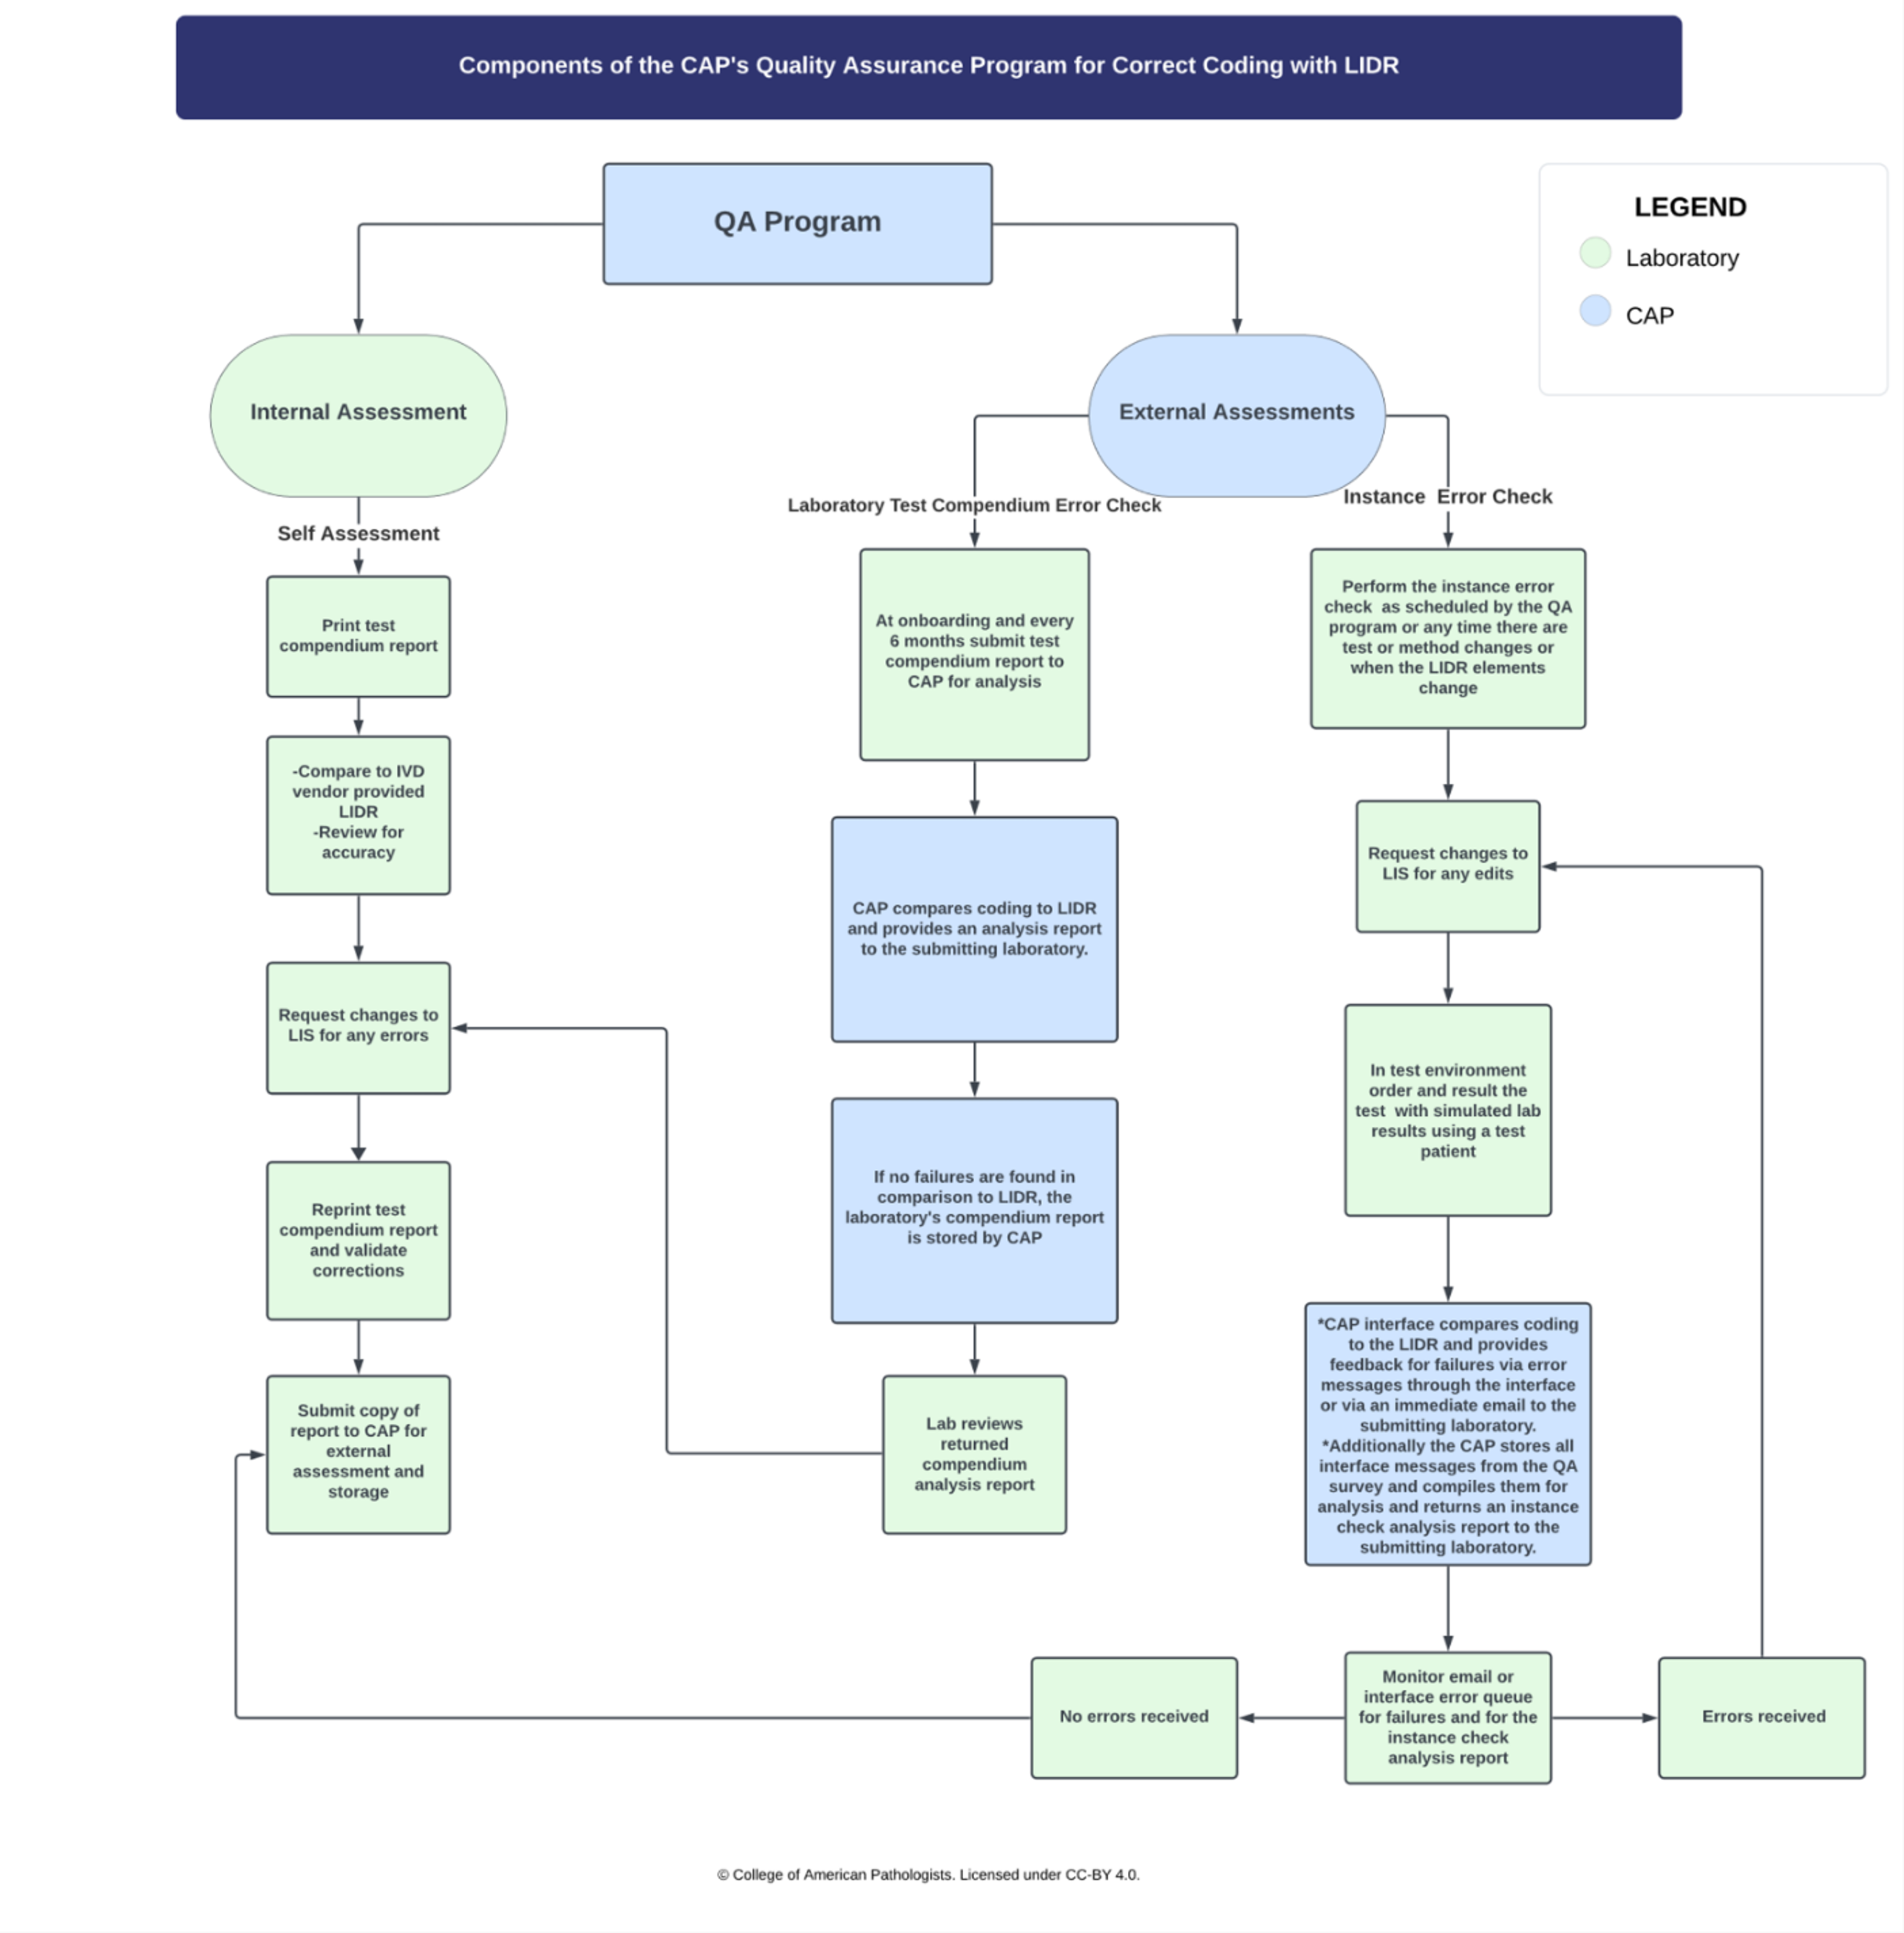
Instance Error Check Workflow and Data Transfer
Workflow: Once the laboratory confirmed that the test definitions within their LIS were satisfactory by performing the self-assessment, the laboratory staff proceeded with the Instance Error Check within the test environment of their LIS. This process required the laboratory staff to place an order for the indicated tests using the same workflow used for ordering tests from proficiency testing surveys. Once the order was placed, the tests were resulted in the LIS with simulated test results. These results were transmitted electronically to the CAP via the HL7 result interface.
Data Transfer: Result messages from the Epic result interface were routed to the Duke interface engine. The interface engine edited the messages to match interface specifications provided during environment development. This transformation was necessary because the LIS could not send all LIDR elements in the expected HL7 segments (Table 3). The edited message was transmitted to the CAP interface engine, ELLKAY Orbit™, which passed it to the newly created CAP HL7 interface.
Analysis: The final HL7 result messages were collected and manually analyzed. The analysis included a comparison to the interface specification to ensure the LIDR elements were in the correct segments of the HL7 message, as well as a comparison to the simulated LIDR for accurate coding. A summary of a urinalysis test analysis is displayed below (Table 7). The complete documentation detailing the analyses and accompanying result messages is provided as an additional attachment alongside this deliverable (Section 7.3.1). Findings highlighted in blue indicate that the location within the HL7 segment and the code are correct, while findings highlighted in red indicate an error. This process was repeated several times to determine if additional modifications to the LIS test build or the simulated LIDR were required.

Table 7: Summary Analysis of Complete Urinalysis Received Message
LIDR Data Element/ Requirement | HL7 Field utilized by the LIS | HL7 Field post -transform by engine | From message
Test Ordered LOINC | OBR-4 | OBR-4 | 24356-8^Urinalysis complete pnl Ur^LN
Test Performed LOINC | OBX-3 | OBX-3 | 50553-7^Color Ur Auto^LN  50552-9^Clarity Ur Refract.auto^LN  50562-8^Sp Gr Ur Refract.auto^LN  50555-2^Glucose Ur Ql Strip.auto^LN  50551-1^Bilirub Ur Ql Strip.auto^LN  57734-6^Ketones Ur Ql Strip.auto^LN^  57751-0^Hgb Ur Ql Strip.auto^LN  5803-2^pH Ur Strip^LN  57735-3^Prot Ur Ql Strip.auto^LN  BEAKERLRR^62487-4  50558-6^Nitrite Ur Ql Strip.auto^LN  60026-2^Leukocyte esterase Ur Ql Strip.auto^LN  46419-8^RBC #/area UrnS Auto^LN  46702-7^WBC #/area UrnS Auto^LN  53320-8^Casts Ur Ql Auto^LN -
Specimen Type SNOMED CT | SPM-4 | SPM-4 | 122575003^Urine
Specimen Source Site SNOMED CT | SPM-8 | SPM-8 | 446775007^Catheter, Indwelling, Foley  Looking for:  16221251000119108 | Urine specimen obtained via straight catheter (specimen) |  122880004 | Urine specimen obtained by clean catch procedure (specimen) |  446846006 | Urine specimen obtained via indwelling urinary catheter (specimen) |
Specimen Collection Method SNOMED CT | SPM-7 | SPM-7 | 73416001  Urine specimen collection, clean catch (procedure)
Test Kit UDI | OBX-17 | OBX-18.1 | 15482736279 – For Dipstick Results Only  4987486738114 – For Microscopic Results Only
Device UDI | OBX-17 | OBX-18.4 | (01)0015482145057(21)12106004 - For Dipstick Results Only  (01)15099590748654(11)211018(21)100022 - For Dipstick Results Only
Numeric result UOM | OBX-6 | OBX-6 | 6.2 – pH  1.025 – Specific Gravity  Missing the result entirely – Urobilinogen -expecting numeric value in mg/dL  1|/hpf – RBC  4|/hpf – WBC  0/lpf - Casts
Qualitative Result SNOMED CT | OBX-5 | OBX-5 | 449251000124106^Dark-brown colored urine^SCT – Color  167236000^Urine looks clear^SCT – Clarity  167261002^Urine glucose not detected^SCT -Glucose  260385009^Negative^SCT – Bilirubin  167287002^Urine ketones not detected^SCT – Ketones  167300001^Urine blood test = +^SCT^^^^^^1+ – Hgb  167273002^Urine protein not detected^SCT - Protein  10828004^Positive^SCT - Nitrite  260385009^Negative^SCT – Leukocyte Esterase
CLIA Identifier | OBX-23 | OBX-23 | 34D0240734
CAP Number | ZRQ-5 | MSH-4 | 1400801
CAP Kit ID | ZRQ-5 | ORC-4 | 879456231
CAP Specimen ID | ZRQ-5 | SPM-2.1 | UA01
Legend
Correct code and location within the HL7 segment
Error in code or location within the HL7 segment
Note: The POC uses HL7 version 2.5.1.
Editing and Retesting: The results of the analysis included the identification of gaps and potential errors in determining the correct LIDR codes due to the uncertainty around how the results would be formatted or transmitted from Epic. Various LIDR elements were updated to ensure they were consistent with the actual test reports generated by the Duke methods. This included updating the qualitative result SNOMED CT codes used in reporting some of the urinalysis components, the test performed LOINC codes used for the organism identification tests performed on the Biofire 2.0 Film Array, and updates to instrument and kit UDIs based on the limitations of Epic. Updates to the specimen descriptor SNOMED CT codes were also required to match recommendations of the LIDR committee: specimen type must be a specimen concept, specimen source must be a substance or body structure concept, and specimen collection must be a procedure concept. The final update was adding and removing antibiotics based on the gram-positive susceptibility panel in use at Duke. Modifying the simulated LIDR also required updating the test code mappings in the Duke system as well as the logic for evaluating the data within the CAP evaluation structure.
Once updated, the tests were reordered and re-resulted, sending new result messages to the CAP for re-evaluation. This retesting process continued until it was determined that the test build, test environment, and the simulated LIDR were as close to the desired state – correct coding and placement within the HL7 message - as possible. This process allowed for a fine-tuning of the testing environment to ensure the proposed design could fulfill the objectives.

3.5 Testing and Validation Process
Full Round Test Plan
Upon stabilization of the systems, a full round testing plan was utilized to assess the design of the QA Program. The test plan (see Section 7.3.1) was utilized to track testing steps and determine whether they passed or failed, identify issues, and document the HL7 messages for the successful transmissions as well as the automated CAP analyses.
Developed test plans included the workflow for the Self-Assessment, the Instance Error Check, and the LIDR Test Compendium Error Check and included testing the CAP technical workflows for automated analyses. Dedicated testing events included teams from Duke, ELLKAY, and the CAP.
To transfer the LIDR Test Compendium Report to the CAP, the Duke team exported the report from their Epic system which was emailed to the CAP in an Excel format. The submitted LIDR Test Compendium Report from Duke is available for viewing (see Section 7.3.1).
The testing documentation included a list of issues discovered through these testing processes with information on whether the issues were resolved. Those that were not resolved were included in the Gap Analysis section. The testing sessions also included interface message validation by the CAP, automated parsing and evaluation of the encoded data, storage of the message, and automated generation of an email to Duke with identified failures. Findings from this phase of testing are incorporated into this document, including identification of what worked well and gap analyses.
The CAP also configured the notification to the LIDR Administrator when it was determined that a LIDR data element exceeded a threshold that could imply the IVD vendor may have provided incorrect information to their laboratory clients.
LIDR Administrator Notification
To ensure continuous improvement of LIDR data, a feedback mechanism was designed to alert the LIDR Administrator of repeated failures that could potentially be due to an error by the IVD manufacturers. The CAP would generate an automated email to the LIDR Administrator if multiple laboratories were to make the same error for the same test/method combination in Instance Error Check and LIDR Test Compendium Check submissions. To calculate the failure threshold, the raw data of the number of submitted test records by a specific instrument (same instrument and kit UDI) would be considered. This threshold should be configurable with the default threshold at 30%, which may change as an understanding of the data becomes more apparent.
The CAP has incorporated a scheduled process to detect and alert the LIDR Administrator of the repeated failures. The scheduler is designed to run at specific intervals and scan the database for errors. The eligible cases will be aggregated and sent to the LIDR administration.

The following are key points incorporated in the design.
- A scheduler has been configured to run the failure threshold check twice a week. The frequency is intended to reduce email volume.
- The scheduler scans the database and determines which records failed between the last and latest runs. This check is to avoid sending duplicate emails.
- During the time between scheduled runs, if any failures are recorded, the scheduler will calculate the overall failure percentage for a test/method data element combination and send an email notification if it exceeds 30%.
- The threshold percentage and email address are configurable parameters.
- The schedule run is used for the periodic scan and has been marked in the database and Spring-based scheduler.
Samples of the email response notifications for the Instance Error Check as well as notification to a simulated LIDR Administrator are available in the Supplemental Materials (Section 7.3.1).

3.6 QA Analysis Reporting
QA analysis reporting is a key element of the QA Program, leveraging data collected from participating laboratories to analyze performance and to identify areas for improvement. This section outlines the process used in the POC and future plans for QA analysis reporting.
QA Analysis Reporting for the POC
The QA Program employed Tableau, a business intelligence and data visualization tool, to analyze data collected from laboratories including LIDR Test Compendium Check submissions and Instance Error Checks. Analysis reports for the QA Program were made available via a web portal provided by the CAP. The interactive reports were accessible through the QA Analysis Dashboard (FDA SHIELD). In the future, access to the reports would be provided to the participating laboratories. For the POC, access was limited to the CAP.
Development of these reports was based on simulated and actual POC results. The reports provided an analysis of the performance of the laboratory over time and had the capacity to provide comparison data of the individual laboratory to peer groups reporting the same tests and methods.
The reports utilized for the POC were prototypes and were limited due to the data sets utilized to create them. While the peer group analysis feature was built into the system, it could not be used effectively without peer group data. The POC reports only compared data from within a single laboratory.
The following section provides an overview of how a user can view and manage the QA analysis reports for the LIDR Test Compendium Check and Instance Error Check.

3.6.1 LIDR Test Compendium Error Check QA Analysis Reports
To view the QA analysis report, the reporting dashboard is accessed. The view will open with a graphical representation of the laboratory’s performance for recent LIDR Test Compendium Error Check submissions to the QA Program (Figure 7). The most recent submission is the ninth submission in the image below.
Figure 7: Overall LIDR Test Compendium Error Check Submission Progress
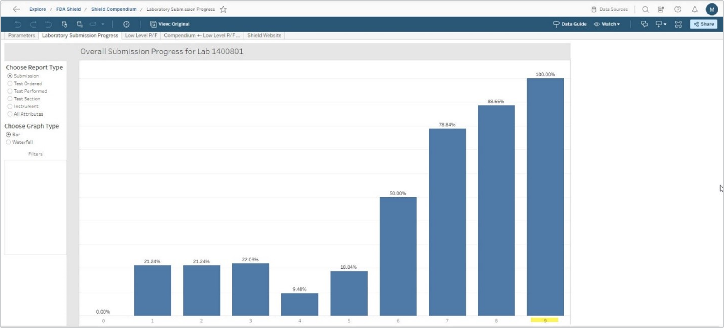
Filtering options are available to obtain information on the performance of the laboratory based on the test ordered, test performed, test section, or instrument by making a selection using the radio buttons to the left of the graph (Figure 8). The report below is filtered by “Test Ordered”, displaying the overall performance of each test compendium submission for ordered tests.
Figure 8: LIDR Test Compendium Error Check Submission Progress Filtered by Test Ordered
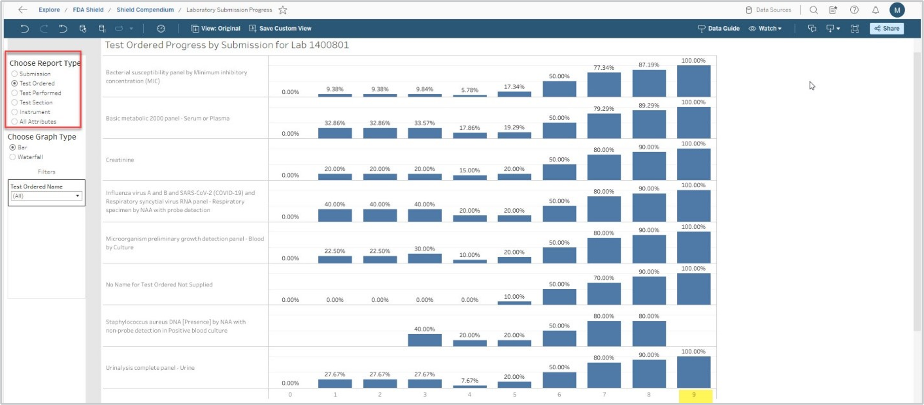
In Figure 8, all the tests (by Ordered Test LOINC code) had 100% correct LIDR elements reported by the ninth LIDR Test Compendium Error Check submission, except for the ordered test “Staphylococcus aureus DNA [Presence] by NAA with non-probe detection in Positive blood culture”.
To further investigate the failure of this test, an alternative tab labelled “Compendium +- Low Level P/F” can be utilized to review the submissions included in the progress report above. In Figure 9 below, this tab has been selected with appropriate filtering options on the right side of the page.
Figure 9: LIDR Test Compendium Error Check Low Level P/F Tab With Filtered Options
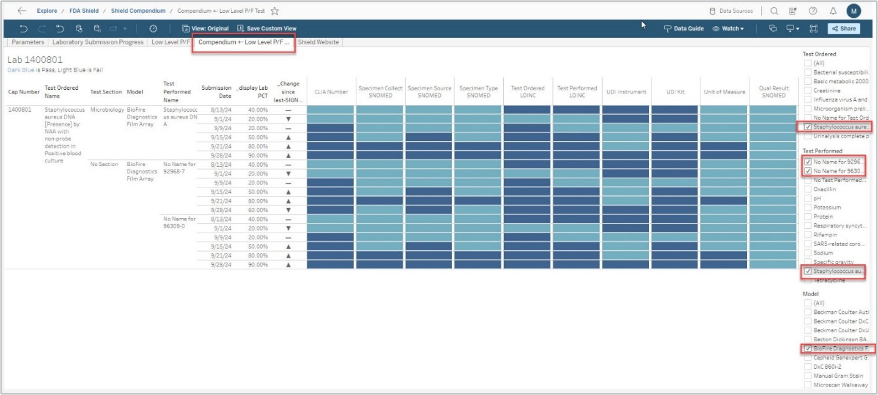
In this view, the dates of submission and an indication of performance from the previous submission are visible. To identify why the previous submission was scored at 80% passing, the row for the 09/28/24 entry should be evaluated. Dark blue cells indicate passing and the light blue cells indicate failure. Hovering over cells provides further information. In the example below, the failure is related to a missing Qualitative Result SNOMED CT code for the performed test Staphylococcus aureus DNA.

Figure 10: LIDR Test Compendium Error Check Low Level P/F Tab With Progress Indicator and Additional Information
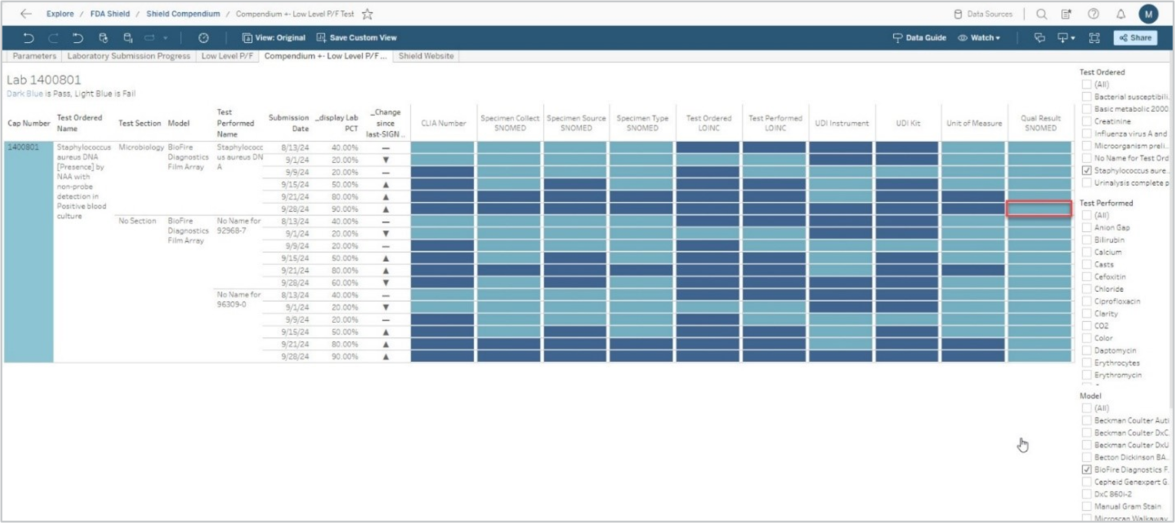
Figure 11: Detailed Information From Hovering Over the Cell
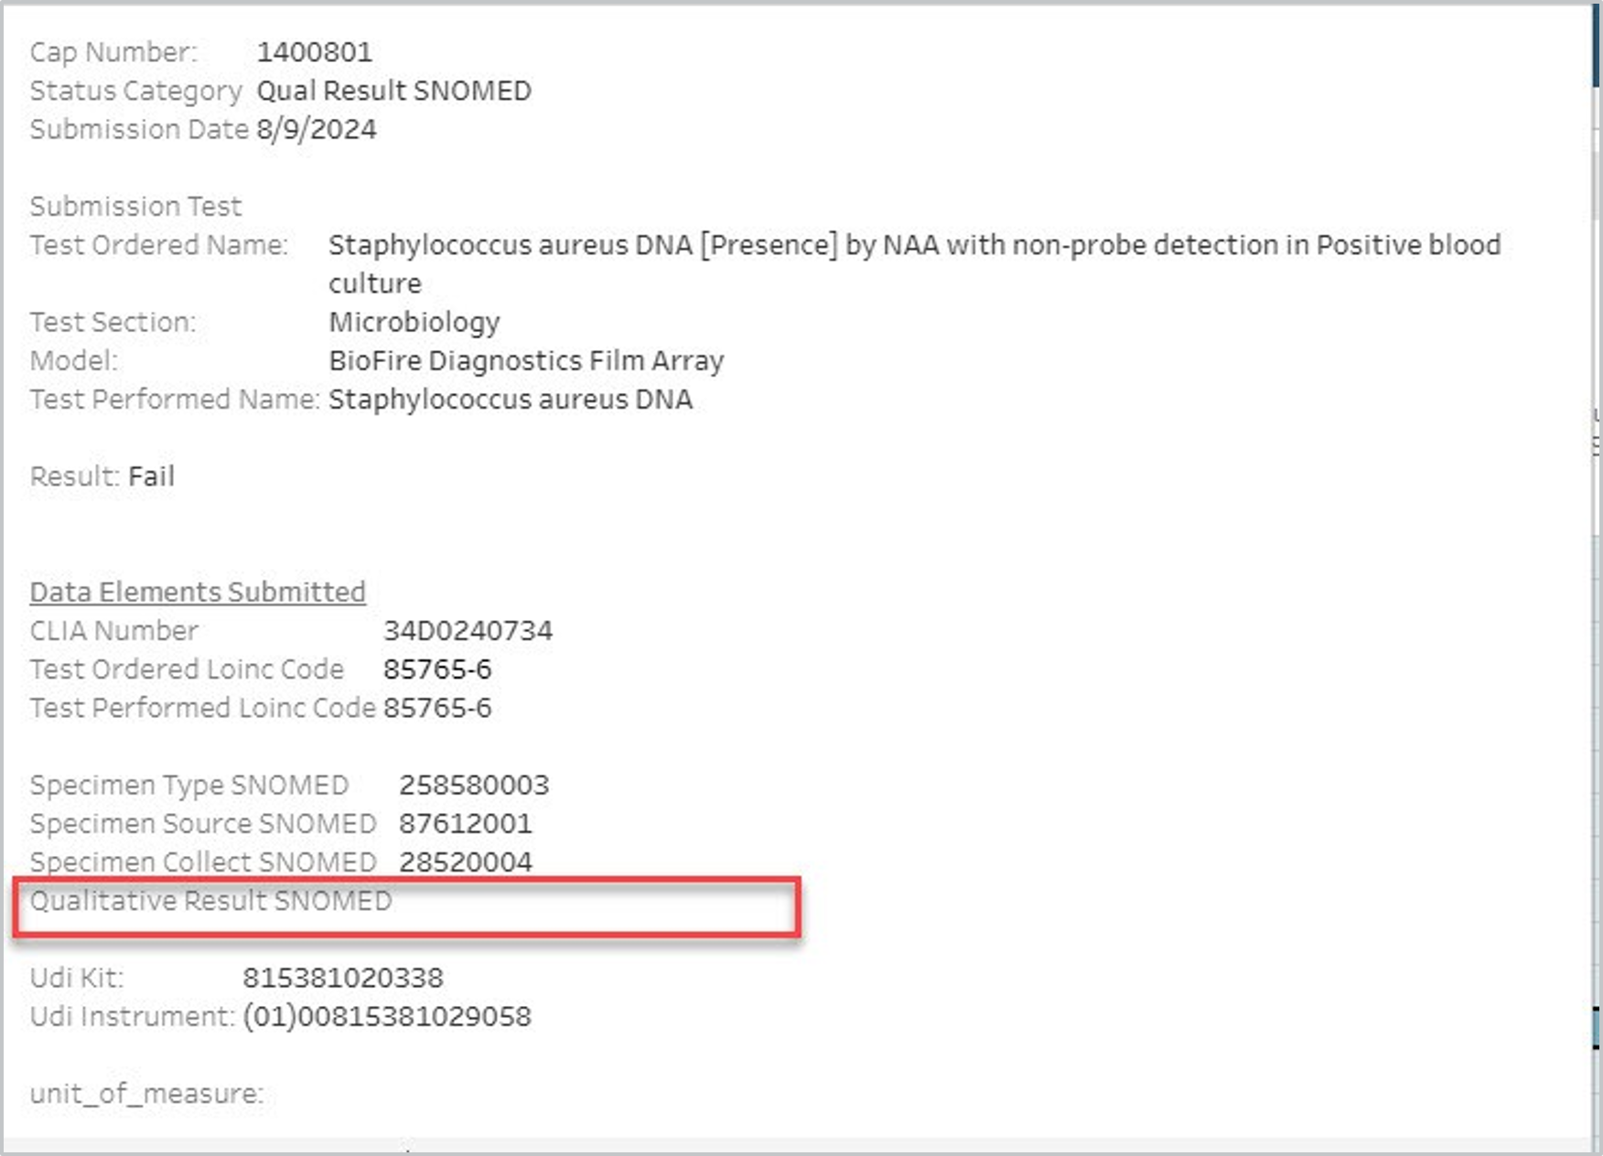
The expected laboratory follow-up involves reviewing their LIDR Test Compendium Report for the reported test to ensure that the qualitative results reported are encoded with SNOMED CT. Once the LIS has been updated with the correct coding, the laboratory should perform an interim Instance Error Check for immediate validation that the correction has been made and then submit another LIDR Test Compendium Report to the CAP at the next scheduled evaluation period.

3.6.2 Instance Error Check QA Analysis Reports
Instance Error Check QA analysis reports can be viewed on the tab labelled “Low Level P/F” and by selecting the radio button to view Instance Error Check reports. This view provides pass and fail results for the correct LIDR element for each performed test in the submitted HL7 result messages. It also displays information on the performance of a laboratory over several submissions. In this report (Figure 12), filters can be selected to examine specific Instance Error Check results by test ordered name, test performed name, test section, and instrument model.
The legend on the left-hand side displays the meaning of the colored cells. A result of “N/A” indicates that the LIDR element was not applicable to the reported test. For instance, a test that is resulted with qualitative results would not include units of measure. A result of “Not Reported” indicates that an element that is not required was not included in the result transmission. For example, kit number is not a required LIDR data element but is an optional CAP element used to determine if the submission is part of a QA survey.
Figure 12: Low Level P/F for Instance Error Check Results
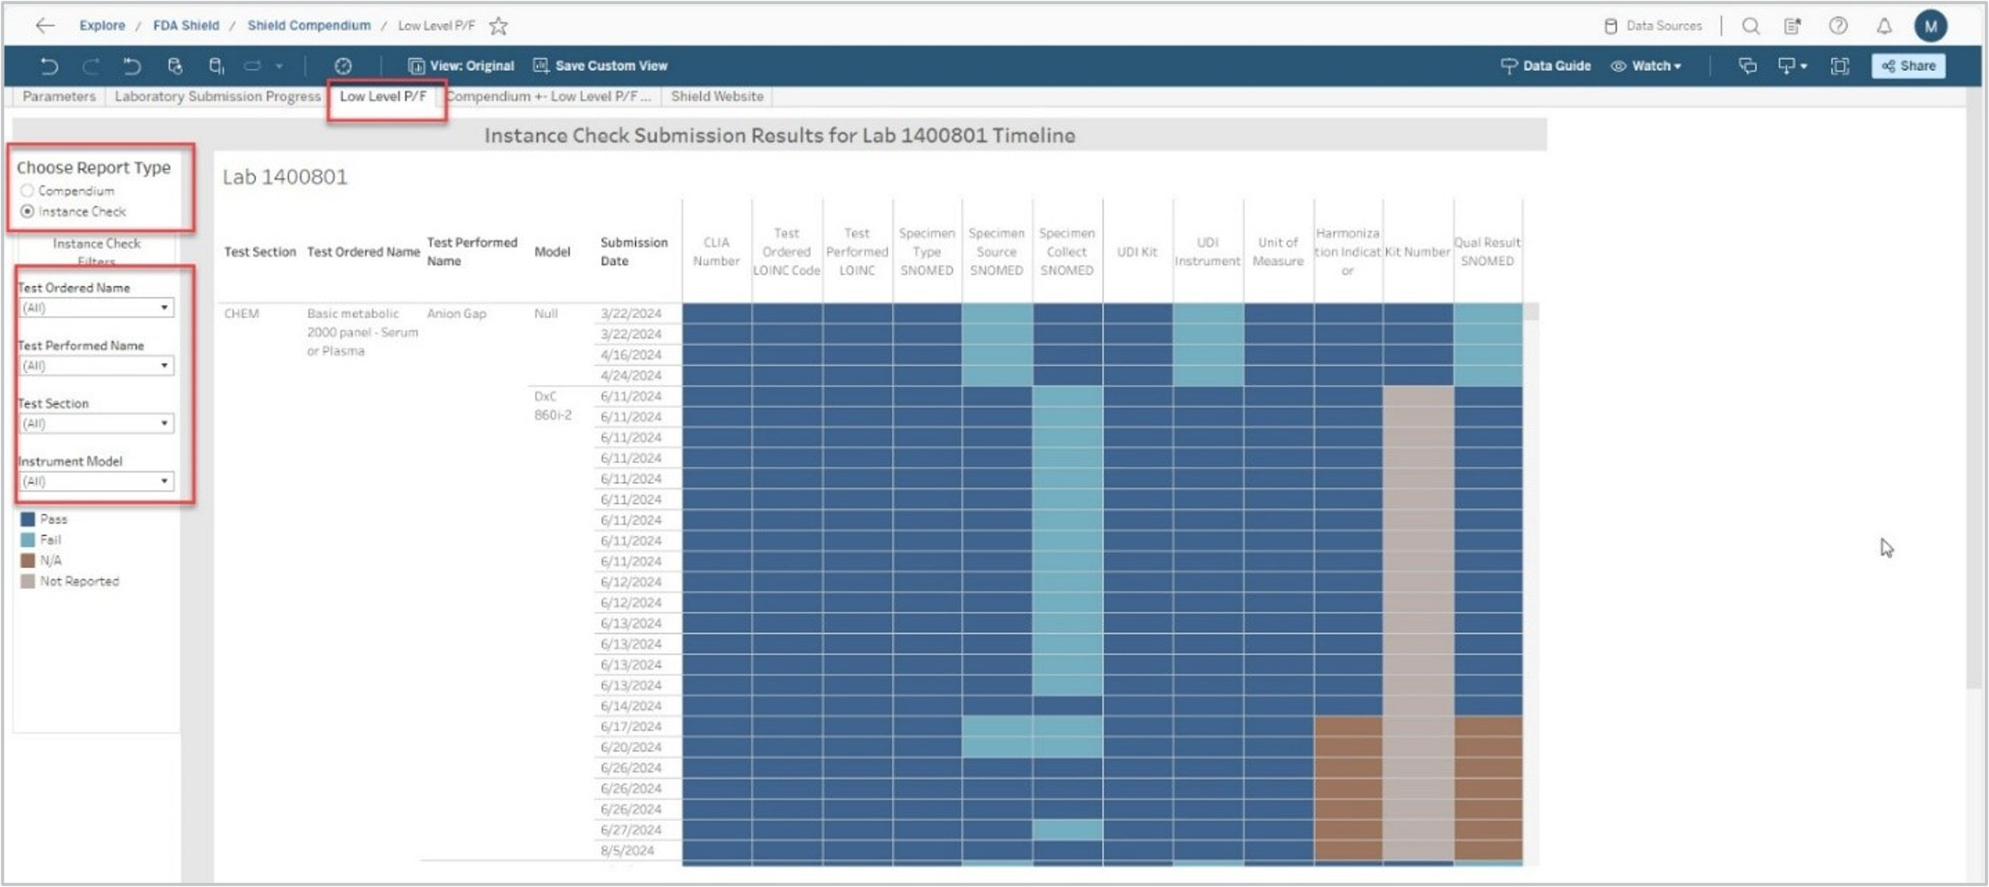
In Figure 13, the filter is set to the Respiratory Virus Panel ordered test. Based on this view, the laboratory has passed for all required LIDR elements for each of the three tests performed in the ordered panel on the 6/26/2024 submission.

Figure 13: Instance Error Check Results by Submitted Date for the Respiratory Virus Panel Ordered Test
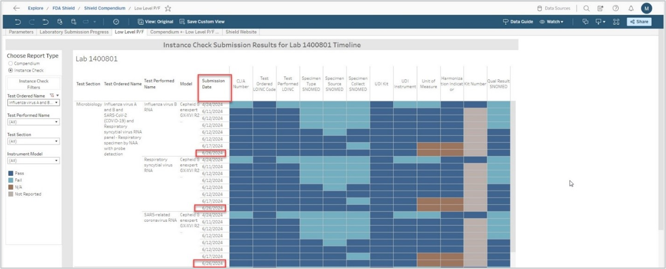
To view what was submitted for a particular data element, hovering over that cell will provide more detail.
In Figures 14 and 15, the detail indicates the resulted test being viewed is the Influenza Virus B RNA performed on the Cepheid Genexpert®. The qualitative result SNOMED CT was 260373001 which was correct and resulted in a pass grading.
Figure 14: Low Level P/F Report Showing Detailed Information by Hovering Over a Cell
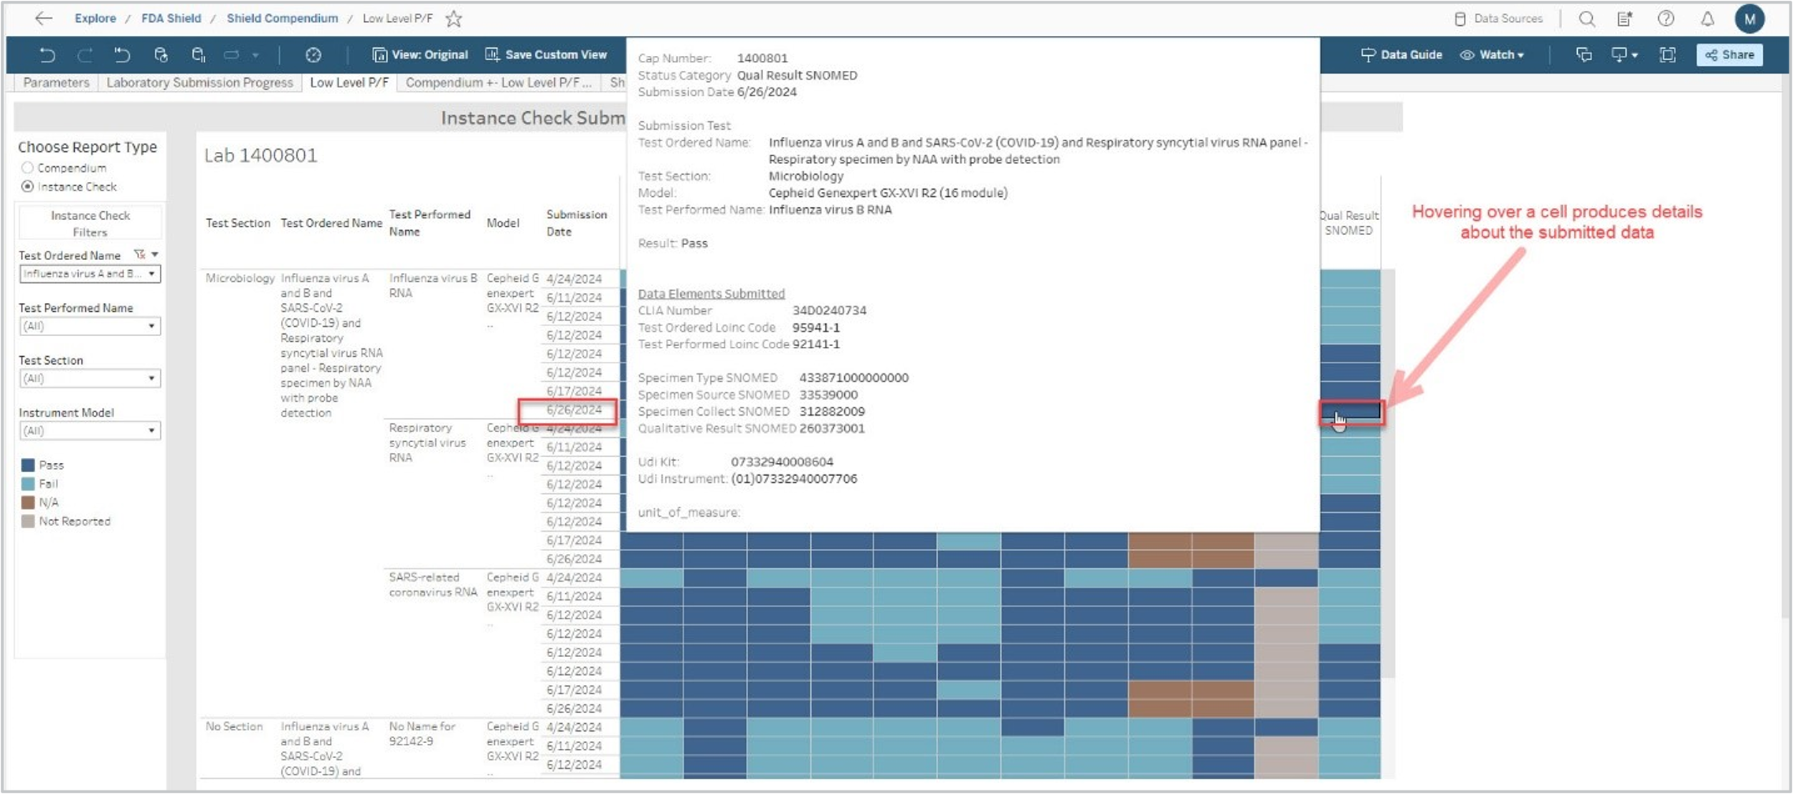

Figure 15: Close-Up of the Detail Provided From Low Level P/F Report by Hovering Over a Cell
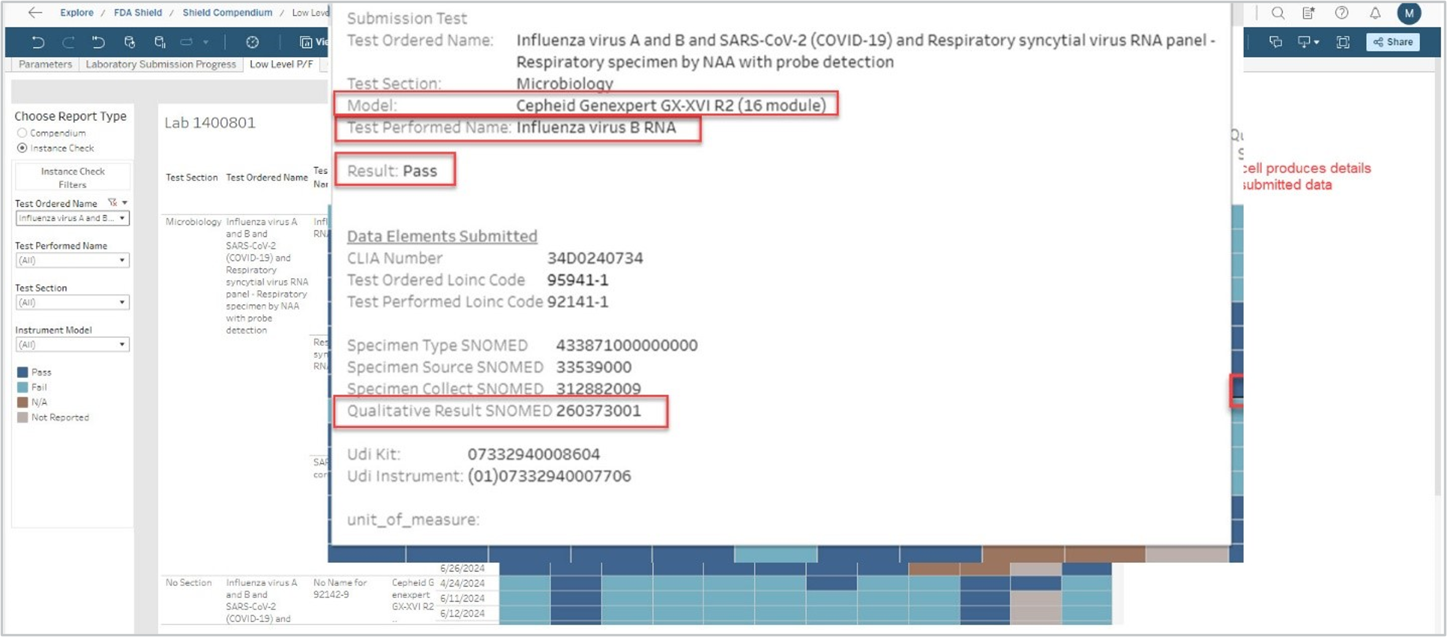
In Figure 16 and 17, the detail indicates the resulted test being viewed is the Glomerular Filtration Rate (GFR) performed on the Beckman Coulter DxC 860i®. The Specimen Collect SNOMED was 73416001 which was incorrect and resulted in a failed grading.
Figure 16: Low Level P/F Report Showing Detailed Information by Hovering Over a Cell
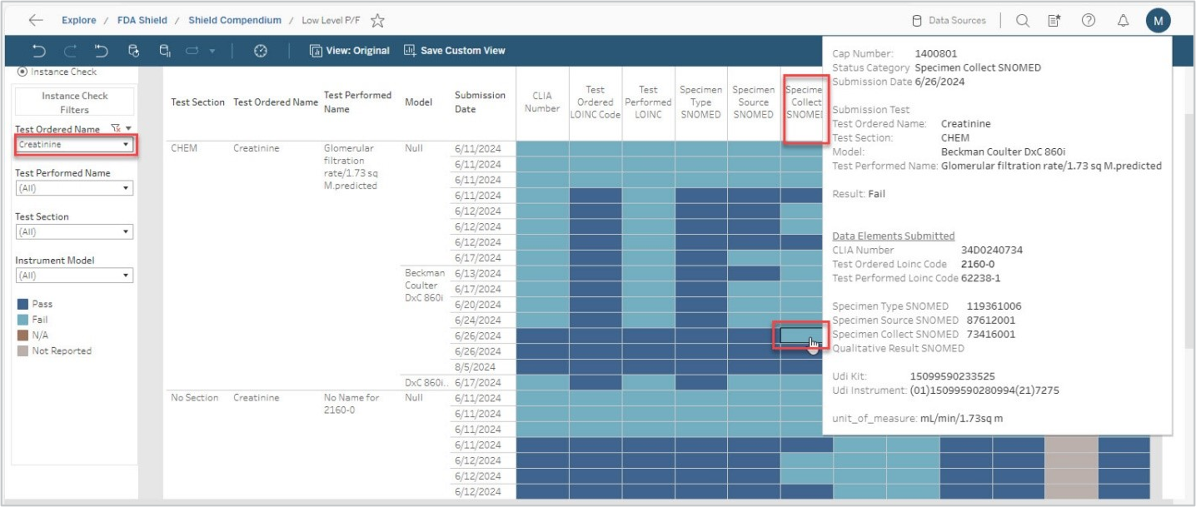

Figure 17: Detailed Information From Hovering Over Failed Cell for the Glomerular Filtration Rate (GFR) Resulted Test
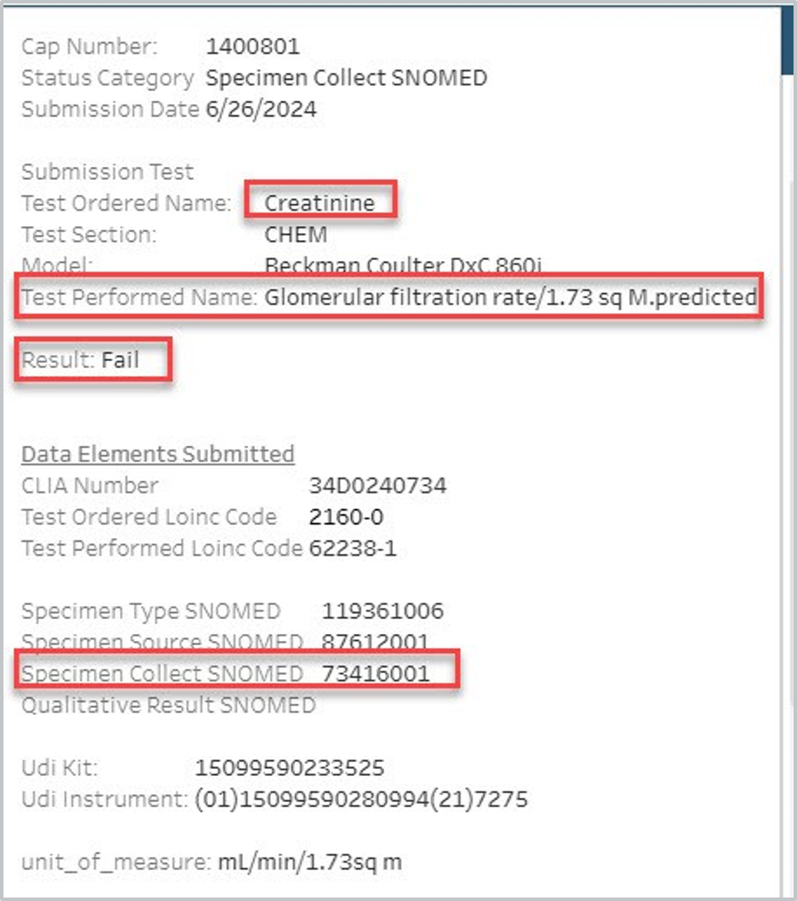
While this display shows this data element failed, the report shows there was a subsequent submission of the test which then passed on the same day. The laboratory would have received an emailed notice of the initial failure and would make a correction to the Specimen Collection SNOMED data element. The next submission shows the correction and a passing status (Figure 18 and 19).
Figure 18: Low Level P/F Report Showing Detailed Information by Hovering Over a Cell
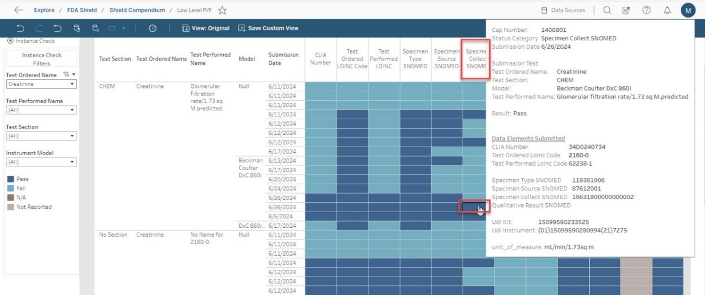

Figure 19: Detailed Information From Hovering Over Passed Cell for the GFR Resulted Test
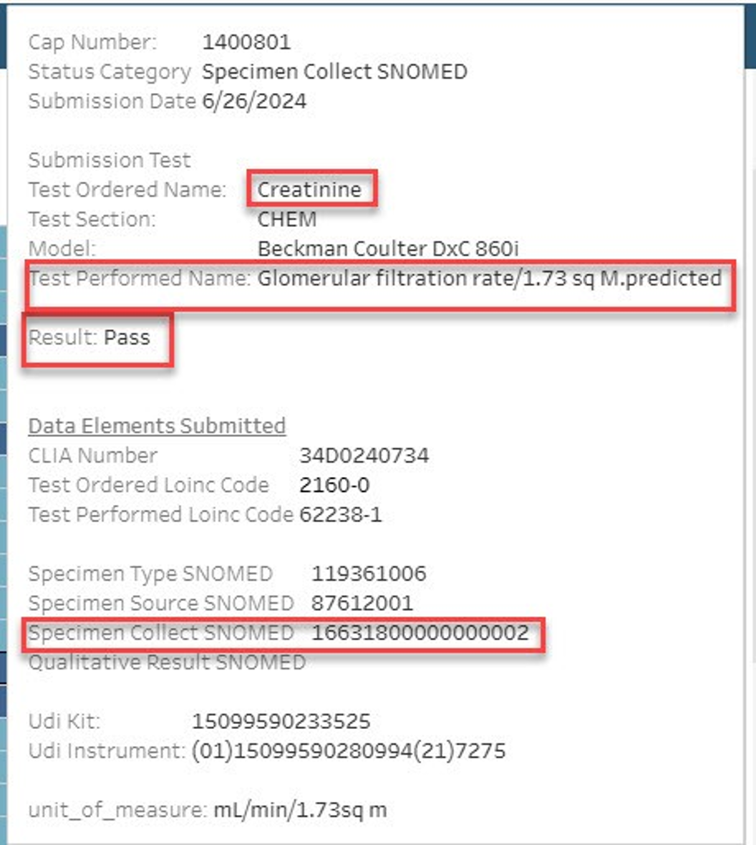

3.6.3 Future Plans for QA Analysis Reporting
To enhance the effectiveness of the QA Program, several improvements are planned for QA analysis reporting:
Scheduled QA Program Testing (Graded):
- Data captured will be included in QA analysis reports
- Laboratories will submit results on a predefined schedule
- Users can revise their coding multiple times but only the first attempt will be considered for grading
- The ability to view peer group performance based on the test and IVD manufacturer will become available as additional laboratories join the QA Program
Non-Scheduled Maintenance Testing (Non-Graded):
- Conducted for updates to LIDR data elements or new method implementations
- Results are not included in QA analysis reporting
- Utilized during initial onboarding
This offers several benefits to laboratories:
- Improved Quality: Identification of areas for improvement in LIDR encoding and error prevention
- Enhanced Compliance: Adherence to regulatory requirements through data-driven insights
- Benchmarking: Comparison of performance against peer groups and industry standards
- Data-Driven Decision Making: Informed decision-making based on quantitative data

QA Analysis Report Access:
In Year 2, reports became available via an interactive web portal. Moving forward, the CAP plans to:
- Notify laboratories when Tableau reports are available online. This will enhance engagement and ensure timely access to critical data.
- Tailor notifications based on specific submitted results. This will provide a more personalized and efficient notification system.
These enhancements are designed to streamline the QA Program and improve the overall user experience through timely and relevant updates.

3.7 Gap Analysis
The proposed QA Program monitors the appropriate LIDR coding of laboratory tests. Laboratories review and submit a LIDR Test Compendium Report to the quality organization to analyze correct test coding as compared to LIDR. Another component of the QA Program uses an HL7 interface to transmit encoded laboratory test results from the information system of a laboratory to the quality organization, using appropriate LIDR elements. These interfaced test results represent the same tests utilized for patient testing. The quality organization parses the message and then evaluates the appropriate placement of the codes within the HL7 structure, as well as the correct test coding as compared to LIDR.
To determine the design feasibility and identify potential challenges, initial testing involved manual analysis of the coded HL7 result messages. These findings were reported back to the Duke analysts, who then amended any inaccurate codes and ensured they were sent in the correct HL7 message segment. Once it was determined that the simulated LIDR, the LIS test build, and the interfaces were stable, the team completed full round testing efforts utilizing a test plan. The test plan included the steps for performing both the Instance Error Check and the LIDR Test Compendium Error Check along with automated feedback and analysis from the CAP. Please refer to Section 7.3.1 to access both the blank and completed versions of the POC test plan. The testing was documented to track the pass and failure status of various steps, and any issues were compiled and monitored. In addition, the interface messages were captured and stored within the document along with the email analysis responses from the CAP.
Identified Gaps: The testing process facilitated the identification of gaps that required a workaround or could not be resolved for the POC. A summary of the gaps and their impact are represented in Table 8. Note: The Table 8 gaps are hyperlinked to their corresponding sections for easy navigation.

Table 8: Summary of Identified Gaps
Identified Gap | Temporary Resolution Used | Long-Term Resolution – Requires Vendor or SDO Involvement | Impact
Gaps Related to LIDR
LIDR is not yet developed | X | X
Lack of IVD vendor provided LIVD files | X | X
Differentiating specimen source and type in LIVD files | X | X
LOINC code search tool variability | X | X
Unavailable SNOMED CT codes | X | X
Identifying UDIs requires research | X | X
Maintaining and updating LOINC codes | X | X
Gaps Related to LIS Build
Inability to accurately map SNOMED CT codes for specimen description | X | X
Device and kit UDIs could not be encoded in standardized formats | X | X
Challenge with UDIs for devices with multiple components | X | X
Data for custom fields was stored in fields intended for other use cases | X | X
Gaps Related to Entering Results in Epic Beaker
Specimen descriptions are a challenge for culture test |  | X
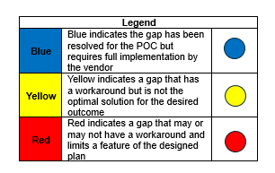

Table 8 (cont.): Summary of Identified Gaps
Identified Gap | Temporary Resolution Used | Long-Term Resolution – Requires Vendor or SDO Involvement | Impact
Gaps Related to LIS Result Interface
Unable to send the device and kit UDIs in OBX-18 | X | X
Issue with Gram stain result UDI in HL7 OBX |  | X
Ordered Test LOINC code issue for AST in Epic Result Message |  | X
Failed to send UDIs in OBX segments for AST with antibiotic results |  | X
Gaps Related to the LIDR Test Compendium Report
Impact of using interface table for mapping SNOMED CT codes |  | X
LIDR Test Compendium Report did not contain specimen collection method column |  | X
LIDR Test Compendium Report was not delivered via ideal electronic transfer | X | X
The delivered LIDR Test Compendium Report had extraneous data and build errors | X | X
Gaps Related to the Instance Error Check
Instance Error Check message receipt by LIS interface was not available | X | X
Gaps Related to Training and Education
Intellectual property rights limitations | X | X
Gaps Related to QA Analysis Reporting
Data elements are missing for analysis | X | X
Gaps Related to Laboratory Analyst Availability
Limited availability to work on required build |  | X
Limited availability to fully explore perceived system limitations and required solutions |  | X

3.7.1 Gaps Related to LIDR

3.7.1.1 LIDR is not yet developed: LIDR is not currently an established standard with an organization supporting its development. The ability to encode all laboratory tests in a standardized fashion will not occur until LIDR is established.
During the POC development, the CAP conducted research and provided a listing of LOINC codes for the test performed LOINC code. Duke provided 47 test build exports from Beaker, which included the LOINC code encoding for the test performed. Six of the exports were missing a LOINC code and 41 were coded with LOINC codes. Research conducted by the CAP included evaluation of the methodology, units of measure, and test name used by Duke to identify the appropriate LOINC code. A discrepancy existed between the LOINC codes used by Duke and the LOINC codes researched by the CAP in 32 of the 41 tests (78%). This observation demonstrated the need for a well-curated LIDR as an authoritative source to help laboratories encode their tests with definitive data elements provided by the test manufacturer.
Resolutions:
- Interim Solution: In the POC, a simulated LIDR was created based on the involved tests, the methods utilized, and the availability of LIVD files for the instruments utilized at Duke.
- Long-Term Solution: LIDR must be developed based on input from IVD manufacturers and stored as a resource for laboratories as an authoritative source.

3.7.1.2 Lack of IVD vendor provided LIVD files: Several IVD vendors do not participate in providing LIVD files. Three of the five analyzers in use at the Duke Raleigh Laboratory were manufactured by an IVD vendor that does not participate in the LIVD program.
Resolutions:
- Interim Solution: Without these LIVD files, laboratory resources (e.g., package inserts, device instructions, manufacturer websites) and the LOINC, SNOMED CT, and the GUDID search tools were required to determine the correct codes for encoding the appropriate LIDR elements for each test.
- Long-Term Solution: IVD manufacturers will provide LIVD files for all of their tests which will serve as the backbone for LIDR. The LIDR Administrator will build upon the LIVD entries with additional information including order LOINC codes and test reference information.

3.7.1.3 Differentiating specimen source and type in LIVD files: Current LIVD files do not clearly distinguish between the specimen source and the specimen type. Consequently, laboratories must determine the difference between these descriptions and what to populate for each.
Resolutions:
- Interim Solution: Without these files, laboratory resources (e.g., package inserts, device instructions, manufacturer websites) and the LOINC, SNOMED CT, and GUDID search tools were required to determine the specimen source and type for encoding the appropriate LIDR elements for each test.
- Long-Term Solution: IVD manufacturers must provide LIVD files which uniquely identify specimen source and type until LIDR is fully developed.

3.7.1.4 LOINC code search tool variability: When utilizing the LOINC search tool, one may receive multiple results from a single search. There is currently no guidance for selecting the optimal coding. This lack of uniformity can potentially lead to variability in the LOINC code that is used.
The susceptibility for vancomycin LOINC codes demonstrate an example of a user determining whether to utilize a general LOINC code for the reportable test or one that is more specific based on the methodology (Figure 20). In some cases, a more specific code was released at a later date than the general code.
Figure 20: Example of Selecting General Versus Specific LOINC Code in Search Tool
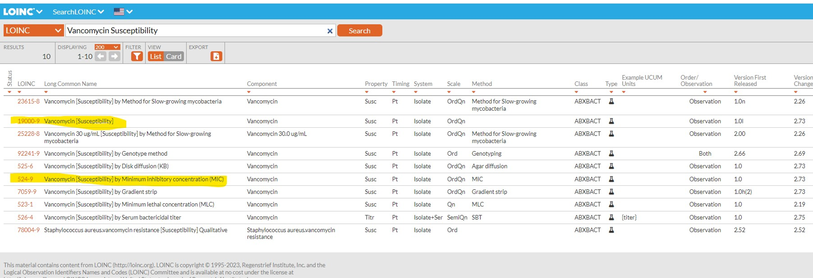
Resolutions:
- Interim Solution: In the case of the simulated LIDR, the CAP selected the more specific LOINC code, 524-9, which Duke utilized to code their tests.
- Long-Term Solution: The example demonstrates the need for a curated LIDR, which would eliminate the decision point for individual laboratories and minimize variability.

3.7.1.5 Unavailable SNOMED CT codes: The chemistry portion of the urinalysis results can be resulted semi-quantitatively for which some tests may not have available SNOMED CT codes.
For example, Duke reports the bilirubin and leukocyte esterase results from the urinalysis using graded values (trace, 1+, 2+, etc.). For each chemical analysis on the urinalysis, Duke may report color interference. SNOMED CT does not have available codes for these results. This affects the completeness of both the simulated LIDR and its integration into the LIS.
Resolutions:
- Interim solution: Trace and all graded results for bilirubin and leukocyte esterase were mapped to the SNOMED CT code for positive. Color interference was not reported in the resulting of POC tests. This result can be added via a comment and is considered a specimen disposition data element, which is not included in the scope of the POC but could be sent in an NTE segment of the HL7 message.
- Long-term solution: Request additional SNOMED CT codes for missing values from the SDO.

3.7.1.6 Identifying UDIs requires research: In the CAP’s development of LIDR, determining the UDIs involved the utilization of AccessGUDID⁴. The GUDID, established by the FDA, is a resource for storing the UDIs of medical devices submitted to the FDA and sold in the US. The UDI is composed of the Device Identifier (DI), a unique numeric or alphanumeric code specific to a device version or model, and a Production Identifier (PI). The PI is a numeric or alphanumeric code that identifies the production information for a device such as the lot number, serial number, expiration date, or manufactured date.
In the case of human cell, tissue or cellular, or tissue-based product (HCT/P), the distinct identification code that allows the manufacturer to associate the HCT/P to the donor is included. Some devices may have the UDI on a label attached to the analyzer or kit.
Resolutions:
- Interim solution: The CAP was able to locate information on some of the instrument labeling which enabled the identification of a specific analyzer or kit in AccessGUDID. Additionally, reaching out to the manufacturer to obtain the UDI had limited success. Leveraging the reagent package inserts was valuable for the kit UDIs as they pointed to a reference that mapped to an entry in the AccessGUDID.
- Long-term solution: The developed LIDR would store and maintain the IVD manufacturer provided UDIs for both the kit and the device.

3.7.1.7 Maintaining and updating LOINC codes: Many laboratories applied LOINC to their tests following the implementation of Meaningful Use incentives, which required the use of structured data to be incorporated in the EHR to identify the test data. Typically, laboratories applied LOINC codes once to a portion of their test menu to meet these requirements and achieve repayment incentive targets. However, they were often not updated after the initial entry because this process requires expertise and coordination with laboratory leadership.
There are frequent updates to the LOINC codes maintained by Regenstrief. However, without explicit prompts for changes to existing LOINC codes associated with their clinical tests, laboratories typically fall behind on version updates. Implementing a QA program to monitor coding to ensure it is up to date is necessary to improve overall interoperability of laboratory test results.
Resolutions:
- Interim solution: The simulated LIDR was developed utilizing the most current resources for identifying LOINC codes appropriate for the Duke laboratory testing methods.
- Long-term solution: The developed LIDR would store and maintain the IVD manufacturer provided LOINC codes and other data elements. Implementing the QA Program for monitoring LIDR codes would keep the laboratory test database current and up to date.

3.7.2 Gaps Related to LIS Build

3.7.2.1 Inability to accurately map SNOMED CT codes for specimen descriptions: The specimen type, source, and collection data elements are not mapped directly in Beaker because the category lists in which they reside are shared by other applications (e.g., ambulatory and surgical providers) within the Epic System structure. These lists cannot be duplicated or edited by modifying the nomenclature or adding to them without obtaining approval from the individual healthcare organization. This includes adding SNOMED CT mappings. Because of this, the SNOMED CT codes are mapped to the descriptors in an interface translation table but did not necessarily match the actual local description of the specimen.
For instance, the correct SNOMED CT code for the specimen type tested in the basic metabolic panel (BMP) is “119361006 – plasma specimen (specimen)” because plasma is the component of blood physically tested. However, the test is defined as a blood specimen type within the Duke system. Duke does not have plasma defined as an allowed specimen type and it cannot be added to their category list. To resolve this, the blood specimen type was mapped to the plasma SNOMED CT code in the interface table. The use of the interface table impacts the ability to fully utilize Epic report features (Refer to Gap 3.7.5.1).
Resolutions:
- Interim solution: The local descriptions were mapped to the correct SNOMED CT code where possible in the interface table. While the local description did not match the SNOMED CT description, it accurately reflected what was physically tested and matched the simulated LIDR.
- Long-term solution: During the SHIELD LIDR committee discussions, the committee determined that specimen source, specimen type, and specimen collection should be based on the SNOMED CT concepts associated with the substance that is physically tested. The committee suggested that the specimen type must be a “specimen” concept, the specimen source must be a “substance” or “body structure” concept, and the specimen collection must be a “procedure” concept. While Epic has category lists for each, they are not based on SNOMED CT, leaving the terms for specimen type and specimen source to end user interpretation.
Reaching agreement on these terms poses a challenge and most organizations have not considered using SNOMED CT as the basis for this decision when developing these locally defined lists. Multiple disciplines, such as laboratory, surgery, and ambulatory procedural areas utilize these category lists and customize them to their own needs and agreements with other users. Most organizations’ locally defined lists were decided upon during their initial Epic implementation and so it is difficult to make further changes to these lists after the system has gone live.
It is recommended that the LIS/EHR vendor prepopulates and maintains these lists with appropriate SNOMED CT codes, establishing them as the only available choices in the procedure definitions. This approach would standardize the interpretation of these categories. For example, the category list for specimen type would only include the descriptions from SNOMED CT codes that are specimen concepts. Specimen source category lists would only include the descriptions from SNOMED CT codes that are substance or body structure concepts, and specimen collection category lists would only include the descriptions from SNOMED CT codes that are procedure concepts. As organizations adopt this approach from the LIS vendor and identify necessary additions, SNOMED CT balloting could occur to address missing concepts. Local lists could still be used to select the necessary specimen requirements for testing as long as the SNOMED CT concepts can be applied to each term when defining the tests in the LIS/EHR.

3.7.2.2 Device and kit UDIs could not be encoded in standardized formats: The standardized UDI format consists of two components. The DI is the first component which indicates the manufacturer and the model/version of a device. It is a required component and is considered the static portion of the UDI, meaning it is the same for all instances of the product model/version. The second component is the PI which identifies one or more variable characteristics. The PI is considered the dynamic portion of the UDI⁵. When combined, the two components form the UDI. The DI always comes first, followed by the PI (Figure 21).
Figure 21: UDI Description and Example
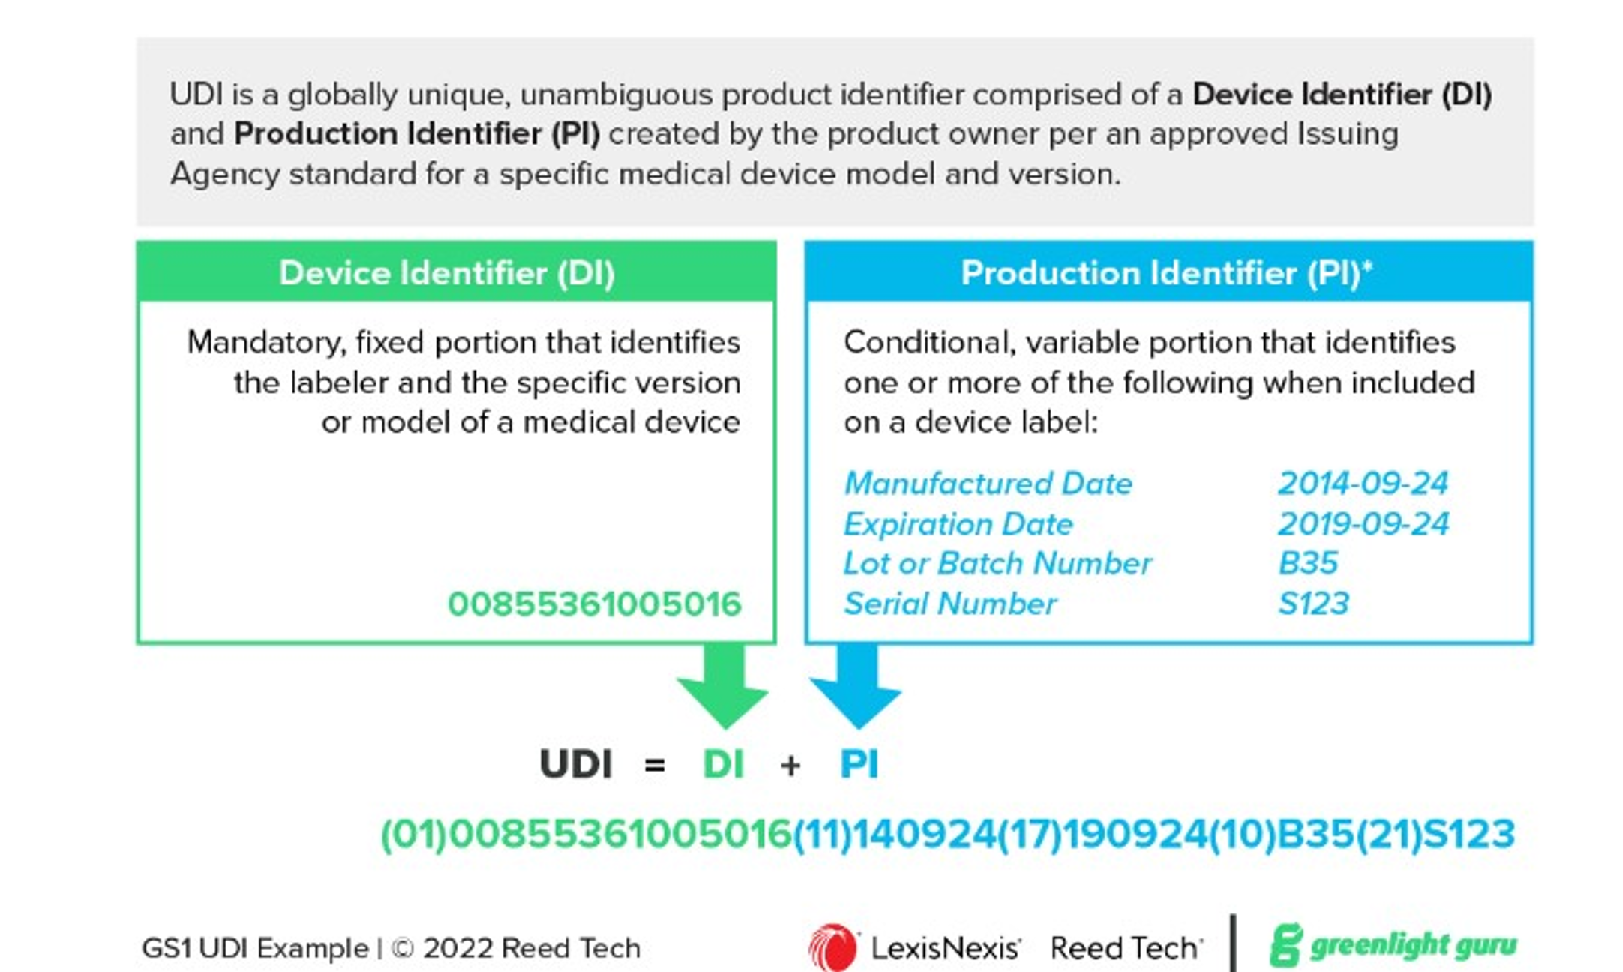⁵
Producing and defining the UDI presented various challenges in the POC. Access to serial number or production information for some methods was prohibitive. Consequently, it was decided to not utilize the production information for the kit UDIs. Another challenge was a character limit of 50 spaces and limitations on using certain alphanumeric characters when entering the UDIs in the LIS. If formatted according to standard guidelines, many of the UDIs used in the simulated LIDR would exceed 50 characters.
Resolutions:
- Interim solution: Nonstandard formatting of UDIs was utilized when the character limits or alphanumeric restrictions could not be accommodated in the LIS.
- Long-term solution: LIS vendors should provide a solution for capturing device and kit UDIs in standardized format and applying them to the result message when sent through an interface.

3.7.2.3 Challenge with UDIs for devices with multiple components: As previously mentioned, the character limit and use of alphanumeric characters impacts the encoding of devices with multiple components, as it is possible for an instrument to contain multiple analytic modules or make use of different kits, each with their own UDI.
The method to encode the UDI for the device and the kit in Beaker is not recommended by Epic, but it functions when sending the UDI via an HL7 message. Epic is aware of this workaround, as it was used during the COVID-19 pandemic for reporting test results to state public health departments. Epic does not endorse this workaround as they agree that it is not scalable and recognize the need for a long-term solution. While the POC team was able to create a workaround for transmitting UDIs, a truly comprehensive solution will require technical development from Epic and other LIS vendors.
The interim solution (Figure 22) for the POC links the single method to device and test kit identity types. Identity types are records within Epic used for mapping identifiers (such as UDIs) that may be used by an external system and that link the identifier to the interface for transmission. The UDIs are stored as Master Patient Index identifiers (MPI IDs) for the Epic method record.
This interim solution is limited because the UDI mappings are associated with the system method definition, which is often a simplified or overarching method, rather than the more granular methods used to produce individual reportable tests. In Beaker, a single method is defined for each analytical system, which includes the analyzer (sometimes composed of multiple analytic modules) and its associated reagent systems.

Figure 22: Mapping and Transmitting the UDI in Beaker
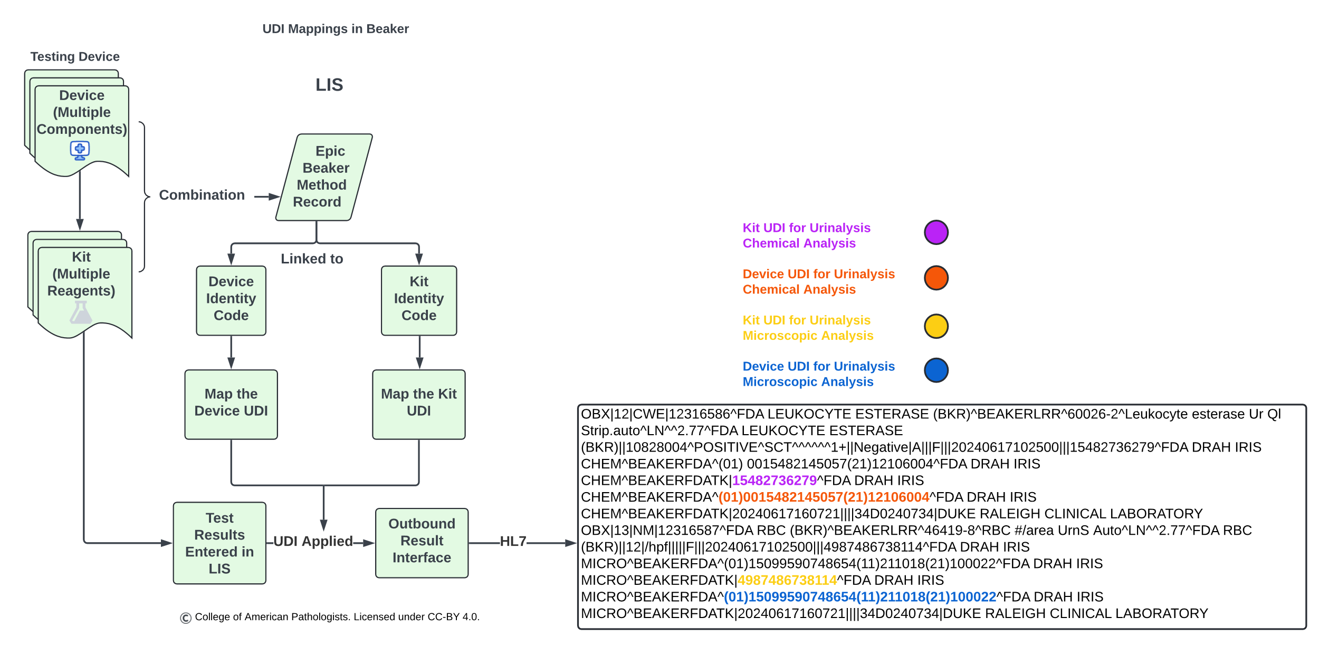
For example, the Beckman Coulter Iris™ is used for performing the comprehensive urinalysis at Duke. It has two analytic modules: the DxU 840m Iris™ (chemistry analysis) and the Aution Max AX4030™ (microscopic analysis). Each analytic module has its own method, each also has a distinct UDI registered with the GUDID. However, the method recorded in the LIS for performing the urinalysis is a single method, the Beckman Coulter Iris™. The LIS system currently lacks functionality to accommodate more than one method for a singular panel.
To address this in the POC, a method was defined for each analytic module and mapped to the individual device UDI. The challenge was to ensure that the correct method is selected when entering the results in the LIS. Because the test in this case was a singular panel, which is a procedure that can be ordered and encompasses multiple reportable tests and results, it typically requires one session for result entry by a laboratory technologist. Introducing a secondary method necessitated an additional result entry session specifically for the microscopic aspect of the test, requiring selection of its distinct method. Using an automated result entry method such as an instrument interface middleware may help to address this challenge in the future.
Another short-term workaround that was considered was to combine the two UDIs into a single string, but this would not have conformed to the standard UDI format. To follow the UDI guidelines for this use case, the team selected the first option for the POC. A long-term solution would be for the instrument vendor to provide a single UDI for the entire system.
In the case of multiple reagent components constituting a single method within Beaker, the team modified the kit UDIs to accommodate character limits by abbreviating some of the UDIs. For example, the BMP ran on a multichannel analyzer that could perform each of the test components but utilized unique kits to acquire each test result. There were four reagent kits utilized: a glucose reagent, an ion selective electrode (ISE) electrolyte reference, a creatinine reagent, and a BUN reagent.
A challenge arose because the kit UDI was linked to the method record rather than to the individual result components within the LIS. Consequently, with only one method record available, it was not possible to associate each individual kit with the specific analyte to which it pertained.
To capture the UDIs of all the reagent kits for the BMP, the team would need to string together each of the kit DI segments. This would result in a UDI of 15099590202491/15099590233501/15099590233525/15099590233082. However, slashes were not permitted and in this case the character length exceeded 50. The chosen solution was to concatenate this string of information as the first nine characters were the same for each kit. The resultant UDI used was (150995902)-02491-33501-33525-33082. While this is not standard format, the goal was to ensure that a kit UDI could be transmitted electronically in the design developed for this use case. This is an issue that will need to be addressed for future usability as it impacts both the LIDR encoding and the integration of this content into the LIS.
Resolutions:
- Interim solution: Utilize a workaround in which two unique identity types are developed for mapping the device UDI and the kit UDI. This approach requires modifications to result entry functionality and the use of nonstandard UDIs.
- Long-term solution: IVD vendors could develop single UDIs for devices and kits with multiple components while retaining the ability to select the more granular UDIs for specific components, as needed. Additionally, the LIS and instrument middleware vendors could improve or define a means to capture the UDIs at the component and system levels.

3.7.2.4 Data for custom fields was stored in fields intended for other use cases: When creating a submitter record for a quality organization, certain custom fields are required. The CAP required the following custom fields - CAP Number, Specimen ID, Kit ID.
However, when these custom fields were implemented in Epic, they did not have a one-to-one match. As a result, analysts were forced to repurpose existing database fields that were originally intended for other uses.
For the implementation at Duke, the fields selected to contain the CAP custom fields were as follows:
- CAP Number – utilized “Purchase Order Number”
- CAP Specimen ID – utilized “Interval Number”
- CAP Kit ID – utilized “Study Number – Free Text”
The system allowed for the modification of how the field name was displayed at the data entry point, however, the data were still in a misnamed field. This discrepancy could have downstream impacts, particularly if Epic were to create and distribute a standard LIDR Test Compendium Report. The custom fields of each organization may lead to different database fields, resulting in inconsistencies and potential errors in the report.
Resolutions:
- Interim solution: No interim solution was able to be identified or implemented.
- Long-term solution: Epic would need to create and modify the hard coded lists that are utilized for creating custom fields to include Quality Organization Number, Specimen ID, and Kit ID. Epic would provide a standard LIDR Test Compendium Report pointing to the fields above.

3.7.3 Gaps Related to Entering Results in Epic Beaker

3.7.3.1 Specimen descriptions are a challenge for the blood culture test: The LIS was unable to capture the specimen descriptors for the blood culture tests which use the isolate as the specimen type. The blood culture performance workflow is complex. It begins with the blood specimen, which is inoculated into collection bottles containing culture media that optimize the growth of microorganisms if present. The culture media bottles are loaded onto an analyzer that detects nonspecific bacterial growth. If growth is detected within a five-day incubation period, follow up testing is performed.
Initially, a gram stain is performed on the blood specimen from the positive culture bottle to determine the type of bacteria that may be present. Based on the gram stain results, steps are taken to isolate the organism on media plates. Once the pathogen is cultured as a pure isolate, it is transferred to one analyzer for organism identification and to another analyzer for antimicrobial susceptibility testing. Because the specimen utilized for the actual identification of the organism and the susceptibility testing is a purified culture isolate, the specimen type is now considered an isolate rather than blood.
The Beaker system views the additional identification and susceptibility tests as add-on tests to the original order. The system limits the ability to add tests to a specimen when the specimen type does not match. The specimen type of the original order is whole blood, but the add-on tests are conducted on a specimen type of culture isolate. Until resolved, the laboratory would continually fail the QA Program analysis for this element of the susceptibility test because the expected specimen type is isolate.
Resolutions:
- Interim solution: No interim solution was able to be identified or implemented.
- Long-term solution: System development by the LIS vendor is required to allow for the addition of the add-on tests so that they can be encoded with the appropriate specimen type, source, and collection method.

3.7.4 Gaps Related to LIS Result Interface

3.7.4.1 Unable to send the device and kit UDIs in OBX-18: The interface specification provided for this project includes the typical segments utilized in a LRI and aligns with the proposed IHE PaLM PT Profile. The specification includes the HL7 segment locations for the LIDR elements. The kit and device UDIs were expected to be sent in OBX-18.1 and OBX-18.4 respectively. The result interface from Epic does not utilize OBX-18 and therefore cannot accommodate these locations. To capture UDIs, the method records associated with the performed test in Beaker were mapped with the UDIs and were sent in the OBX-17 sub fields. The Duke interface engine transforms the message by copying the UDIs to the OBX-18 segment as specified.

Resolutions:
- Interim solution: The interface engine modified the result message to move to the correct HL7 segments.
- Long-term solution: System development by the LIS vendor is required to improve or define a means to capture the UDIs in a more workable solution and configure their interface to utilize OBX-18.

3.7.4.2 Issue with Gram stain result UDI in HL7 OBX: Capturing and sending the UDIs (kit and device) for gram stain results in the HL7 OBX segment was not possible. In Epic, resulting a positive blood culture is a single-entry session that includes both the culture result identifying the organism and the gram stain result. To capture the UDIs of both the blood culture and the gram stain, methods are defined for each which map to the device and the kit UDIs. The Duke team updated the build of the culture test definition to include a default method for the gram stain that was unique from the method for the culture result. Because it was a default method, there was no need to modify the method record when entering and finalizing test results. Despite applying this edit to the test definition in Beaker, the interface failed to send the UDIs for the gram stain in OBX-18.
The two OBX segments from an HL7 result message sent after the test definition modification are presented below. The UDIs for the culture result are present in the first OBX, as highlighted in OBX-18.1 (kit UDI) and 18.4 (device UDI) in Figure 23. In the second OBX, which codes the results for the gram stain, the same highlighted fields are absent despite being properly coded in the test dictionary.
Figure 23: HL7 Result Message After Test Definition Modification
OBX|1|CWE|12316643^FDA CULTURE BLOOD (BKR)^BEAKERLRR^90435-9^Microorg prel grow Bld Ql Aerobe Cult^LN^^2.77^FDA CULTURE BLOOD (BKR)|1|115329001^METHICILLIN RESISTANT STAPHYLOCOCCUS AUREUS^SCT^^^^^^METHICILLIN RESISTANT STAPHYLOCOCCUS AUREUS (MRSA)|||A|||F|||20240809095600|||00382904420239/00382904420222^FDA DRAH BACTEC FX^BEAKERFDA^(01)00382904413859/00382904413866^FDA DRAH BACTEC FX^BEAKERFDATK|00382904420239/00382904420222^FDA DRAH BACTEC FX^BEAKERFDA^(01)00382904413859/00382904413866^FDA DRAH BACTEC FX^BEAKERFDATK|20240809151309||||34D0240734|DUKE RALEIGH CLINICAL LABORATORY
OBX|2|ST|12316644^FDA GRAM STAIN RESULT BLOOD (BKR)^BEAKERLRR^87969-2^Gram Stn Bld^LN^^2.77^FDA GRAM STAIN RESULT BLOOD (BKR)||Gram positive cocci in clusters|||A|||F|||20240809095600|||||20240809151309||||34D0240734|DUKE RALEIGH CLINICAL LABORATORY
Resolutions:
- Interim solution: No interim solution was able to be identified or implemented.
- Long-term solution: System development by the LIS vendor is required to improve or define a means to capture the UDIs in a more workable solution and configure their interface to utilize OBX-18.

3.7.4.3 Ordered test LOINC code issue for AST in Epic Result Message: It was not possible to send the ordered test LOINC code for the anti-microbial susceptibility test (AST) in the Epic result message. The Beaker system treated susceptibility tests as add-ons to the original culture order. This process ensured that the organism identified in the culture is correctly associated with its susceptibility, especially when multiple organisms are present. Consequently, it linked directly to the ordered culture test rather than creating a new order. Until resolved, the laboratory would continue to fail QA Program analysis for this element and other data elements of the susceptibility test due to the CAP logic hierarchy based on the ordered test LOINC code.
Duke addressed this issue by creating a procedure record for the susceptibility test, where the ordered test LOINC code is typically stored for most orders and linked it to the Beaker test definition. However, the add-on process for culture tests did not reference this procedure and the solution did not resolve this gap.
Resolutions:
- Interim solution: The attempted workaround failed. In order to test the CAP logic for the entire susceptibility panel, the Duke team manually inserted the test ordered LOINC code into the OBR segment and resubmitted the message. This was not a viable solution and was only implemented to test out the logic built in the CAP system.
- Long-term solution: LIS vendor system development is needed to define a means to capture and transmit the test ordered LOINC code.

3.7.4.4 Failed to send UDIs in OBX segments for AST with antibiotic results: Capturing and sending UDIs (kit and device) in the OBX segments was unsuccessful for the antibiotic susceptibility results. Duke correctly defined the method associated with the AST test which contains the UDIs for both the kit and device. This issue is similar to Gap 3.7.4.3, where the absence of the AST ordered test LOINC code in the HL7 message was due to the AST being an add-on feature to the culture order. This issue was not resolved in the POC.
Resolutions:
- Interim solution: No interim solution was able to be identified or implemented.
- Long-term solution: LIS vendor system development is needed to define a means to capture the UDIs in a more workable solution and configure their interface to utilize OBX-18.

3.7.5 Gaps Related to the LIDR Test Compendium Report

3.7.5.1 Impact of using interface table for mapping SNOMED CT codes: Using an interface table to map SNOMED CT codes for specimen descriptions led to their omission in the LIDR Test Compendium Report. The Duke team was unable to directly map the specimen descriptors with SNOMED CT in the system. As a result, the LIDR Test Compendium Report could not capture the SNOMED CT codes for specimen type, source, or collection method. As mentioned, these SNOMED CT codes were mapped using an interface table and were added to the result message after it was received by the interface. This process prevented the codes from being captured in the LIDR Test Compendium Report, which pulled the data from the actual test build dictionaries. Although the LIDR Test Compendium Report had columns for the specimen type and source, they were not populated. If the laboratory decided to update these terms with SNOMED CT, they could then be displayed on the developed report.
Resolutions:
- Interim solution: No interim solution was able to be identified or implemented.
- Long-term solution: Prepopulating and maintaining category lists with the correct SNOMED CT concepts by the LIS vendor could resolve this issue, as described in the Gap 3.7.2.1 long-term solution.

3.7.5.2 LIDR Test Compendium Report did not contain specimen collection method column: Despite the ability to add column headers to the LIDR Test Compendium Report, the data remained blank for the specimen type and source due to the use of the interface table for mapping to SNOMED CT codes. The Duke team was unable to add a column for the specimen collection method, even though it mapped to SNOMED CT in the same manner as the specimen source and type. The issue was related to the data structure and the linkage of these records to the ordered test, as well as how the report compiled this information. Even if a column for the specimen collection method was included in the report (e.g., specimen type and source columns), the data would still have been blank due to the use of an interface table.
Resolutions:
- Interim solution: No interim solution was able to be identified or implemented.
- Long-term solution: LIS vendor system development is needed to create a test compendium report which allows the capture of all LIDR data elements.

3.7.5.3 LIDR Test Compendium Report was not delivered via ideal electronic transfer: The proposed LIDR Test Compendium Report export and delivery method was not implemented due to the set up required to store the report and make it available for file pickup.
Resolutions:
- Interim solution: The interim solution was to email the LIDR Test Compendium Report to the CAP once it was exported from Beaker. The CAP was able to extract the required information from the emailed spreadsheet.
- Long-term solution: The ideal solution is to have the exported report stored on the laboratory network with an automated process designed to transfer the file to the CAP interface engine for delivery to CAP.

3.7.5.4 The delivered LIDR Test Compendium Report had extraneous data and build errors: The report delivered during testing contained build errors and extra data, which are artifacts of the POC work (see Supplemental Materials section for the link to the PDF version.)
For example, the Duke chemistry laboratory used two analyzers of the same model and manufacturer. Duke represented the analyzers as FDA DRAH DXC860I 1 and FDA DRAH DXC860I 2. The reason for using two analyzers in this POC was to ensure that the first one was exclusively chosen as the method for the BMP with the test order LOINC code 24321-2 and the kit UDI for the full BMP associated with it. The second DXC860I was intended to be used exclusively for performing the creatinine test orderable, LOINC code 2-0160. The device had a unique instrument UDI (with a different serial from the other DXC860I) and the kit UDI includes only the creatinine test reagent. It was never intended to be used as the method for the BMP, enabling the team to demonstrate the UDI for the creatinine single test. However, an artifact was identified where the BMP reportable tests were accidentally linked to this method (DXC8601 2), which was captured in the LIDR Test Compendium Report.
Other items that were erroneously included involved incorrect associations of device UDIs with reportable tests, the retention of modified data elements that should have been removed, as mentioned earlier, the absence of the specimen collection method column, and the SNOMED CT codes associated with the specimen descriptors. Developing the LIDR Test Compendium Report was challenging because the team sought a customized report which is not currently available in the Epic Beaker system. Due to time constraints, the necessary corrections for the LIDR Test Compendium Report could not be accommodated.
Resolutions:
- Interim solution: The interim solution was to create an “ideal” test compendium report based on the generated LIDR Test Compendium Report from the Duke laboratory. This ideal report was modified by removing extraneous information and adding required LIDR elements that could not be captured initially. This approach allowed QA analysis reporting to be developed using an ideal sample of the report (see Supplemental Materials section for the ideal LIDR Test Compendium Report attachment.)
- Long-term solution: The ideal solution is for Epic to develop the LIDR Test Compendium Report specifically for the use of generating it for the QA Program.

3.7.6 Gaps Related to the Instance Error Check

3.7.6.1 Instance check error message receipt by LIS interface was not available: The initial POC design planned to use either an interface error message system or an automated email when the Instance Error Check interface message failed upon receipt at the CAP. The CAP-developed system could generate an automated error message to pass back through the CAP interface engine (ELLKAY) to the Duke inbound interfaces.
Further development outside of the POC would be required in coordination with Epic and Duke to determine if the error can be processed and how the error message would present on the Epic interface error queue. Error messages are typically specific to the system sending the message and the type of error.
Resolutions:
- Interim solution: The alternate method of transmitting error messages via automated email from the CAP to Duke was implemented.
- Long-term solution: Coordination with the LIS vendor, the quality organization, and the interface engine providers would be required to develop the error message.

3.7.7 Gaps Related to Training and Education

3.7.7.1 Intellectual property rights limitations: The LIS intellectual property rights limited development of the training and education components and the ability to provide meaningful implementation guides. The training and education developed for the POC focused on implementing LIDR into the Epic Beaker LIS. Certain build descriptions and screenshots are considered intellectual property of Epic. The inability to use specific administrative information for building the Beaker system limited the creation of meaningful educational materials, particularly in the technical guide.
Resolutions:
- Interim solution: After reviewing the documentation developed with Epic, it was determined that end user workflows and screenshots could be included in CAP-produced educational materials. Since administrative build information was not permitted, Epic developed a guide for future users that can be accessed by Epic customers via a link, should the implementation of the QA Program go forward.
- Long-term solution: The coordinated interim solution was suitable for the POC. Similar coordination with other LIS vendors may be required to allow adoption for other laboratories who do not utilize Epic Beaker.

3.7.8 Gaps Related to QA Analysis Reporting

3.7.8.1 Data elements are missing for analysis: The analytic reporting tool, Tableau, was unable to capture accurate analysis statistics because certain data elements were missing. When the ordered test LOINC code was not included in an Instance Error Check result message, Tableau could not identify the test to associate the remaining data elements parsed from the HL7 message. As previously mentioned, the result interface was unable to send the ordered test LOINC code for the blood culture AST test. Consequently, the cumulative performance data for a laboratory could not be captured in the summary reports.
Resolutions:
- Interim solution: The analysis reports that provide cumulative statistics excluded submissions that were missing the ordered test LOINC code. However, a report detailing the number of submissions that could not be evaluated due to missing data was generated. Additionally, the Instance Error Check emailed evaluation notified the laboratory about the individual missing test data elements, helping the laboratory track down the error.
- Long-term solution: The interim solution was suitable for the POC, as the gap was an inherent artifact of the POC. In the future, addressing the gap related to missing data elements and developing a true LIDR Test Compendium Report could eliminate this issue.

3.7.9 Gaps Related to Laboratory Analyst Availability

3.7.9.1 Limited availability to work on required build: The team at Duke was assigned the POC project work in addition to their traditional work requirements. Because of this, there were instances where the ability to complete POC build tasks were secondary to the production needs of the laboratory.
For example, the laboratory was unable to complete the task of encoding the qualitative results for the gram stain result and the culture identification panel with SNOMED CT codes. Therefore, these items continued to fail on the analysis performed for the Instance Error Check and the test compendium analysis.
Resolutions:
- Interim solution: The LIS analyst mapped some of the qualitative results with SNOMED CT for other tests but was not able to complete the task for the gram stain and culture ID result.
- Long-term solution: It is recommended that the LIS/EHR vendor prepopulates and maintains these lists with appropriate SNOMED CT codes, establishing them as the only available choices in the procedure definitions. This approach would standardize the interpretation of these categories. For example, the qualitative result category list would only include the descriptions from SNOMED CT codes that are qualitative result concepts. Additionally, support for dedicated LIS analysts following a full implementation schedule and access to resources from Epic would be required for future implementations of this design.

3.7.9.2 Limited availability to fully explore perceived system limitations and required solutions: As mentioned above, the priority of the QA Program POC work was secondary to the Duke laboratory production needs which hindered the ability to fully investigate and resolve some of the gaps.
For example, Gap 3.7.4.2 involves the need to transmit the device and kit UDIs for the gram stain in the result messages for blood culture. To resolve, it may potentially require an edit to a setting on the interface. The method record for the gram stain (containing the link to the device and kit UDIs) had been properly defined in Beaker, however, the field it belonged to in the OBX segment was blank in the transmitted result messages. Due to lack of time and resource availability, this was not fully investigated and was documented as a gap.
Resolutions:
- Interim solution: No interim solution was able to be identified or implemented.
- Long-term solution: Support for dedicated interface analysts following a full implementation schedule and access to resources from Epic would be required for future implementations of this design. Additionally, an implementation guide that identifies gaps and provides solutions would facilitate future implementations.
Summary Comments
To address the gaps and challenges identified during the POC implementation and testing, future efforts will require contribution from EHR, LIS, IVD vendors, and SDOs. The most critical need is the development of a curated and accessible LIDR. The QA Program design and testing were based on Epic Beaker capabilities. Other laboratory information systems must be evaluated to ensure test encoding and electronic transmission via a result interface can be assessed through the QA Program. Implementing LIDR requires government support for multiple stakeholders including laboratories, LIS vendors, and IVD vendors. These efforts should aim to minimize compliance strain on laboratories, which would be essential to establishing a more interoperable national healthcare system.

3.8 Successes and Challenges of Implementing the POC
Despite the presence of gaps found during the implementation of the POC, there were several design features which worked well. These features are listed below in Table 9 and were proven successful by the demonstration of the Instance Error Check performance for these tests: basic metabolic panel, plasma creatinine, complete urinalysis, and respiratory viral panel. Each of these tests were able to be transmitted via LIDR encoded HL7 messages to the CAP for analysis and obtained a full passing “grade” for each resultable test and every LIDR element (see the completed test plan in the Supplemental Materials section.)

Table 9: Successes and Challenges of Implementing the POC
Successes and Challenges | Discussion
Related to LIDR
Search tools for LOINC, SNOMED CT, and GUDID | The online tools utilized to research LIDR were useful once the identity of the methods and reporting requirements for the laboratory were established. Links to these sites are included in the Appendix.
Related to LIS
Ability to encode and transmit the test ordered LOINC code | This was a relatively routine task for most of the tests which were completed with an import of the information via a spreadsheet into Epic. Additionally, a simple setting was required for the coding of the interface used to capture and transmit. As mentioned in the Gap Analysis, there was an issue related to sending the test ordered LOINC code for the culture susceptibility test. Please see Section 3.7.4.3.
Ability to encode and transmit the test performed LOINC code | The encoding of the test performed LOINC was a more routine task within Beaker as public health departments required it when reporting infectious disease tests.
Ability to encode and transmit the device and kit UDI for the test method | The POC utilized a workaround that was developed by Epic for transmitting method information during the COVID-19 pandemic and was expanded upon by the CAP’s design. The UDIs for device and kit were successfully transmitted via HL7 messaging for most of the tests. As mentioned in the Gap Analysis, the formatting of the UDIs posed a challenge to conform to the FDA required format.
Ability to encode and transmit the Units of Measure (UOM) | The encoding and transmission of appropriate UOM with numeric test results is a CLIA requirement. Due to this requirement, there was zero to minimal time spent encoding the units and the result interface to send these elements as most tests had units applied where needed.
Ability to encode and transmit qualitative results with SNOMED CT | The process of encoding qualitative results with SNOMED CT in Epic became more familiar to Beaker analysts due to the necessity of providing these results for COVID-19 reporting to public health departments. This encoding process became a standard for interfaces used to transmit infectious disease results. As mentioned in the Gap Analysis, this task was not fully completed during the POC implementation, primarily due to time constraints faced by the LIS analyst. Given that this was a more recent process for Beaker teams, it took several iterative edits to ensure the encoding was correctly applied to the result and was present in the interface message.
Creation of the submitter record and ability to order non-patient tests and transmit the results | The use of a submitter for ordering the tests for the Instance Error Check workflow was already a familiar process for most laboratory end users. Additionally, creating submitters for non-patient samples was a routine build in Beaker. While the ability to define custom fields and create non-patient samples that can be resulted through the interface was a more recent concept to some Beaker users, it was not difficult to set up. A related gap was identified with a proposed long-term solution suggesting that Epic create specific records for the quality organization laboratory ID, kit ID, and specimen ID.
Performing the Instance Error Check | The end user workflow used for performing the Instance Error Check was already familiar to Beaker users. It involved ordering a test using the requisition entry feature and resulting the test in Beaker with simulated results. Additionally, if the laboratory wished to test its entire compendium in this manner, Beaker provided a tool that allowed for multiple tests to be ordered and resulted automatically by the system. The use of Rosie the Resulter tool could be validated with Epic as a viable future state solution for conducting the full laboratory test compendium Instance Error Check.
Related to Analysis Process by CAP
Receiving the HL7 Interface messages | The front end of the CAP intake interface utilized the ELLKAY LKTransfer tool. While this interface engine served as a pass through to the CAP when messages were received from the Duke interface engine, it also proved useful for resending result messages. This feature eliminated the need for Duke to recreate a new order and result when troubleshooting issues that arose after CAP updated the logic.
Logic developed for parsing and analyzing the interface messages with encoded elements | The development of this back end workflow was dependent on the CAP technical team understanding of the hierarchy of the data being submitted, how to parse the HL7 message, and having access to a static LIDR file. This allowed for accurate and comprehensive analyses indicating the failed data element and identifying the element which was expected. This further assisted the participating lab in identifying where a correction to their encoding was required. This may be time consuming if the logic to expand to a full LIDR file for every IVD test is required or when there is a new release of the LIDR file.
Email notification was the alternate to sending an interface error message | Once the HL7 message was filed and parsed, the analysis took a few minutes. The email notification appeared in the inbox of the recipient within a few minutes, depending on the security features and firewalls of the receiving email inbox.
Emailing the LIDR Administrator when repeated failures may indicate an IVD vendor error | The logic built for the CAP analyses of the encoded LIDR data was developed to monitor the recurrence of data element failures for tests performed by the same IVD test manufacturer method and from multiple laboratories. The compilation of failures from both the Instance Error Check and the LIDR Test Compendium Error Check were used to trigger an email to the LIDR Administrator when a threshold of errors is exceeded for a reported test data element from an IVD test manufacturer method. The purpose was to notify the LIDR Administrator that the failed element may be due to an IVD manufacturer communication issue to clients.
Related to Training and Education
Creating Technical Guide utilizing Epic screenshots | Epic approved use of select intellectual property for use in the QA Program training and education materials. They developed a formal process for content approval and allowed the Technical Guide to be stored by Epic with the appropriate administrative screenshots available. The guide can be accessed by Epic customers via a link should the implementation of the QA Program go forward.

3.9 Lessons Learned
To encourage continuous improvement and progress for the QA Program POC, the CAP utilized resources such as testing results, vendor feedback surveys, and open discussions to identify opportunities for enhancing future work, design, and collaboration. The CAP, ELLKAY, and Duke laboratory teams provided their perspectives on the lessons learned from the Year 2 POC efforts.
Please note that the feedback provided reflects the experience of implementing a POC using a simulated LIDR and subset of six laboratory tests. The lessons learned are intended to promote ongoing enhancements should the POC continue in the future and to provide high-level perspectives on an ideal state for the QA Program. The lessons learned for each group are summarized in subsequent sections.

3.9.1 CAP Perspective
Throughout Year 2 development and testing of the POC, the CAP team identified several key takeaways to enhance design and collaboration. The lessons learned underscore the importance of meticulous planning and clear communication to ensure project success. One major takeaway was the necessity of planning for rework due to the iterative nature of POC development, which often involves continuous updates and adjustments. Furthermore, the project highlighted the need for utilizing expert resources from the outset to ensure smooth development.
The POC employed a hybrid agile approach which proved to be an effective strategy for analyzing, learning, and implementing the POC. While the project adhered to the necessary steps, there were opportunities to further optimize the process and reduce rework by implementing standard CAP IT project methodologies.
The lessons learned by the technical team highlight a need for improved requirements clarity and adherence to standard project processes. While the current project is limited in scope, the lack of a structured requirements gathering and tracking process presented challenges during implementation. To mitigate future risks and ensure project success, it is recommended to adopt a more rigorous approach, such as utilizing a project management tool (e.g., Jira™) for requirements management.
By focusing on these key areas, the team can enhance its ability to navigate complexities and deliver successful project outcomes.
The key lessons learned are summarized below.
Lessons Learned:
- Plan for Rework: The team should anticipate an iterative POC development process. Continuous updates to the mock LIDR file resulted in downstream rework, as LIDR development depended on accurate methods and reporting information from the participating laboratory. Additionally, an absence of laboratory technical capabilities required unexpected workarounds or non-scalable solutions that were noted as gaps.
- Ongoing Communication: It is critical to maintain open and transparent communication with stakeholders throughout the project lifecycle to address any questions or concerns.
- Investigate LIS Access Options: The lack of access to the partnering laboratory’s LIS proved problematic and caused significant delays in troubleshooting because the CAP team could not view Duke’s progress in parallel. This challenge is expected to persist in future implementations, as it is unlikely to have direct access to the LIS. Increased collaboration strategies could mitigate this issue.
- Complete Interface Set-Up and LIS Build First: Concurrent development of back-end technology was inefficient due to a poor understanding of inputs from external systems. It is crucial to complete the interface set up and LIS build prior to developing the technical solutions designed and implemented by the CAP.
- Resource Allocation: The implementing laboratory needs to have expert resources available at the start of the project to avoid delays caused while waiting to onboard appropriate resources.
- Evolving Requirements: The requirements were initially at a high-level but evolved and matured into more detailed requirements. This led to revision of CAP’s technical design and development efforts. The team was not able to fully understand nuances and track changes effectively until the detailed requirements were available. In future implementations, the team should adopt a standardized approach, such as using a project management tool (e.g., Jira) to capture, review, document, track, and update requirements. Additionally, the team should conduct periodic reviews to assess the accuracy and relevance of requirements and make necessary adjustments.
- Limited Project Scope: While the impact was minimal for this proof of concept, the absence of a robust requirements process could pose risks in larger projects.
- Understanding Business Requirements: The technical team faced challenges in understanding complex business requirements (e.g., test compendium workflow, graded vs. non-graded analysis reporting), hindering their ability to deliver solutions that effectively meet business needs. It is recommended to consider including high-level training programs to equip the technical team with a deep understanding of business processes, terminology, and objectives, enabling them to deliver more effective solutions.

3.9.2 Duke Laboratory Perspective
Members of the CAP team visited the Duke laboratory in person and held a session to gather feedback and lessons learned from the laboratory’s perspective regarding participation in the POC. Additionally, the CAP designed a coding feedback survey for Duke to provide feedback on roadblocks and challenges to proper coding, development, and collaboration. Due to the nature of the POC, the feedback received varied based on the role of the resource. The findings below are summarized from the perspective of the IT analyst, rather than clinical laboratory staff. Because the laboratory staff had limited roles in the POC, valuable feedback related to decision making, research required, and time involvement was not captured. Please refer to Section 7.3.1.28.3.1.2 for the full survey that was shared with Duke.
The feedback from the meeting and findings from the survey are incorporated into the lessons learned below.
Lessons Learned:
- Resource Constraints: Although Duke backfilled some LIS resources, additional backup support would have been beneficial. Additionally, competing work priorities contributed to project challenges.
- Difficulty in Encoding and Transmitting LIDR Codes: The average difficulty rating for encoding LIDR codes was an average of 3.5 out of 5 (5 being the most difficult), while transmitting them was rated at an average of 3 out of 5. Encoding the LIDR codes proved difficult due to multiple changes and versions of the LIDR file. The team acknowledged that once the process became more standardized, encoding the LIDR codes was less burdensome. Additionally, there were limitations in how Epic Beaker could transmit the data, requiring several workarounds and manipulations. Particular challenges cited included the 50-character limit for the UDI entries and the processes for encoding microbiology results. These ratings indicate a need for system enhancements to reduce the complexity of these tasks.
- Scalability Challenges: Duke indicated that applying the QA Program design to the entire laboratory test compendium would require a tremendous amount of work and potentially poses a challenge to future scalability.
- Enhance Onboarding Experience: There was a general lack of awareness and understanding of SHIELD, its broader vision, and how the POC related to the SHIELD initiative. The CAP used the lessons learned from laboratory onboarding and implemented them into the training and education materials, which can be leveraged to support future engagement with laboratories participating in the QA program.
- Instrument and System Limitations: Encoding laboratory test results to the LIDR standard posed several technological challenges, as identified in the Gap Analysis section. These challenges suggest a need for system enhancements and better integration across platforms.
- Understanding the Purpose: Having a clear understanding of the project's purpose from the beginning proved to be crucial. As the project progressed, enhanced understanding of the project and its goals helped to improve alignment with the timeline and objectives.
Despite the challenges, the project proceeded as expected. Addressing these themes and challenges can enhance the efficiency and accuracy of the POC.

3.9.2.1 Laboratory Effort Estimations
The metrics below are estimated based on the experience of Duke’s resources throughout the POC. The POC utilized a simulated LIDR and subset of laboratory tests, which influenced certain time and resource requirements. The workarounds and lessons learned during initial implementation of the POC will affect future time and effort requirements.
Table 10 illustrates the estimated number of resources required for each stage of the POC.
Table 10: Duke Laboratory Resource Estimations
Metric | Estimated Resources (average)
How many FTEs are dedicated to building and maintaining the LIS | 15 resources
How many personnel were involved in the testing environment set-up and technical build phase? | 3 resources
How many personnel were involved in the testing phase? | 3 resources
Table 11 provides insight into the estimated level of effort for Duke. The Duke resources provided metrics based on various assumptions. “Estimated Duration with Dedicated FTE” represents the level of effort estimated if a full-time allocated resource was working on the POC. “Overall POC Duration” represents the actual duration of each project phase, as Duke resources were balancing other work priorities in parallel with POC work.

Table 11: Duke Laboratory Level of Effort Estimations
Metric | Estimated Duration with Dedicated FTE | Overall POC Duration
How long did it take the LIS analyst(s) to set up the testing environment, including interface setup, configuration, and implementing the LIDR subset in Beaker? | 6 weeks | 28 weeks
How much time was involved for the interface analyst(s) in the technical build (developing interface engine, duplicating and creating new test builds, etc.)? | 4 weeks | 28 weeks (5 tests)
How long did it take to test the transmission of the LIDR Test Compendium Report? | 3 weeks | 4 weeks
How much time was involved in testing the transmission of HL7 messages? | 6 weeks | 4 weeks
How much time was involved in general project tasks and collaboration? | 10 weeks | 24 weeks
Based on the feedback and lessons learned from the initial implementation of the POC, the CAP anticipates that the duration and level of effort will be optimized in future projects as more standardized processes and resources are acquired. A fully developed LIDR could potentially minimize the need for updates and version changes in subsequent implementations, thereby reducing the amount of time and effort required. Additionally, as the POC implementation process becomes more standardized, the need for one-off workarounds and troubleshooting sessions will decrease, further reducing the overall time spent on detailed project tasks and collaboration.
Generally, the Duke resources were satisfied with the overall execution of the project, their scheduling and time commitment, project communication, and collaboration with the CAP. However, they noted that project objectives and scope could have been clearer at the start of the project.

3.9.3 Vendor Collaboration Feedback
The CAP collaborated with a third-party vendor, ELLKAY, to establish the interface engine for the POC. An additional survey was designed to gather ELLKAY’s feedback on the challenges encountered during the POC. Their insights were valuable for the CAP to enhance the collaboration. Please refer to Section 7.3.1.2 for the full survey that was shared with ELLKAY.
The survey responses highlighted that the project faced challenges due to changes in scope, which impacted both time and resources. ELLKAY experienced difficulties because the initial scope was not clearly defined and underwent modifications. However, recurring testing calls and pre-established connections facilitated faster turnaround times.

4. TRAINING AND EDUCATION MATERIALS

4.1 Development Process and Overview
The Year 2 training and education initiatives expanded upon the design from Year 1 which established a plan for the QA Program POC. The objective was to design and develop training and education material prototypes to educate laboratories on system changes required to implement the LIDR codes, connect to the quality organization interface, and participate in the QA Program. This section provides an overview of the final training and education material prototypes and their content.
The training and education material prototypes are intended to supplement the QA Program POC. While these materials are not designed for immediate use in a production environment, they can serve as a valuable blueprint for potential future training materials.
Training and Education Material Prototype Development Process
Methodology
The development of the training and education material prototypes was based on a systematic and research-driven approach, ensuring instructional integrity from conception to delivery.
The development process adhered to the following key phases, accompanied by a technical review procedure: Analysis, Design, Development, Testing, Production, and Evaluation. These phases dictated the project’s primary tasks and timeline, ensuring a comprehensive and systematic progression towards completion.
Additionally, key considerations were applied to each training and education material prototype, aiming to provide an optimal learning experience for every participant.
- Uses an interactive approach employing balanced levels of information delivery and learner-centered application activities that enhance knowledge and skills
- Uses media that reflects the participants’ needs and learning styles, settings, and objectives while considering logistics issues of learners, including available resources and equipment
- Places emphasis on knowledge and skills transfer to the learners’ work experiences, including job aids and suggestions for transferring new learning to on-the-job practical situations
- Applies and integrates the participants’ background, experience, and expertise in training activities
Training Objectives
The training and education material prototypes were designed to accomplish the following objectives:
- Create educational material showcasing the value of IVD laboratory data coding validation, including SHIELD.
- Create and provide training material for the data submission processes.
- Create and provide training material for the implementation of technical solutions.
- Create documentation and training for troubleshooting potential failures and managing error messages.

Target Audience
The materials were geared towards both information technology (IT) staff and laboratory personnel. Participants in the learning activities will likely have a range of knowledge, skills, and experience. Each target audience group includes, but is not limited to, the following:
IT Staff
- LIS administrators/analysts
- Laboratory interface team members

Laboratory Personnel
- Laboratory medical directors
- Pathologists
- Laboratory staff who use the program

Based on the objectives and target audience, the training and education delivery methods were selected to prioritize ease of delivery, implementation, and maintenance.

4.2 Training and Education Material Prototypes
Four types of training and education material prototypes were developed: a high-level video introduction, a technical guide in PDF format, a user guide in PDF format, and an online e-learning course. The link to the final materials and descriptions of their anticipated benefits are included in Table 12.
Table 12: Training and Education Material Prototypes
Training and Education Material Prototype | Target Audience | Benefits
High-level video introduction to the program concepts | All audiences | - Can use across different audiences  - Can be used to market the program  - Can be used to introduce training modules  - Motivational in nature by highlighting the impact on the healthcare ecosystem, laboratory, and patient care
Technical Guide (PDF) | LIS administrators, laboratory interface team members, and laboratory staff | - Lower cost way to document processes during development of the program  - Lower cost way to provide instructions to configure the LIS  - Easy access to content to configure initial set-up  - Serves as an ongoing reference resource for staff
User Guide (PDF) | Laboratory medical directors, pathologists, and laboratory staff who use the program | - Provides step-by-step instructions on tasks for participating in the QA Program  - Cost-effective compared to in-person training  - Serves as an ongoing resource for staff
e-learning Course (Online) | Laboratory staff | - Cost-effective compared to in-person training  - Ability for learners to work at own pace  - Consistent training across learners  - Ability to easily update content  - Includes a link to the user guide, technical guide, and video
Note: The final training and education material prototypes are linked in the table above.
The video introduction provides an introduction and overview of the QA Program. It opens with a scripted, live action patient scenario to illustrate the possible consequences of insufficient clinical interoperability.
The full-length video is available as a standalone resource for audiences to watch in its entirety. This format is ideal for audiences watching the video live or using it as marketing or introductory material. Additionally, the video is integrated into the e-learning platform and is divided into three distinct modules. This approach provides users with a more engaging learning experience and helps them better understand the connection between the video and the e-learning content. Please refer to Section 7.3.2 to view the script and screenplay used in the final video.
The video includes the following topics:
- Why clinical interoperability is important
- SHIELD overview
- The QA Program for monitoring the encoding of the LIDR data elements
- Data elements and mapping
- Benefits of the QA Program
The technical guide serves as a reference document for LIS analysts. It addresses the QA Program design, interface configuration instructions, LIS encoding with LIDR elements, and preparation guidelines for QA Program submissions. Note that these guides occasionally refer to Epic-specific acronyms that are well known and understood by certified LIS analysts.
The technical guide addresses how to:
- Configure the LIS to interact with the QA Program
- Configure submitter records
- Prepare the system to encode the instrument and kit UDIs
- Encode additional LIDR data elements into the laboratory LIS and/or EHR
- Create a non-patient proficiency test result interface
- Create a new interface
- Edit settings to allow for transmission of LIDR elements
- Use settings on the interface engine to transform the message to accommodate the interface specifications
    - Configure the LIDR Test Compendium Report
        - Work with report writer to develop the LIDR Test Compendium Report to ensure all laboratory reportable tests are included with their associated LIDR codes
The user guide serves as a reference document for laboratory staff responsible for executing the QA Program processes. It contains instructions for carrying out the necessary internal and external quality assessments.
This includes the following three processes:
- Perform the Self-Assessment
  - Print the LIDR Test Compendium Report and internally review for accuracy
- Perform the External Assessment: LIDR Test Compendium Error Check
  - Submit a LIDR Test Compendium Report for external assessment by the quality organization for comparison to LIDR
  - Understand how to interpret the LIDR Test Compendium Error Check analysis reports
  - Resolve coding errors identified through the LIDR Test Compendium Error Check
- Perform the External Assessment: Instance Error Check
  - Generate test orders and results sent through the result interface to the quality organization for evaluation of accurate LIDR coding of the encoded test results
  - Understand how to interpret Instance Error Check error messages as well as analytic reports on overall performance
  - Resolve coding errors identified through the Instance Error Check process
The e-learning supports laboratory staff who use the program and reinforces the topics in the user/technical guides, focusing on critical tasks for executing the QA Program.
These include how to:
    - Use a LIDR Test Compendium Report to assess quality
- Generate a LIDR Test Compendium Report
- Perform a self-assessment
- Perform an external assessment
    - Use the Instance Error Check process to test the laboratory’s test result coding against the expected LIDR codes
- Register and order test cases in the LIS
- Enter the results of the tests into the LIS
- Resolve error messages for the Instance Error Check
- Notify LIS for any updates that may need to be made to encoded tests following the organization’s communication process
The final video, technical guide, user guide, and e-learning materials are housed within the CAP AWS S3 cloud storage platform. This cloud-based storage solution offers broad accessibility, allowing any individual with the appropriate URL to access the content.
Storage Details
- Platform: Amazon Web Services (AWS) Simple Storage Service (S3)
- Location: CAP-specific AWS S3 folders
- Access: Publicly accessible via URL
- Link: CAP Training and Education Materials
Additionally, the CAP collaborated with Epic to host a version of the technical guide prototype on the Epic user web. This guide includes detailed technical instructions for integrating the elements into test definitions and is available exclusively to laboratories that are Epic customers.
Please note that access to this prototype document is restricted to Epic users, accessible here: Technical Guide (Epic Version). The intent would be for Epic users implementing the QA program to work with their technical specialist and access the document via the Epic user web.

4.3 Training and Education Recommended Next Steps
In the future, the CAP intends to leverage training and educational materials similar to these prototypes to provide appropriate education and support to IT staff and laboratory personnel.
The current training and education material prototypes were developed specifically for the POC for use with Epic Systems. Future training and educational materials would need to be customized based on the LIS or EHR system used in each laboratory. Additional adjustments to the prototypes could further enhance the user experience.

5. ANALYSIS NORMAL FORM (ANF)

5.1 ANF Background and Overview
According to the ANF Ballot,⁶
“Analysis Normal Form (ANF) is intended for projects that aggregate clinical statements from a variety of sources, independent of formalism or approach used by the source system. The users of ANF—and subsequent implementation guidance—are developing applications that require determination if a clinical fact or situation was observed to exist or happen, and they wish to ensure that this determination is reliable and performed in accordance with the principles of patient safety and high-reliability organizations. These applications may include clinical decision support, reimbursement, public health reporting, outcomes research, and other types of data analysis. The Learning EHR, 21st Century Cures, Patient-Centered Outcomes Research, and other US national, or international initiatives all examples of efforts that can benefit from ANF as they all depend on interoperable, reusable, and analysis-ready information that can improve outcomes, produce new therapies, and put into practice ‘precision medicine.’”
As outlined in Section 5.1.5 of the BAA Contract #75F40122C00179, the original objective of the CAP ANF initiative was to identify which terminologies should be used to support specific use cases in the laboratory medicine domain.
After discussions among the key stakeholders, the objective was revised to the following: develop clinical narratives focused on laboratory workflows involving IVD tests to provide recommendations supporting ANF statement development.
The clinical narratives that were developed depict orders and tests exchanged between laboratories. These necessitate the use of IVD instruments and their resulting outputs. Based on these narratives, the CAP identified and recommended appropriate data elements to accurately convey elements of anatomic pathology (AP) and clinical pathology (CP) laboratories to help ensure that ANF is an understandable, reproducible, and useful framework incorporating these domains.
This section outlines the process, key outcomes, and final recommendations developed during the project.
ANF and Use Cases Within Laboratory Medicine
ANF is intended to create a standard set of clinical data elements to describe any use case in the clinical care of a patient, ranging from radiology and pathology to surgery and clinical medicine. Until now, ANF did not include use cases that represented the patient care delivered by the clinical or anatomic pathology laboratories.
The Year 2 efforts of the CAP’s In Vitro Diagnostic Encoded Test Result Data Validation and Quality Improvement Project included evaluating the applicability of ANF to pathology and laboratory medicine and its relationship to LIDR. The CAP developed eight specific use cases for this evaluation, listed below in Table 13.

Table 13: Laboratory Use Cases
Use Case Type | Use Case
Clinical Pathology | Serum Albumin Test
Anatomic Pathology | Renal Biopsy with Light Microscopy, Immunofluorescence, and Electron Microscopy
Clinical Pathology | Complete Blood Count with Hemolytic Anemia Evaluation including Transfusion Medicine
Anatomic and Clinical Pathology | Lymph Node Biopsy with Hematopathology, Immunohistochemistry, Flow Cytometry, FISH, PCR and NGS
Anatomic Pathology | Breast Resection for Cancer with Light Microscopy and Immunohistochemistry
Clinical Pathology | Point of Care (Self-Administered Syphilis Test) with Public Health Reporting
Anatomic and Clinical Pathology | Toxicology with Qualitative and Quantitative Results used for Autopsy Reporting
Clinical Pathology | Blood Culture with Microorganism Identification and Antimicrobial Susceptibility
Note: Refer to attached Excel file for details of ANF use cases (Section 7.3.3). The Excel tab name that corresponds to the use case is highlighted in bold. The Blood Culture use case is embedded in Excel- 4.0 Complete Blood Count.
The CAP utilized the following documents to assist in understanding the current state of ANF: ANF User Guide,⁷ HL7 ANF Ballot,⁶ and Clinical Information Modeling Initiative (CIMI).⁸ A list of ANF data elements used for ANF statements was derived from these documents, based on the type of “circumstance” the statement describes.

5.2 ANF Process and Outcomes
Process Overview and Rationale for Evaluating ANF Elements
To evaluate the applicability of ANF data elements to pathology and laboratory medicine, a team was constructed with subject matter experts (SMEs) from the CP laboratory and the AP laboratory. Each SME was tasked to independently align commonly used laboratory terms to the corresponding ANF data elements using the use cases listed in Table 13. The outcome was considerable divergence between the two SME interpretations of the initially defined ANF data elements.
This output generated substantial debate without a useful consensus. The team concluded that the original ANF data elements had significant overlap with terms currently used in laboratory workflows, albeit with slightly different meanings in the AP versus the CP laboratory. As a result, the use of these laboratory terms as ANF data elements introduced user bias and conflicting interpretations.
The basic philosophy of ANF is to apply generic elements to any field of medicine. To adjust the approach, the team extended the exercise of evaluating the ANF elements by using WHO, WHAT, WHEN, WHERE, WHY, and HOW (W₅H) as the basic questions for any medical encounter. This drew upon the original philosophy of ANF as first envisioned by the Solor project. This approach was more successful because both SMEs independently reached very similar conclusions when answering the questions for the laboratory use cases.
The CAP initially recommended exploring the use of these questions for grouping ANF data elements in ANF across all medical specialties as they cover the spectrum of the data being collected. More importantly, because they do not have inherent overlap with existing medical terminologies, they neither led to user bias, nor did they engender a defensive resistance to change based on the need to learn or apply a new vocabulary. WHO, WHAT, WHEN, WHERE, WHY, and HOW are basic tenets of a narrative that are well understood but are not owned in any way by a particular medical practice. The CAP recommended continuing with the exercise using these questions as the basic framework for ANF.
Development of Use Cases as ANF Statements
Utilizing the eight laboratory use cases (Table 13), a narrative was composed outlining the steps that would be used to construct the ANF statements. An Excel spreadsheet was utilized to list the steps and associate them with the appropriate ANF statement (see attached Excel spreadsheet in Section 7.3.3). The team followed the suggested workflow from the ANF User Guide,⁷ using flowcharts to distinguish between the types of circumstances each ANF statement represented – either a "request" or a "procedure" type (Figure 24). For the serum albumin use case, two ANF statements were developed. One represented the “request” circumstance by the clinician, while the other represented the “procedure” circumstance carried out by the laboratory functions. The latter was further broken down into two "associated" ANF statements for specimen collection and test performance.

Figure 24: ANF Workflow: Determining Serum Albumin Use Case ANF Statements
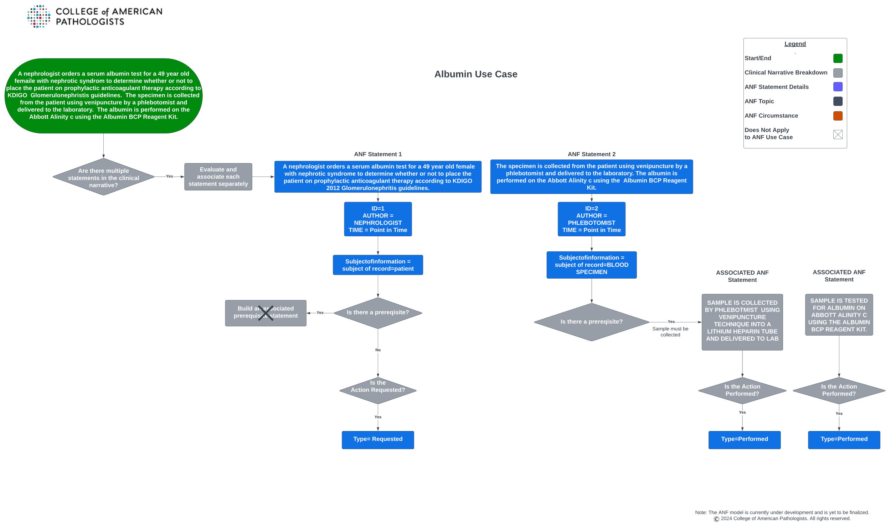
Note: Refer to Section 7.3.3 for high resolution version of Figure 24.
Upon determining the circumstance of each ANF statement, the “request” circumstance was further evaluated using the flowchart from the User Guide (Figure 25). Steps which did not apply to the ANF use case were marked with an “X” in the flowchart.
Figure 25: Building Albumin Request ANF Circumstance
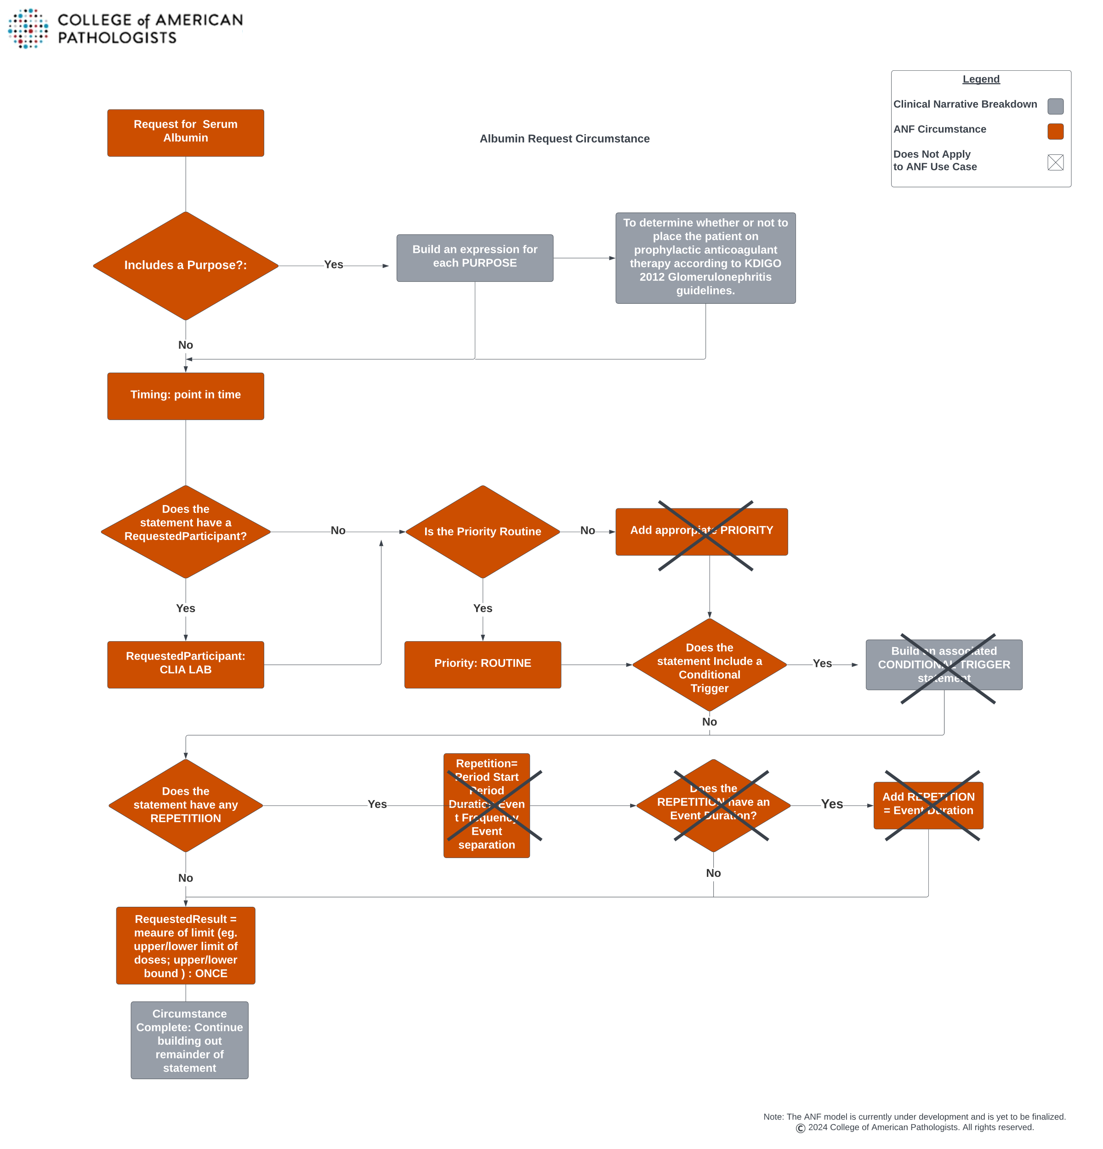
Note: Refer to Section 7.3.3 for high resolution version of Figure 25.
Following this exercise, the below table was compiled for the serum albumin request circumstance (Table 14).
Table 14: ANF Albumin Request Statement
 | QUESTION | ANSWER | RATIONALE
 |  | 1.BUILD OUT TOPIC
1.1 | Observation Procedure | Observation procedure - >  Topic: Serum Albumin Request
 |  | 2. REQUEST FOR ACTION
2.1 | Does the statement include a Purpose? | YES | Determine whether or not to place the patient on prophylactic anticoagulant therapy
2.2 | Timing? | Point in Time in the Future | Will always have a future time as they have not yet been performed/requested
2.3 | Does the statement have a requestParticipant? | YES: CLIA LAB | The statement is a request for the CLIA lab to perform the Serum Albumin Test
2.4 | Is the priority Routine? | YES: Routine | The Narrative does not state that this is a STAT request or other urgent time specification
2.5 | Does the statement include a conditional trigger | NO | Insufficient Information is given to indicate the conditional trigger/indication
2.6 | Does the statemen have any Repetition? | NO | The narrative does not indicate repetition
2.7 | Repetition = Period Start, Period Duration, Event Frequency, and Event Separation | N/A
2.8 | Does Repetition have an Event Duration? | N/A
2.9 | requestedResult= measure of limit (e.g., upper/lower limit of doses; upper/lower bound) | requestedResult = (1,0) | The requestedResult specifies the measurable result. In this case the number of orders for albumin is one at a point in time. It does not indicate any other orders beyond the 1st one
Table 15 depicts the outcome of transforming the “Request for Serum Albumin via Electronic Order Entry” into an ANF clinical statement.

Table 15: Transform Serum Albumin Request into ANF Clinical Statement
Topic | Observation procedure -> Topic: Serum Albumin
Technique | Electronic Order Entry
Circumstance | Period Start = [Now, Now], Period Duration = [Now, Now] Event Frequency [1,0] once, Separation = [0,0]; RequestedResult = [1,1] countable quantity
Prerequisite | N/A
Rationale | Topic –N/A  Technique- N/A  Circumstance-The circumstance field indicates timing  Prerequisite- insufficient information given regarding actions performed prior to request for serum albumin via electronic order entry
The “performance” circumstance was further evaluated using the flowchart from the User Guide (Figure 26). Steps that did not apply to the ANF use case were marked with an “X” in the flowchart. Note, this circumstance has two associated ANF statements, making this flowchart more complex. Additionally, questions arose related to the applicability of certain flows for the performance of the specimen collection and the performance of the test.
Specimen collection is considered a critical step and is defined as an “associated ANF statement”, because it captures the collection method of the specimen as well as the collection container, both of which are LIDR elements. However, the flow ends before capturing that data due to the completion of status.

Figure 26: Building Albumin Performance ANF Circumstance
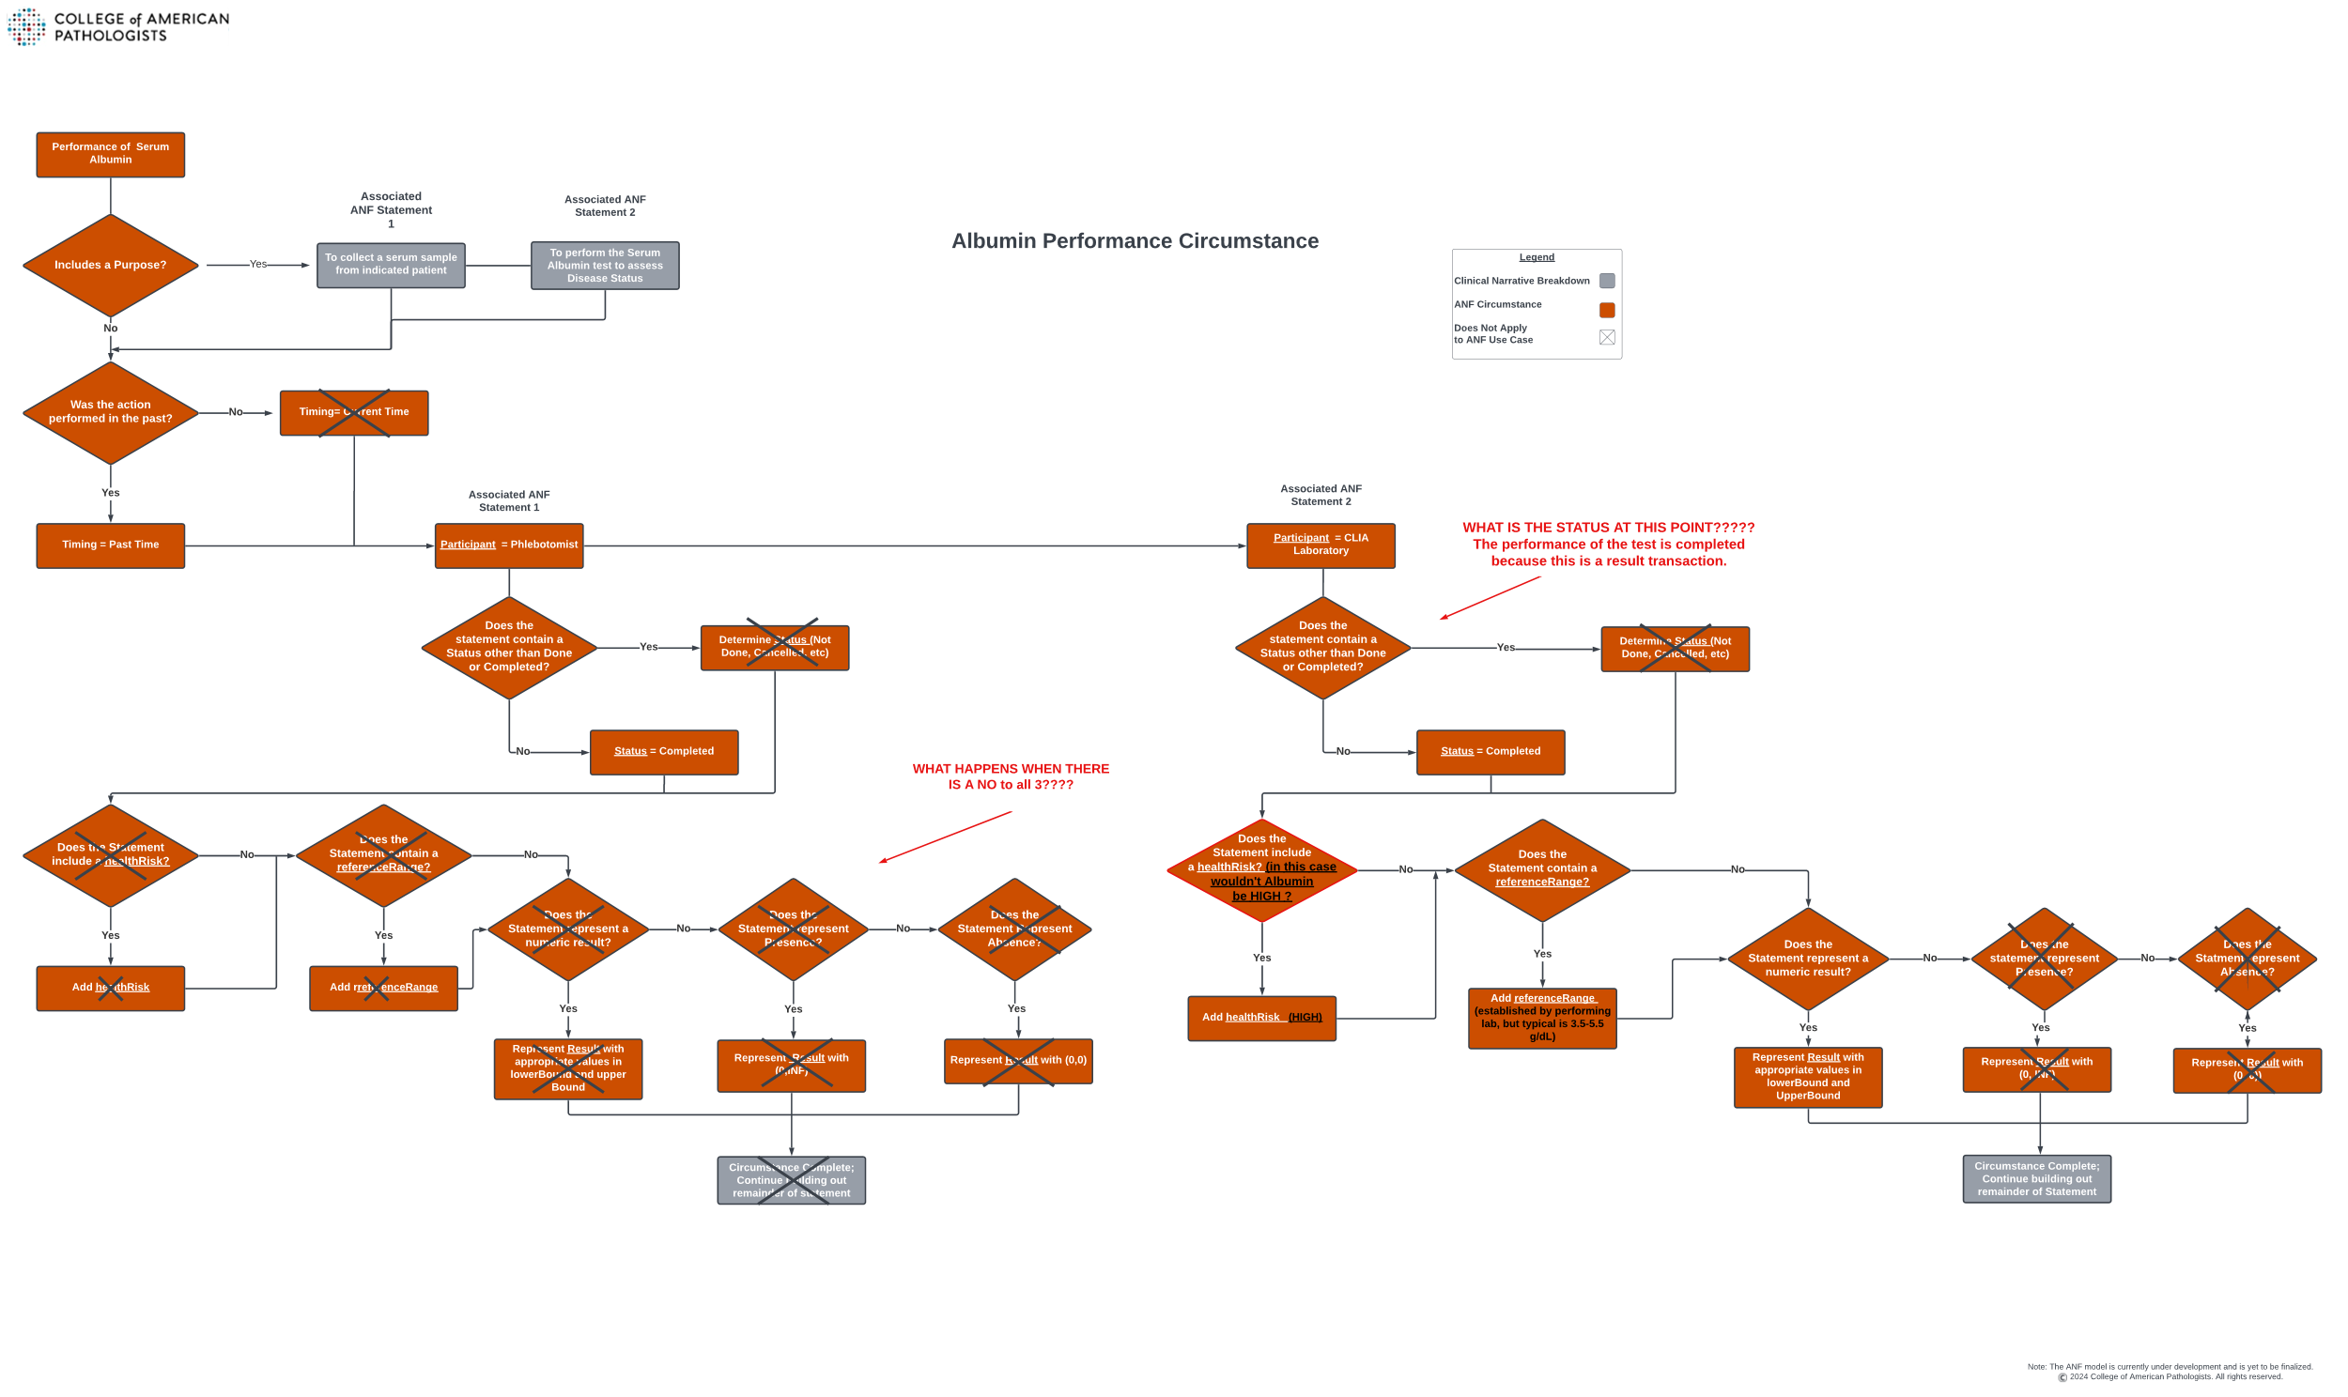
Note: Refer to Section 7.3.3 for high resolution version for Figure 26.
Following this exercise, the below table was compiled for the serum albumin performance circumstance (Table 16).
Table 16: ANF Albumin Performance Statement
 | QUESTION | ANSWER | RATIONALE
 |  | 1.BUILD OUT TOPIC
1.1 | Administration of Observation Procedure or Other? | Observation procedure: Topic = Observation procedure -> Has focus: Serum Albumin collected by venipuncture into a Lithium Heparin collection tube to be performed at a CLIA certified laboratory on the Abbott Alinity c™ instrument utilizing the Albumin Bromcresol Purple Reagent Kit | Describing the procedure
 |  | 2. REQUEST FOR ACTION
2.1 | Does the statement include a Purpose? | YES | Assess Disease State
2.2 | Timing? | Point in Time | In the case of test result, this has been performed at a designated date and time. (Thinking in the context of a test which has been resulted)
2.3 | Add Participant (responsible practitioners) | CLIA Lab | The statement is the collection of a specimen and the performance of the Serum Albumin test on the specimen by the CLIA laboratory
2.4 | Does that statement contain a Status other than done or completed? | NO (assuming we are talking about the test performance and the result availability) | Not done, cancelled, on-hold and stopped would be consider examples of a status other than done or completed. (In the case of the collection, it is completed; could other statuses for the actual test performance be “specimen received”, “in process” “preliminary”? If so, then perhaps our answer might be YES. However, in terms of transmitting lab results, would they not be transmitted at COMPLETED or possibly “preliminary”?)
2.5 | Does the statement contain a healthRisk? | YES - HIGH | This optional data element is used to flag results with coded values. For example, values could be coded as having a low, medium or high risk related to a lab result finding.
2.6 | Does the statement contain a referenceRange | YES: 3.5-5.5 g/dL | The reference range is defined by the performing laboratory
2.7 | Does the statement represent a numeric result? | YES circumstance: [6.5,6.5] g/dL | The clinical statement is asking for the numeric value of the albumin. The numeric result should be represented with the lowerBound and upperBound results indicated.
Table 17 depicts the outcome of transforming “Albumin 6.5 g/dL resulted on a Serum Sample from an Allinity c Device using the Bromcresol Purple Methodology” into an ANF clinical statement.
Table 17: Transform Serum Albumin Performance into ANF Clinical Statement
Topic | Observation procedure -> has focus: Serum Albumin
Technique | Serum sample collected via venipuncture tested on the Allinity c device using the Bromcresol purple reagent
Circumstance | (6.5, 6.5) g/dL; ReferenceRange = [3.5, 5.5] g/dL"
Prerequisite | N/A
Rationale | Topic –N/A  Technique- the clinical statement specifies the collection method and container as well as the test performance method (Abbott Allinity)  Circumstance-N/A  Prerequisite- insufficient information given regarding actions performed prior to albumin 6.5 g/dL resulted on a serum sample from an Allinity c device using Bromcresol purple methodology
Early Realizations Using the Current State of ANF Model Data Elements
The Excel Workbook (Section 7.3.3) contains a series of worksheets listing the steps in the use case narratives used to generate the ANF statements, as well as the resulting values for each of the ANF data elements that were selected by the SMEs.
In the initial exercise, there were differences in interpretation that led to different usage of the ANF data elements, along with the realization that certain ANF data elements were missing that were critical to the performance of a particular test.
For AP reports, there was no consistent location to report items that are collected discretely (e.g., Collection Time, Receive Time, and Fixation Time). Additionally, the team faced challenges when defining certain terms. For example, there was discord regarding whether “Target” and “Component” were synonymous with “Analyte”. This lack of consensus was illustrated by the estrogen receptor (ER) immunohistochemical assessment of a breast cancer use case (Excel- 2.0 Breast Resection). The “Target” was defined by the SME as the "Analyte” (ER) but the "Component” was defined as invasive cancer cells. Furthermore, the renal biopsy use case with light microscopy (Excel- 1.0 Renal Biopsy) raised the questions of:
- What is the target?
- Is the target any abnormality?
- What is the component if a sampling of glomeruli, tubules, and mesangium is necessary for an adequate study?
“Technique” and “Method” were other terms that generated conflicting meanings.
Table 18 and 19 presented below were developed with a revised approach, using the fundamental questions that ANF data elements seek to define: WHO, WHAT, WHEN, WHERE, WHY, and HOW (W5H) for any medical encounter. These questions were leveraged to create preliminary definitions for the ANF data elements, and their function was exemplified in the revised renal biopsy use case (Excel- Method 2- Renal Biopsy). Each SME was able to formulate a list of sub-elements that described the AP and CP use cases in a consistent manner, resulting in consensus on the proposed definitions.
Please note that the below tables were a starting point to better understand how the workflow in laboratory testing would overlay the existing ANF model.

Table 18: Preliminary ANF Request Statement Data Elements
ANF Request Statement Data Elements
Question | Data Element | Description
Who | Patient Identifier | Identifies the patient for whom the service or action is being requested
 | Requesting Provider | Identifies the practitioner(s) making the request for the service or action
 | Requested Service Provider | Identifies the practitioner(s) providing the service or actions requested.  May be another Provider, Hospital, Practice Group, or Laboratory
What | Requested Action or Service | Includes the name of the test or procedure and provides information on any treatment of the patient or timing that is required for interpretation of the result (e.g., Glucose Tolerance Test or Androgen Sensitivity Test)
When | Time Order is Placed | Time stamp for when the order was placed
 | Time Interval Order is Valid | Provides the time interval for which the order is valid
 | Repetition | Pertaining to (or properties of) the test:  Non-repeating (single point in time)  Repeating n times at specified y(i) time intervals where i goes from 0 (first time performed) to n and each y(i) can be different (or the same)
 | Urgency | Pertaining to the timing of the requestor’s need for action or results:  Immediate  Urgent  Rush  Routine  Not Specified (assume anytime for the time interval for which the order is valid)
Where | Facility Identifier for the Requestor | Identifies the facility or practice setting of the requesting provider
 | Facility Identifier for the Service Provider | Identifies the facility or practice setting of the service provider
Why | Clinical Diagnosis | Serves as indication for service
 | Relevant Co-Morbidities | Information on relevant co-morbidities that may impact the performance of the action or test or affects the interpretation of results
How | Technique | Specific action performed by an individual (e.g., light microscopy, gram stain, or ultrasound guided FNA)
 | Method | Comprehensive approach or protocol that employs or is inclusive of individual technique or steps (e.g., flow cytometry, electron microscopy, next generation sequencing)
 | Specimen Type | Substance or tissue being sampled or tested (e.g., nasopharyngeal swab, whole blood, serum, urine, wound swab)
 | Specimen Source | Body location from where a specimen was obtained
 | Target | The requesting provider may specify a particular area of focus, biomarker or gene in the order or request (e.g., wrist radiograph, FISH for BCL2, BCL6, and MYC)

Table 19: Preliminary ANF Performance Statement Data Elements
ANF Performance Statement Data Elements
Question | Data Element | Description
Who | Patient Identifier | Identifies the patient for whom the service or action is being performed
 | Service Provider | Identifies the practitioner(s) responsible for the results reported:  Clinician, Pathologist, Radiologist, Laboratory, Lab Section
What | Performed Test/Action | What is being performed (test) or resulted (the final report)
 | Resulted Test/Action Report | May include narrative, individual components/analytes, qualitative or quantitative results. Quantitative results should include units of measure as appropriate
 | Reference Range | Interval of values that are used to interpret the observation or finding and may include values that are deemed normal for a physiological measurement in healthy persons or values that indicate adequate therapeutic response or drug level (e.g., anticoagulation, therapeutic drug monitoring)
 | Results Flag | Results comment or flag indicating abnormality or risk to health (e.g., a flag with coded values, such as 'low', 'normal', high', and 'critical')
 | Rejection Criteria/Adequacy Condition | Result might be insufficient for diagnosis in which case Rejection Criteria/Adequacy Condition should be used to indicate any information regarding the condition and disposition of specimens that do not meet the laboratory's criteria for acceptability or compromise an observation or exam (e.g., hemolyzed specimen, inadequate bowel prep, inadequate fixation, or sample size)
When | Relevant Time Records | Time Records Relevant to Performance:  Challenge Time ((HH:mm:DD:MM:YYYY)  Collection Time (HH:mm:DD:MM:YYYY)  Receive Time (HH:mm:DD:MM:YYYY)  Specified Procedural Times (e.g. Time in Fixative, Time out of Fixative)
 | Status | Status of the result or observation with time stamps as needed:  Preliminary Result  Final Result  Addended Result  Amended Result
Where | Facility Identifier | Identifies the facility or practice where the action or service was performed (e.g., CLIA Laboratory identifier)
Why | Clinical Diagnosis | This data element can inherit a parent order or be specified as the individual reason for a reflex
 | Relevant Co-Morbidities | This data element can inherit a parent order or be specified as the individual reason for a reflex
How | Technique | Specific action performed by an individual (e.g., light microscopy, gram stain, or ultrasound guided FNA)
 | Method | Comprehensive approach or protocol that employs or is inclusive of individual technique or steps (e.g., flow cytometry, electron microscopy, next generation sequencing)
 | Instrument | Instrument or platform used to produce the result
 | Test Kit | Test kit or reagent system used to produce the result
 | Target | Particular area of focus, biomarker, or gene (e.g., wrist radiograph, FISH for BCL2, BCL6 and MYC)
 | Specimen Type | Substance or tissue being sampled or tested (e.g., nasopharyngeal swab, whole blood, serum, urine, wound swab)
 | Specimen Source | Body location from where a specimen was obtained
At this stage, the CAP was asked to pivot from the development of ANF statements to developing enriched clinical narratives that explicitly exposed gaps and challenges.
These clinical narratives depict the steps by which data are generated and exchanged during test request, execution, and reporting for a broad range of IVD applications. Information and/or specimen transfer might involve any of several pathways between a variety of participants (e.g., submissions by patients directly to a laboratory [at-home test], exchanges between healthcare providers and laboratories, submissions to public health agencies by a laboratory or healthcare provider, or exchanges between laboratories). The CAP used these narratives to propose additional ANF data elements for accurate conveyance of information created in both anatomic pathology and clinical pathology laboratories, ensuring that ANF supports interoperability in those domains.

5.3 Development of Clinical Narratives
The Excel document was translated into a narrative format using the eight clinical use cases referenced in Table 13. These narratives include extensive detail to support proposed additions to the ANF model such that it includes laboratory reporting. These clinical narratives, presented below (Sections 5.3.1-5.3.8), will serve as a tool for the FDA and other ANF contributors as they continue to strengthen the ANF model.
The clinical narratives incorporate existing mature data models that are widely used for data exchange. Given that selected clinical narratives relate to cancer reporting, reference is made to the use of data elements defined by the CAP Cancer Protocol templates. The CAP published its first cancer protocols in 1986 as best practice guidelines for reporting on common AP cancer cases. These protocols have been expanded and are now available in both human readable (paper) and in electronic format (since 2007), with the latter supporting the capture of discrete data elements. Both HL7 and FHIR® transport protocols are available for sending and receiving the discretized data from the reports, thereby achieving interoperability. The individual data elements are vetted for their clinical utility by subject matter experts in a process presided over by the CAP Cancer Committee. Histological subtypes are based on the World Health Organization (WHO) Blue Books and staging on the American Joint Committee on Cancer (AJCC) guidelines. Electronic protocols are maintained by the CAP Pathology Electronic Reporting (PERT) Committee. They are used extensively across the United States and Canada for local reporting and interoperable data exchange. Laboratories with Commission on Cancer (COC) Accreditation are required to incorporate the CAP Cancer Protocol synoptic report that includes the required data elements. If an electronic cancer protocol is used by a facility, then these required data elements can be electronically submitted to the local cancer registry and subsequently to national cancer registries. The Assistant Secretary for Technology Policy/Office of the National Coordinator for Health Information Technology (ASTP/ONC) is in the process of reviewing a recommendation that the CAP Cancer Protocols be adopted for cancer reporting as part of USCDI+ (United States Core Data for Interoperability extension to include cancer registry reporting).
The most recent versions in human readable format with guidelines and references can be found at this link: CAP Cancer Protocol Templates. In the clinical narratives, the reader will be guided to the website above rather than presented the data elements specific to a cancer report.
Similarly, a general Autopsy Protocol with discretized data capture using standard terms was developed by the PERT Committee in concert with the CAP Autopsy Committee and is available at this link: CAP Autopsy Protocol.
There is not a mature medical renal biopsy synoptic report, although there are published recommendations from the medical renal community on the items that should be reported. These recommendations were used to populate Table 20.

5.3.1 Clinical Narrative 1: Serum Albumin Test
A nephrologist orders a serum albumin test for a 49-year-old female with nephrotic syndrome to determine whether to place the patient on prophylactic anticoagulant therapy according to the Kidney Disease | Improving Global Outcomes (KDIGO) 2012 Glomerulonephritis guidelines. A phlebotomist collects the blood from the patient into a lithium heparin test tube via venipuncture. This specimen is delivered to the laboratory. The albumin assay is performed on the Abbott Alinity c™ instrument with the Albumin BCP Reagent Kit™, which uses the bromocresol purple (BCP) dye binding method. The result is a quantitative value expressed using g/dL as the unit of measure and with a normal reference range of 3.6-5.1 g/dL, as determined by the performing laboratory for their patient population.

5.3.2 Clinical Narrative 2: Renal Biopsy
This use case is an example of a medical kidney biopsy for worsening chronic kidney disease (CKD) in a patient with a history of hepatitis and diabetes.
A 59-year-old male patient with a history of hepatitis C virus infection (HCV) and diabetes mellitus Type 2 (Type 2 DM) presents for a regular checkup with a nephrologist. It is noted that the patient’s glomerular filtration rate (GFR), measured longitudinally, has worsened dramatically over the last six months. The nephrologist records in their progress notes that they are requesting a comprehensive renal biopsy and refers the patient to their staff to arrange the specimen collection. Hematology and coagulation laboratory report values available from the patient’s recent laboratory tests are reviewed to ensure that there is no evidence of a bleeding diathesis. The nephrologist’s staff then submit an order for an ultrasound guided needle core biopsy of the kidney from a nearby outpatient imaging center to be submitted to a specified regional laboratory with expertise in processing renal biopsies. The nephrologist’s office uses an online electronic ordering system to request a renal biopsy kit from the regional laboratory to be sent to the imaging center for use to collect the patient’s specimen(s).
The regional laboratory sends the kit with instructions. The imaging laboratory confirms the time and place of the appointment with the patient, having received the kit. This kit asks for three biopsy cores to be submitted. These three cores are separately placed in 10% buffered formalin (for light microscopy [LM] and immunohistochemistry [IHC]), Zeus fixative (for immunofluorescence [IF]), and glutaraldehyde (for electron microscopy [EM]). There may also be a request for snap frozen tissue for use with IF. The samples are sent together with paperwork corroborating an online order for a comprehensive renal biopsy interpretation and with a description of the patient’s co-morbidities and current lab values to include the trending GFR and the lack of a coagulopathy. The specimen samples are sent as a refrigerated package due to the warm summer temperatures being experienced. Otherwise, they could be sent at room temperature. The test request lists the nephrologist as the ordering physician with a copy of the report to be sent to the radiologist who performed the biopsy.
Upon arrival at the regional laboratory, the core biopsy that was fixed in formalin is processed to a hematoxylin and eosin stain (H&E), with the option to include silver, trichrome, periodic acid-Schiff (PAS), or other special stains (SS) for LM review. They are examined by a medical renal pathologist to assess for quality based on the number of glomeruli for review and reported with enumeration of glomeruli and histopathological evaluation of the status of the glomeruli in terms of sclerosis, mesangial expansion, and any other relevant histopathology.
If abnormal, additional testing by IF or possibly immunoperoxidase (IP) staining with specification of antibodies of interest, and by EM is requested by the renal pathologist who performed the LM. Antibodies of interest for IP and/or IF include IgG, IgA, IgM, C3, fibrinogen, albumin, kappa, and lambda. These reflex requests are secondary to the judgment of the medical renal pathologist performing the LM, and are submitted to the IP, IF, and/or EM laboratories as needed. The appropriate laboratories perform the technical operations to create the appropriately stained material and images. Interpretation is performed by a pathologist. The medical renal pathologist might interpret all of the reflex testing, or it might be interpreted by another pathologist or professional (e.g., the EM report) with the report given to the medical renal pathologist for integration with other results.
The medical renal pathologist collects the information reported for the modalities used to generate an integrated report of the results. Technical charges are based on how many stains were performed and the techniques applied to create them (H&E, SS, IP vs IF, EM) while the professional charges are based on the review of each stain and the integrated report.
The following items are recommended in published healthcare literature for complete reporting (Table 20).

Table 20: Essential Pathologic Parameters for Reporting⁹
Parameter | Elements
Clinical history/data | - Brief summary of history provided by clinician or obtained from another authoritative source
Gross description | - No. of tissue core(s) for LM core length(s) & fixative  - No. of tissue core(s) for IF/IHC/immuno - microscopy, core length(s) & fixative  - No. of tissue core(s) for EM, core length(s) & fixative
Microscopic description | - Light microscopy  - Histochemical SS (e.g., PAS, Jones methenamine silver, Masson trichrome, Congo red) with kit information for preparation if applicable  - Presence of cortex/medulla/capsule/calyceal mucosa  - Glomeruli  - No. of glomeruli  - No. of glomeruli (%) with global sclerosis (if present)  - No. of glomeruli (%) with segmental sclerosis (if present)  - No. of glomeruli (%) crescents, cellular to fibrocellular (if present)  - No. of glomeruli (%) with fibrinoid necrosis (if present)  - Additional abnormalities (e.g., hypercellularity, deposits, thrombosis, double contours, spikes)  - Tubulointerstitium  - Extent of interstitial fibrosis/tubular atrophy, at least semiquantitative  - Interstitial inflammation, tubular injury, crystals  - Arteries/arterioles  - Intimal fibrosis (absent/present/severity)  - Arteriolar hyalinosis (absent/present/severity)
Immunofluorescence (IF) or Immunoperoxidase (IP) microscopy | - Glomeruli  - Method (IF or IP) with kit information for preparation if applicable  - No. of glomeruli present  - No. of globally sclerosed glomeruli  - Specify each antibody used and its source clone/commercial identifier  - Staining intensity, location/pattern of staining for each antibody, and specify intensity scale (0-3+ or 0-4+)  - Relative intensity of kappa/lambda staining of tubular casts  - State when IF performed on paraffin sections that were fixed in Zeus vs. frozen sections cut in OCT
Electron microscopy | - State when EM performed on tissue processed from paraffin sections versus plastic  - State whether a sample or all the submitted tissue examined by toluidine or methylene blue stain  - Glomeruli (note that because of the use of much smaller sections, percentages are not requested as they are not necessarily representative of the kidney state)  - No. of glomeruli present in toluidine blue thick sections  - No. of globally or segmentally sclerosed glomeruli  - No. of glomeruli with crescents or necrosis or proliferation  - No. of glomeruli evaluated by EM  - Absence or extent of podocyte foot process effacement  - Absence or presence and location of electron dense deposits  - GBM thickness (normal, thin, thick) and appearance (e.g., layered). If abnormal, state reference range of GBM thickness for age and sex  - Additional abnormalities (e.g., infiltrates, deposit substructure, fibrillary deposits, cellular interposition, tubuloreticular inclusions, fibrin tactoids)  - Indicate if tubulointerstitium was evaluated  - Specify if tubulointerstitial deposits present  - Indicate peritubular capillary basement membrane was evaluated (for transplant biopsies),  - Specify if multilayering present (focal vs diffuse)
Final integrated reports are generated within four-five days of the receipt of the biopsy by the regional specialty laboratory and sent to the ordering nephrologist with a copy to the radiologist who performed the biopsy.
To develop this renal biopsy use case, practice guidelines for renal biopsy procedures,¹⁰ a comprehensive kidney biopsy workup provided by ARUP Laboratories,¹¹ and recent advancements in automated identification of glomeruli using machine learning techniques were referenced.¹²

5.3.3 Clinical Narrative 3: Complete Blood Count
A complete blood count (CBC) is requested by the clinician for a 15-year-old male patient complaining of fatigue and dark urine. The specimen is to be collected from a patient as soon as possible, one time, using venipuncture technique into a lavender top test tube with ethylenediaminetetraacetic acid (EDTA) by a phlebotomist and delivered by the phlebotomist to the laboratory.
The CBC is performed on the Sysmex CBC Analyzer™ which produces a hemogram result containing the white blood count (WBC), red blood count (RBC), hemoglobin (HGB), hematocrit (HCT), mean corpuscular volume (MCV), mean corpuscular hemoglobin (MCH), mean corpuscular hemoglobin concentration (MCHC), platelet count (PLT, RDW with), red cell distribution width (RDW) with an automated differential containing the percent neutrophil, lymphocyte, monocyte, eosinophil, and basophils, as well as the absolute count of neutrophils, lymphocytes, monocytes, eosinophils, and basophils. The RBC and platelet counts are derived using the direct current (DC) sheath flow detection method. The HGB is derived using the cyanide-free sodium lauryl sulphate method and Sysmex Sulfolyzer™ reagent kit. HCT and MCV are direct measurements on the Sysmex. The MCV is an average of all RBC size measurements collected in the impedance counter. The HCT is the sum of all the RBC size measurements and reported in proportion to the total volume of the analysis sample. Red cell distribution width is reported on the Sysmex as both standard deviation from the mean red cell size (RDW-SD) and as coefficient of variation from the mean (RDW-CV). The red blood cell indices – MCH and MCHC – are calculated values. The WBC and automated differential are derived using fluorescence flow cytometric analysis and the Sysmex Fluorocell WNR™ reagent. The results are reported as numerical results with reference ranges determined by the performing laboratory for their local patient population. For this patient, the results were:

Table 21: Complete Blood Count Results
Component | Result | Reference Range
WBC | 3.5 k/mm3 | 4.5-11.0
RBC | 2.67 M/mm3 | 4.5-5.9
HGB | 7.7 g/dl | 13.2-17.0
HCT | 23.4% | 40.0-51.0
MCV | 87.6 fL | 76.0-92.5
MCH | 28.8 pg | 26.0-34.0
MCHC | 32.9 g/dL | 33.0-37.0
RDW | 13.6% | 11.5-15.0
PLT | 350 k/mm3 | 150-450
MPV | 10.0 fL | 9.6-11.8
Table 22: Peripheral Blood Differential Count
Component | Result | Reference Range
Band Forms and Segmented Neutrophils | 61.7 % | 36.0-66.0
Lymphocytes | 30.3% | 24.0-44.0
Monocytes | 8.0% | 0.0-10.0
The result is reviewed by the medical laboratory scientist (MLS) and if there is no indication of abnormality, it is verified in the LIS. If there is any indication of suspicious cells, abnormal results, or error messages from the analyzer, the whole blood specimen is then applied to a slide and stained with Wright stain for preparation to perform a manual differential. The MLS performs the manual differential either using light microscopy or with an automated digital hematology analyzer such as CellaVision™. CellaVision uses light microscopy and a digital camera to capture individual images of white blood cells and uses artificial intelligence software to classify the cells under the appropriate cell type to populate a differential count. The results must be verified by an MLS who is able to reclassify cells as needed to correct any errors by the software program in classifying the cells. The MLS then determines which results (the automated or manual differential count) to be entered into the LIS.
Blast cells or other indications of extreme abnormality that present on the blood smear may require review and interpretation by a pathologist. The pathologist enters their interpretation of the peripheral blood smear slide as a Result Comment.
The clinician receives the result of the CBC and is concerned by the patient’s moderate anemia and the finding of degmacytes (bite cells) on the peripheral smear and orders tests for haptoglobin, direct antiglobulin test (DAT), Glucose-6-Phosphate Dehydrogenase (G6PD) Enzyme Activity, and hemoglobin electrophoresis.
A new blood sample collected in a lithium heparin test tube must be drawn by the phlebotomist to perform the haptoglobin assay. Haptoglobin is performed on the Abbott Alinity cTM instrument using immunoturbidimetry method and the Abbott Haptoglobin Assay™ reagent kit. The result is reported as a numerical value with mg/dL unit of measure and age specific reference range determined by the performing laboratory for their patient population. In this case, the haptoglobin was reduced at 6 mg/dL, indicating hemolysis.
The DAT was able to be performed on the original whole blood in EDTA sample. The DAT was performed using hemagglutination method on the Ortho Vision™ instrument with Polyspecific Gel Card. The DAT is used to determine if there are IgG and Complement C3d on the patient’s red blood cells that may be inducing hemolysis. This is a qualitative test and the results are reported as ordinal results with a reference range of negative. In this case, the DAT was positive.
The G6PD Enzyme Activity Test also required a new blood sample to be collected from the patient in a yellow top test tube with acid citrate dextrose (ACD) solution B. The G6PD Enzyme Activity Test is performed using kinetic spectrophotometry on the UV-1800 Shimadzu™ (Shimadzu Scientific Instruments) instrument with the Quantitative G6PD kit™ (Trinity Biotech). The G6PD Enzyme Activity Test is used to identify patients who may have glucose-6-phosphate dehydrogenase deficiency as cause of hemolysis. Patients should not be tested during hemolytic episodes as "false-negative" results may occur because the most severely deficient red cells have already been removed from the circulation via hemolysis. The patients should be tested approximately six months after a hemolytic episode for the results to be valid. The results are reported as numerical values with units/trillion RBCs unit of measure and age specific reference range.
Hemoglobin electrophoresis was also able to be performed on the original whole blood in EDTA sample. Hemoglobin electrophoresis is performed using capillary electrophoresis on the Sebia Capillarys 3 Octa™ instrument and CAPI 3 HEMOGLOBIN(E)™ reagent. Capillary electrophoresis separates molecules such as hemoglobin due to their electrophoretic mobilities. Direct detection provides accurate relative quantification of individual hemoglobin fractions: A, F, A2, S, C, D, and E. Because different hemoglobin variants can have overlapping electrophoretic mobility, the CAP requires the use of a complementary method such as Isoelectric Focusing (IEF) for confirmation of results. The premise of IEF is that a molecule will migrate so long as it is charged. Should it become neutral, it will stop migrating in the electric field. Hemoglobin variants will migrate along the IEF gel until they reach the gradient where they become neutral and stop in that position. The hemoglobins are reported in percent (%) units along with an electrophoresis scan by the instrument. The results are reported as numerical values for the hemoglobins present along with nominal results for specific variants or interpretations. The reference range is age specific with variation in the literature and between laboratories depending on methodology. Such as:
Table 23: Hemoglobinopathy Evaluation Results Example 1
Component | Result | Reference Range
Hb A | 97.5% | Normal: >95%
Hb A2 | 2.5% | Normal: 1.5 to 3.7%
Interpretation: Hemoglobin distribution is appropriate for age.

Or
Table 24: Hemoglobinopathy Evaluation Results Example 2
Component | Result | Reference Range
Hb E | 30.% | Normal: 0%
Hb A | 74.5% | Normal: >95%
HB A2 | 4.5% | Normal: 1.5 to 3.7%
Interpretation: Hemoglobin E Trait (heterozygous Hb E)

5.3.4 Clinical Narrative 4: Lymph Node Biopsy
An ultrasound-guided fine needle biopsy of an enlarged right cervical lymph node is performed by an interventional radiologist on a 12-year-old male patient with a six-month history of enlarged lymph nodes on the right side of the neck. Samples are sent to the laboratory for: a) cytology, b) flow cytometry and c) tissue examination.
During the FNA procedure, the interventional radiologist makes several passes with the needle through the lesion as identified by ultrasound. Cells collected by the needle passes are aspirated onto slides. The cytology specimen slides are stained with Wright Giemsa and Papanicolaou stain for light microscopy examination by the cytopathologist. Residual material collected in the syringe is centrifuged onto a slide and made into what is referred to as cell block and stained with the H&E stain. If needed, the cytopathologists order special and immunohistochemical (IHC) stains on the cell block in order to further evaluate any atypical cells. The cytopathologist evaluates the cells on the slide for atypia and issues in a cytopathology report with narrative results that include a microscopic description of the cells, description of the result of any special or IHC stains and a final diagnosis such as “Atypical Cell Population Present.”
The flow cytometry specimen is prepared and examined using laser interrogation of cells suspended in a buffered salt-based solution with multiple fluorescent labeled antibodies. Flow cytometry examination in this case was performed on the 10-color BD FACSCanto™ with multiple markers (CD2, CD3, CD4, CD5, CD7, CD8, CD10, CD19, CD 20, CD22, CD30, CD38, CD45, CD56, CD64, kappa light chain, and lambda light chain) using Research Use Only Reagents from multiple manufacturers that have validated for clinical use per CLIA. The results are provided in a Flow Cytometry Report with narrative results describing the immunophenotype of any atypical cell population present and an interpretation of the findings such as:
“Immunophenotypic analysis shows an aberrant B-cell population (30% of total events) with monotypic loss of immunoglobulin expression and the following immunophenotype” CD5(-), CD10(+), CD19(+), CD20(+), CD22(+), CD30(-), CD38(partial +), CD45(+)”.
“Monoclonal B-cell population identified (30% of total events). Correlation with clinical and morphologic data is recommended. Flow cytometry is an ancillary testing and is not a final diagnosis.”
Tissue cores were also collected during the FNA and the specimen for tissue examination is fixed in formalin and prepared into paraffin embedded blocks for preparation into slides for light microscopy and immunohistochemistry. The tissue core dimensions are measured with a gross description of the tissue included in the tissue examination report. The tissue sections are placed in labelled cassettes and submitted to the histology processing laboratory for overnight processing. The tissues are then sectioned and stained with H&E stain. The pathologist reviews the material and sees sheets of medium to large sized atypical lymphoid cells with irregular nuclear contours, vesicular chromatin, and prominent nucleoli. The description of the atypical cell infiltrate is included in the microscopic description for the case. The pathologist orders IHC stains to be performed and the histology laboratories cuts additional unstained slides from the tissue block and stains them with the order IHC stains.
The description of the IHC stains is included in the tissue examination report:
The atypical cells demonstrate the following immunohistochemical/ISH staining profile (block A4):

Table 25: Immunohistochemistry Interpretation
IHC | Interpretation
CD3 | Negative
PAX-5 | Diffuse positive
CD20 | Diffuse positive
CD10 | Diffuse positive
BCL-6 | Diffuse positive
MUM-1 | Negative
BCL-2 | Negative
C-MYC | Patchy variable positive, 50-60%
BCL-2 | Negative
CD21 | Disrupted follicular dendritic meshworks
CD23 | Disrupted follicular dendritic meshworks
CD30 | Negative
Ki-67 | 95%
EBV ISH | Negative
TdT | Negative
ALK | Negative
Unstained slides suitable for molecular tests are prepared from the formalin-fixed paraffin-embedded (FFPE) for:
Fluorescence in situ hybridization (FISH) for the Lymphoma (Aggressive) Panel which evaluates for rearrangements in the BCL2, BCL6 and MYC genes was performed on the tissue on the Dako Omnis™ instrument using the Vysis LSI IGH/BCL2 Dual Color™, LSI BCL6 Dual Color Break Apart Rearrangement Probe™, and LSI MYC Break Apart Rearrangement Probe™. The results are reported as narrative results and in this case were negative for BCL2, BCL6, and MYC gene rearrangements.
B-cell receptor gene rearrangement studies to evaluate for clonal rearrangement if the immunoglobulin heavy chain gene (IgH) and kappa light chain gene (Igκ) using BIOMED-2 multiplex polymerase chain reaction (PCR) was performed on the Thermo Fishers Applied Biosystems™ instrument using the 2-tube, 2-fluorochrome EuroClonality/BIOMED-2 TRG PCR (TRG-2T-2F) ™ kit. The results are provided as a narrative interpretation and in this case was positive for a clonal B-cell population.
Additional unstained slides are sent for a lymphoma 34 gene next generation sequencing panel to be performed. The panel was performed on the Ion Torrent Personal Genome Machine (PGM) Sequencing™ instrument with PGM data analysis using the Lymphopanel which evaluates for 34 genes associated with the following pathways: Immunity (CIITA, B2M, TNFRSF14, ), NOTCH (), Apoptosis/Cell cycle (MFHAS1, XPO1, MYC, CDKN2A/B, FOXO1, TP53, GNA13, ), NFκB (TNFAIP3, MYD88, PIM1, CARD11, IRF4, ), Epigenetic Regulation (EZH2, KMT2D, EP300, MEF2B, ), MAP Kinase (BRAF), JAK-STAT (), and BCR (CD79A/B, ITPKB, TCF3. The results are reported as narrative results. It is recommended that results are reported using Human Genome Variation Society (HGVS) Nomenclature. At the minimum the genomic coordinates, which are directly related to the reference genome and include the chromosome name, start position, and end position, must be included.

5.3.5 Clinical Narrative 5: Breast Resection for Cancer
This 38-year-old female previously presented with a palpable mass that was biopsied. The biopsy site was marked with a clip for easy identification. Invasive ductal carcinoma not otherwise specified was diagnosed, Nottingham Grade 3, without ductal carcinoma in situ (DCIS). Biomarker studies indicated that the tumor was ER/PR/Her2neu negative with a proliferation index as measured by ki-67 of 75%.
Clinically, the tumor measured 1.5 cm (cT1c) and ultrasound examination of the axilla was negative.
She now proceeds for a lumpectomy (aka partial mastectomy, aka excision, aka segmental excision) to remove the tumor. She will undergo a sentinel lymph node biopsy simultaneously.
Prior to surgery, the patient is interviewed and has laboratory testing as deemed appropriate for surgical evaluation. Additionally, three magnetic seeds are placed under imaging guidance to determine the boundaries of the tumor. Also, she has a technetium 99 injection for sentinel lymph node identification. These procedures are not included in the final AP report as they were performed by radiology.
Patient reports at the time and location designated for surgery. The surgeon removes breast tissue and a sentinel lymph node for evaluation. The surgeon requests a surgical pathology examination with report of both specimens, obtained as part of a single procedure, to be returned to the surgeon with a copy to the patient’s medical oncologist and radiation oncologist.
During the surgery, the surgeon identifies the magnetic seeds with a probe. Blue dye is injected into the area. The surgeon performs the lumpectomy and designates the margin assignments (superior, inferior, anterior, posterior, medial, and lateral). The pathology laboratory receives the specimen. They perform a gross examination that includes a faxitron image study to confirm that the three magnetic seeds and the biopsy clip are present in the specimen. This is reported as an intraoperative finding. Separately, the axilla is opened, and blue dye is recognized by the surgeon. Radioactive probes are used to localize the sentinel lymph node, which is removed.
Grossly, the breast specimen is inked according to the margin inking (color) protocol designating each of the 6 oriented aspects. The specimen is breadloafed and location of the three magnetic seeds is noted. These mark the boundaries. The tumor itself is associated with a biopsy clip, which is also localized. Grossly, the size of the specimen in three denoted dimensions (S-I, M-L, A-P) is recorded along with the dimensions of the tumor and the distance to each of the six margins for the grossly identifiable tumor. Margin sections, tumor sections to include those needed for microscopic sizing of the tumor, and at least one full cross section of the tumor is obtained.
The lymph node is sectioned per local protocol (either longitudinal sectioning, which translates into three H&E levels and an IHC for cytokeratins or sections taken perpendicular to the hilar axis with one H&E and an IHC for cytokeratins).
The sections of tissue, placed in labelled cassettes, are submitted to the histology processing laboratory. They are processed overnight and then sectioned and stained the following day. Additional unstained sections of the lymph node are submitted to the immunohistochemistry laboratory for cytokeratin staining.
When all the H&E-stained slide are completed and aggregated, the case is delivered to the surgical pathologist. The IHC for cytokeratins on the lymph node will be delivered separately from the IHC laboratory. The report will include the antibody type and staining protocol that was used.
The pathologist reviews the material. The AP report includes a synopsis with the required data elements for the CAP Cancer Protocol for resection of invasive breast cancer (CAP Cancer Protocol Templates). The ancillary testing of biomarkers from the previous biopsy is included in the Invasive Breast Cancer Resection Protocol. Per the practice of this laboratory, specimens with prior negative biomarker results on a biopsy will have these biomarker studies repeated as requested additional laboratory tests. This means that there will be another set of ancillary tests, to include ER, PR, Her2neu, and ki-67 immunohistochemical results. These will be reported using the CAP Breast Cancer Biomarker Protocol, which includes collection of antibody type and staining procedure, or commercial kit used.
Final reports are made available to the surgeon and the managing physician, typically the medical oncologist. Reports will also be referred to a radiation oncologist if the managing physician sees this as an appropriate adjuvant therapy. The pathology report is submitted to the local cancer registry for abstraction, or, if in electronic format, then by HL7 message to the registry to automatically populate the registry database.

5.3.6 Clinical Narrative 6: Self-Administered Syphilis Test
This is a case of syphilis testing in adults and does not include congenital syphilis, which is reported separately to the local, state, and national public health authorities.
A nursing home recently discovered that one of its patients had contracted syphilis, the disease caused by Treponema pallidum. Given the risk of the residents being unable to deliver accurate histories, the head of the facility decided to use at-home testing with the assistance of a nurse’s aide on patients for whom she could obtain informed consent, either from the patient personally or their designated medical power of attorney. The facility requests that test results be reported to the facility physician and to the patient or patient’s medical power of attorney if the information is not to be sent to the facility physician.
Each patient’s consent document, age, birth sex, current sex, current gender identification, race, ethnicity, name, and room number within the facility is collected.
The facility purchases at-home test kits. The following collection procedure is exemplary of a typical at-home test kit (see Superdrug Online Doctor for syphilis test at onlinedoctor.superdrug.com).
- Before you use the syphilis test kit, you should wash and dry your hands.
- Use the swab found in the test kit to clean the tip of the third or fourth on the hand you don’t write with.
- Take a lancet and twist and pull out the purple stick. Put the stick on the cleaned fingertip and press the button at the end. You will feel a small prick and a small drop of blood should form.
- Use a clean tissue to wipe away the first drop of blood and use your other hand to massage the pricked finger until another drop appears.
- Take the collection tube and use it to catch the blood. You will need to fill the tube to the top line, and you might need to use another lancet to get the blood you need. If you need to use another lancet, then use it on a different finger.
- When the collection tube is full, close the lid and screw it on tightly. Find the label provided in the pack and write your details on it before sticking it to the collection tube.
- Place the collection tube in the protective wallet and then put it in the prepaid envelope provided.
- Post the envelope to the supplier. There is no need to buy a stamp.
The performing laboratory receives this sample via the mail. A report is sent to the facility physician or other designee, including the patient, as approved by the patient or the patient’s medical power of attorney.
Specific laboratory data elements are required by state law to be reported to the state public health department. These vary by state and can include patient history including sexual partners, HIV comorbidity, known stage of disease to include early or late disease, presence of skin lesions, and otic or neurological symptoms, treatment data such as drug, dosage, date administered, and longitudinal serological test results. As an example, the reporting form for the state of Wisconsin can be found here: Wisconsin Sexually Transmitted Infection Reporting Form. Because this clinical information might not be available to the laboratory, the CDC recommends that at a minimum all positive syphilis direct detection test (i.e., by light microscopy) along with specimen site, and all positive syphilis serologic tests, should be reported to state and local health departments by the laboratory. Table 26 shows these minimum reporting data elements.
Table 26: CDC Recommendations for Minimum Test Reporting Requirements (not complete for ANF modeling)
# | Requirement
1 | Type of test (Direct [Light Microscopy]) and Indirect or Serological (e.g., VDRL, RPR, EIA)
2 | Specimen Site
3 | Date Specimen Collected
4 | Sensitivity of Antibody Used (for serological testing)
5 | Resulting Titer (for serological testing)
6 | Attending physician
7 | Name of laboratory performing the test
8 | Details of reporting office and physician with location and details
9 | Date Report Submitted
For complete ANF modeling, the laboratory results should also indicate relevant comorbidities such as HIV, the type of test kit/reagent identifying information, instrument identifier, reference range, units of measure if applicable, and any other information relevant to the test performed as outlined in Table 26. However, the additional history of the illness, its signs and symptoms, and the patient’s sexual contact history that might be required by the state for reporting are not a part of the laboratory reporting of results. These would be incorporated into a separate ANF clinical report or progress note.
As follow-up, if the result of the at-home test is positive, the patient, their agent, or the facility physician will typically be requested to perform follow-up confirmation. This information is often requested by the state public health department. The confirmation method depends upon the patient presentation. Light microscopy of fluid samples from sores or lesions might be used, or further antibody testing. Recently, positive and sensitive results from a PCR test for the presence of T. pallidum was reported. However, it is not readily available in the US.
If the result is negative and there is concern about the timing of exposure such that serological evidence may not be present, then the at-home test might be repeated in a reasonable time interval (e.g., three months).
As stated above, all positive results must be reported to the state and local public health department and subsequently to the CDC. As of December 31, 2003, all 50 states and the District of Columbia converted from summary hard copy reporting to electronic submission of line-listed (i.e., case-specific) data for chlamydia, gonorrhea, syphilis, and chancroid through the National Electronic Telecommunications System for Surveillance (NETSS).

5.3.7 Clinical Narrative 7: Toxicology
An 18-year-old male presents to the emergency department of a local hospital by ambulance after being found unresponsive in his room by a roommate. The patient had some initial response to naloxone but had difficulty breathing and was intubated. A urine drugs of abuse screen test is ordered by the emergency medicine physician and the specimen is collected upon placement of the foley catheter and sent to the laboratory for testing.
The urine drug screen is performed on the Abbott Alinity c with the Abbott and ARK™ Fentanyl II Assay Reagents using the immunoassay method. The drug screen tests for PCP, Benzodiazepine, Cocaine, Amphetamine, THC, Opiates, Barbiturates, Ecstasy, and Fentanyl. It is a qualitative test, and the results are reported as nominal results. In the case, fentanyl was reported as positive. The ARK™ Fentanyl II Assay has a cutoff value of 1 ng/mL, above which a result of positive is reported. The expected reference range is negative.
Based on the reported positive for fentanyl by the laboratory, the managing physician orders a urine comprehensive drug profile. The laboratory adds on the comprehensive drug profile to the urine specimen already in the laboratory. The urine comprehensive drug profile is performed on the Sciex 4600 Triple Quad-Time of Flight™ mass spectrometer (ToF) using the Liquid Chromatography/Tandem Mass Spectrometry (LC/MS-MS) method. Liquid chromatography separates dissolved analytes by utilizing variations in their respective affinities for the solvent or mobile phase and that of the stationary phase or column medium. The resulting chromatogram are compared to a library database by software to identify the substances present. The comprehensive drug profile tests for Alcohol Biomarkers, Amphetamines, Analgesics, Antidepressants, Antiemetics, Antiepileptics, Antihistamines, Antimicrobials, Antipsychotics, Barbiturates, Benzodiazepines and Metabolites, Cannabinoids, Cardiac Agents, Cocaine and Metabolites, Hallucinogens, Muscle Relaxants, Opioids/Opiates, Sedative Hypnotics, and Stimulants. The results are reported as quantitative results with ng/mL unit of measure. In this case, fentanyl was reported with a value of 3.3 ng/mL. The reference range for fentanyl on this assay is <1.0 ng/mL.
Unfortunately, the patient passed away despite resuscitative measures and the family was consented for an autopsy to be performed on the patient. The autopsy was performed with gross examination of the body along with dissections and weighing of organs. Representative sections of tissue were taken and placed in labelled cassettes and submitted to the histology processing laboratory for overnight processing. The tissue sections are sectioned and stained on slides for microscopic examination by the pathologists. The recommended adult autopsy report template is available at this link: CAP Autopsy Report Template. The results are reported as narrative results. In this case, the autopsy showed cerebral edema, pulmonary edema, and hypertrophic cardiomyopathy.

5.3.8 Clinical Narrative 8: Blood Culture
A 53-year-old female presents to the emergency department with fever and altered mental status. The ED physician initiates a fever of unknown origin workup which includes an order for blood culture. The ED nurse receives the order and collects blood culture specimens in the BD BACTC™ Plus Aerobic and BD BACTC™ Plus Anaerobic blood culture bottles.
The two blood culture bottles are received into the microbiology laboratory and are incubated on the BD BACTEC™ FX Blood Culture System. If there is no growth from the blood culture bottles, they will be resulted with ordinal results as “No Growth”. If there is growth in either or both bottles, the preliminary ordinal result of “Positive for Microorganism Growth” will be reported in the patient’s electronic medical record.
Gram stain will be performed on the positive specimen and the result of the gram stain is expressed as nominal results will be reported to the electronic medical record (EMR) as an additional preliminary result. In this case, there were “Gram-Negative Rods” reported from the aerobic culture bottle.
At this point, some laboratories may use the Verigene System™, which uses bacterial DNA hybridization to target specific capture DNA in a microarray format and mediator and gold-nanoparticle probe hybridization to capture bacterial nucleic acids, for limited identification of bacteria and detection of the presence of certain genetic resistance determinants to some antimicrobial drugs. The Verigene System has single use cartridges for gram-positive and gram-negative organisms. In this case, the Blood Culture-Gram Negative (BC-GN) test cartridge would have been used. The test cartridge is capable of detecting the presence of the blaCTX-M gene that is a marker for extended-spectrum β-lactamases (ESBL) along with genes (blaKPC, blaNDM, blaVIM, blaIMP, blaOXA) associated with carbapenemases that have the ability to hydrolyze penicillins, cephalosporins, monobactams, and carbapenems. The Verigene System BC-GN cartridge can detect Acinetobacter spp., Citrobacter spp., Enterobacter spp., Proteus spp., Escherichia coli, Klebsiella pneumoniae, Klebsiella oxytoca, Pseudomonas aeruginosa, however, Verigene cannot distinguish Escherichia coli from Shigella spp. (S. dysenteriae, S. flexneri, S. boydii, and S. sonnei). The preliminary results are reported as nominal results. In this case, the result would be E. coli identified with the result comment that the assay does not distinguish Escherichia coli from Shigella spp.
The specimen is then plated on agar media plates to produce isolated colony growth. Although different agar media are used by protocol, the results do not specify growth on particular agar plates. Growth on agar plates are preliminarily resulted at some laboratories and can be reported as a quantitative value (colony count by visual count) or semi-quantitative result (e.g., Present+ out of++++) rather than a numerical value.
Identification is performed on any colony isolates using the Bruker Maldi Biotyper sirius™ System, which using the protein profile of the organism to obtain an organism identification. The system compares the peak list of the sample against a database of known spectra, producing a match score. The match score ranges from 0 to 3.0. Score Interpretation: A higher match score indicates a strong match, suggesting a more accurate identification. This is reported as nominal data to the EMR as a preliminary result, in this case E. coli.
The bacterial isolate undergoes susceptibility testing for multiple antimicrobial drugs on the Microscan using gram-negative and gram-positive reagents appropriate to the organism, in this example the gram-negative panel was used. The results of the susceptibility testing are reported with both the minimal inhibitory concentration (MIC) as a numerical result (with of units µg/mL, mg/L, [arb’U]/mL) and the interpretation as ordinal data (Susceptible, Intermediate, Resistant), as two separate components for each antimicrobial drug. The interpretation element is useful to record the qualitative rating of the respective susceptibility which can be reported according to Clinical & Laboratory Standards Institute (CLSI) standards. As CLSI has changed their definitions over the years, it is mandatory to enter the standards’ version used to report the susceptibility category. The MIC and susceptibility interpretation are combined with the identification for a final result to the EMR. Note, some laboratories only report the interpretation. It depends on the institution and the method of testing used.
Identify New or Modified ANF Data Elements
Upon completing the development of clinical narratives, subject matter experts adhered to the suggested workflow from the ANF User Guide,⁷ HL7 ANF Ballot,⁶ and CIMI⁸ to engage in in-depth discussion about the current model. The focus was on applying the existing ANF data elements to the clinical narratives and identifying any modifications or additions that could enhance the model’s relevance to pathology. The group reached a consensus on the recommendations, which are summarized in the table below.
Table 27: Recommended Additional ANF Data Elements
Data Element | Description | Allowable Values
Facility Identifier for the Requestor | Identifies the facility or practice setting of the requesting provider | National Healthcare Safety Network (NHSN) Healthcare Facility Patient Care Location (HSLOC) Version 2022
Facility Identifier for the Service Provider | Identifies the facility or practice setting of the service provider | CLIA Identifier
Relevant Co-Morbidities | Information on relevant co-morbidities that may impact the performance of the action or test or affect the interpretation of results  This information should be supplied by the test requester | International Classification of Diseases, Tenth Revision, Clinical Modification (ICD-10)
Method | Comprehensive Approach or Protocol that employs or is inclusive of individual technique or steps (e.g., flow cytometry, electron microscopy, next generation sequencing) | SNOMED CT
Instrument Identifier | Identifies the instrument used to produce the result | GUDID
Reagent Kit Identifier | Identifies the reagent kit or system used to produce the result | GUDID
Specimen Type | Substance or tissue being sampled or tested. (e.g., nasopharyngeal swab, whole blood, serum, urine, wound swab, smear) | SNOMED CT (Specimen Hierarchy)
Collection Method | Technique used to obtain the specimen for testing (e.g., venipuncture, fine needle aspiration biopsy, core biopsy, incisional biopsy, excisional biopsy, or resection). Procedure to include imaging method if utilized | SNOMED CT (Procedure Hierarchy)
Specimen Collection Device | Container or device used in collecting and transporting the specimen to the laboratory for testing (e.g., purple top test tube with EDTA additive, blood culture bottle, Universal Transport Media) | SNOMED CT (Physical Object Hierarchy)
Specimen Source | Body site from which a specimen was obtained | SNOMED CT (Body Structure Hierarchy for solid tissues, Substance Hierarchy for fluids)
Specimen Rejection Criteria / Adequacy Condition | Result might be insufficient for diagnosis in which case Rejection Criteria/Adequacy Condition should be used to indicate any information regarding the condition and disposition of specimens that do not meet the laboratory's criteria for acceptability or compromise an observation or exam (e.g., hemolyzed specimen, inadequate bowel prep, inadequate fixation, or sample size) | SNOMED CT, HL7 Code System Specimen Condition
Target | Manufacturer defined elements that are evaluated by the assay to produce a result | SNOMED CT (e.g., Substance Hierarchy, Organism Hierarchy)
Cutoff Value | Manufacturer defined numerical value used to determine the reporting of qualitative tests | Unified Code for Units of Measure (UCUM)
To complete the evaluation of the ANF model and the integration of new data elements, the team incorporated the proposed ANF data elements for AP and CP (Table 27) into the existing ANF Reference Model (Health Level Seven International, 2020, p. 15)⁸. This integration aimed to assess compatibility and functionality, resulting in the generation of Figure 27 below. According to the CIMI⁸:
The ANF Reference Model is a logical model described herein using the Object Management Group (OMG) Unified Modeling Language (UML) statements 2.0 notation to describe the structure of normalized clinical for computational analysis. This logical model may be implemented using any programming language, database technology, or interoperability specification (e.g., FHIR) suitable for analysis. ANF is intended to normalize approaches and methodologies in use across the industry and provide a uniform representation of data to enable analysis. The following diagram describes the logical structure of a clinical statement that conforms to the Analysis Normal Form specification. At a high-level an ANF statement defines the topic (WHAT happened, was observed, requested, measured, asserted, etc.) and under what circumstances-(HOW, WHY, WHEN, and with what RESULT) (Health Level Seven International, 2020, pg.14).⁸
Figure 27: ANF Model With Proposed New Data Elements
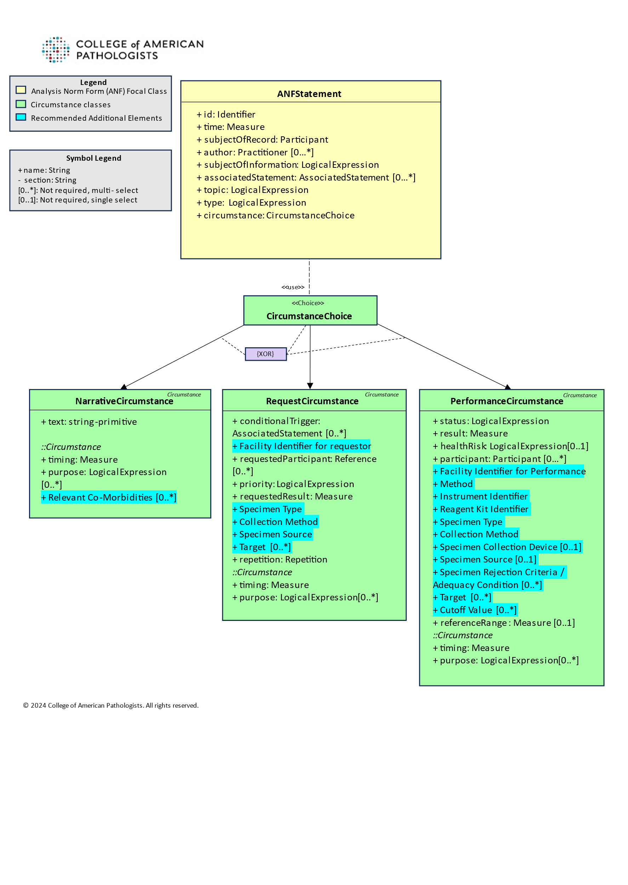

Note: A high resolution version of Figure 27 is included with this deliverable submission.

5.4 ANF Lessons Learned
The exercise to develop the ANF Request and Performance Statement ANF data elements for multiple anatomic pathology and clinical pathology use cases led to two conclusions. First, the concept of ANF is applicable to both anatomic pathology and clinical pathology. However, there were terms derived from the user guide that produced a lack of consensus when applied to the laboratory use cases. This was particularly evident when discussing the meaning of “Technique” versus “Method” and “Target” versus “Component”.
The divergence was attributed to two factors. Terms such as “Technique” and “Target” are routinely used in the laboratory and therefore elicit implicit bias in their interpretation. Additionally, they are not captured discretely in current pathology LIS and therefore have no precedent to apply a fixed and unique definition.
ANF is a framework for gathering informational elements in a standardized fashion. Therefore, the terms need to be of sufficient clarity to guide future ANF users on how best to encode the ANF data elements and identify what pieces of information would suffice to represent them. The intent of ANF is to be broadly applied and act as an intuitive model across many medical disciplines. Ideally, it would be achieved by automated population of the fields from the medical record systems, including pathology LIS. The team’s efforts were most successful when considering WHO, WHAT, WHEN, WHERE, WHY, and HOW (W₅H) as the overarching questions used to develop the elements of ANF. Each of the AP and CP SMEs were able to generate underlying questions that were more meaningful to the different laboratories and did not conflict. ANF data elements could be defined uniquely for the appropriate laboratory setting.
The conclusion at this stage was that while terms and definitions are important for the ANF data model, rules for the appropriate application of the terms are essential for their usage and adoption. These rules need to be developed with clinical and anatomic pathology as well as other medical specialties in mind.

5.4.1 Recommended Next Steps
The CAP has transferred the clinical narratives to the FDA and other contributors to serve as a foundational tool for refining ANF statements. The CAP recommends that pathologists and laboratory SMEs be embedded in ANF development teams moving forward to ensure applicability to both clinical and anatomic pathology.

REFERENCES
- Centers for Disease Control and Prevention. LOINC In Vitro Diagnostic (LIVD) Test Code Mapping. https://www.cdc.gov/csels/dls/livd-codes.html. Published 2024. Accessed date unknown.
- Regenstrief Institute. The international standard for identifying health measurements, observations, and documents. LOINC from Regenstrief. https://loinc.org/. Published 2024. Accessed date unknown.
- SNOMED International. SNOMED CT Browser. https://browser.ihtsdotools.org/?perspective=full&conceptId1=404684003&edition=MAIN/SNOMEDCT-US/2024-03-01&release=&languages=en. Published 2024. Accessed date unknown.
- National Library of Medicine. AccessGUDID. https://accessgudid.nlm.nih.gov/. Published 2024. Accessed date unknown.
- Nichols E. Ultimate Guide to UDI for Medical Devices. Greenlight Guru. https://www.greenlight.guru/blog/udi-medical-devices. Published 2022. Accessed date unknown.
- Health Level Seven International. HL7 CIMI Logical Model for Analysis: Analysis Normal Form (ANF), Release 1. HL7 Informative Ballot. Clinical Decision Support Work Group. Published 2019.
- Campbell KE, M, PhD. Building Analysis Normal Form (ANF) Clinical Statements. US Department of Veterans Affairs. April 2021.
- Health Level Seven International. HL7 CIMI Logical Model for Analysis: Analysis Normal Form (ANF), Release 1. HL7 Informative Publication. Clinical Decision Support Work Group. https://www.hl7.org/. Published 2020. Accessed date unknown.
- Chang A, Gibson IW, Cohen AH, et al. A position paper on standardizing the nonneoplastic kidney biopsy report. Hum Pathol. 2012;43:1192-1196.
- Walker P, Cavallo T, Bonsib S, et al. Practice guidelines for the renal biopsy. Mod Pathol. 2004;17:1555-1563. https://doi.org/10.1038/modpathol.3800239. Accessed date unknown.
- ARUP Laboratories. Comprehensive Kidney Biopsy Workup. https://ltd.aruplab.com/Tests/Pub/2013259. Accessed date unknown.
- Wilbur DC, Smith ML, Cornell LD, Andryushkin A, Pettus JR. Automated identification of glomeruli and synchronised review of special stains in renal biopsies by machine learning and slide registration: A cross-institutional study. Histopathology. 2021. https://doi.org/10.1111/his.14376. Accessed date unknown.

7. APPENDIX

7.1 Success Metrics
To guide the Year 2 efforts of the FDA BAA, the CAP established specific success criteria for each task within the project. These success criteria served as essential milestones, ensuring that each phase of the project was completed successfully and in alignment with the overall objectives.
Table 28: Project Success Metrics
Task Name | Success Metrics | Link to Section Addressed
Year 2 – Proof of Concept | - Completion of QA Program POC and analysis | Section 3: IVD Test Data Coding Quality Assurance Program POC
Create environments | - Duke successfully updated interface pre POC specifications  - ELLKAY split HL7 interface messages into separate channel for the FDA POC (in addition to existing CAP channel)  - The CAP received messages, extracted LIDR elements, and stored in POC database | Section 3.2: Environment Development
Implement LIDR subset in LIS | - Duke encoded LIDR elements into test environment and identified any build gaps | Section 3.3: Implement LIDR subset in LIS
Data quality analytics | - Generate a formatted analysis report specific to the laboratory’s submitted data  - Develop QA analysis report based on CAP project team feedback | Section 3.6: QA Analysis Reporting
Test outgoing interface feeds | - Successful result message generation from Duke | Section 3.4: Simulate Test Submission
Analyze transmission of data | - Appropriate HL7 fields populated with the encoded LIDR elements and identify build gaps | Section 3.4: Simulate Test Submission
Simulate test submission | - Successful transmission of a test  - The CAP processes and analyzes an HL7 message  - The CAP produces error message for structural validity | Section 3.4: Simulate Test Submission
Provide gap analysis on LIDR | - Provide complete review and documentation of LIDR implementation and data/file gaps | Section 3.7: Gap Analysis
Training and Education development | - Successful completion of Training and Education content that would assist in configuration of different systems to use LIDR | Section 4: Training and Education Materials
ANF | - Analyze whether ANF is fit for purpose or needs modification; identify whether it adds value or additional complexity | Section 5: Analysis Normal Form (ANF)
Overall Project | - Provide all FDA Deliverables within the Year 2 timeline | N/A

7.2 Terminology Glossary
Term | Definition
American Joint Committee on Cancer (AJCC) | The American College of Surgeons Cancer Programs provide tools, resources, and data that enable cancer programs to deliver comprehensive, high-quality, multidisciplinary, evidence-based, patient-centered care to patients with cancer and diseases of the breast. https://www.facs.org/quality-programs/cancer-programs/
Analysis Normal Form (ANF) | Analysis Normal Form (ANF) is a logical model intended to represent a normalized view of aggregate clinical statements for analysis, research, clinical decision support, and other purposes. ANF can be used to represent any clinical statement irrespective of how the information was captured at its source The ANF Reference Model and methodology can be used in conjunction with other models intended to ensure that clinical information is structured and complete at the time of entry (e.g., CIMI models, ISO/TS 13972 Detailed Clinical Models) or exchanged among systems (e.g., HL7 CDA templates, HL7 V2 message profiles, FHIR profiles).  https://www.hl7.org/implement/standards/product_brief.cfm?product_id=523
Anatomic Pathology (AP) | Anatomic pathology primarily consists of tissue evaluation—from individual cells from a Pap smear, a fine needle aspiration of a mass, or evaluation of the entire body in an autopsy, and everything in between. https://documents.cap.org/documents/overview-anatomic-clinical-pathology-medical-students.pdf
Application  Programming  Interface (API) | A means for two or more computer applications to communicate with each other utilizing defined rules. Application programming interfaces (APIs) are powerful tools that help support interoperability in healthcare. Simply put, APIs allow a software “Application A” to interact with a software “Application B” without Application A needing to know how Application B’s software is designed internally. The adoption and use of standards for APIs (like HL7 Fast Healthcare Interoperability Resources (FHIR), OAuth 2.0, and OpenID Connect 1.0) can facilitate interoperability and serve as a catalyst for innovation and support the development of new technologies and use cases.  https://www.healthit.gov/buzz-blog/21st-century-cures-act/application-programming-interfaces-in-health-it
Assistant Secretary for Technology Policy/Office of the National Coordinator for Health Information Technology (ASTP/ONC) | The Assistant Secretary for Technology Policy/Office of the National Coordinator for Health Information Technology is at the forefront of the administration’s health IT efforts and is a resource to the entire health system to support the adoption of health information technology and the promotion of nationwide, standards-based health information exchange to improve health care. https://www.healthit.gov/topic/about-astponc
Broad Agency Announcement (BAA) | A technique for the United States government agencies to solicit proposals from outside groups for certain research and development projects.
Basic Metabolic Panel (BMP) | A basic metabolic panel (BMP) is a test that measures eight different substances in your blood. It provides important information about your body's chemical balance and metabolism. Metabolism is the process of how the body uses food and energy. https://medlineplus.gov/lab-tests/basic-metabolic-panel-bmp/
CAP (College of American Pathologists) | The College of American Pathologists (CAP), the leading organization of board-certified pathologists, serves patients, pathologists, and the public by fostering and advocating excellence in the practice of pathology and laboratory medicine worldwide. https://www.cap.org/about-the-cap
CAP Number | A custom field used to identify the laboratory that sends the test sample to the CAP. The field may also be referred to as: CAP_Num, CAP #, or CAP Lab Number
Clinical Information Modeling Initiative (CIMI) | Clinical Information Modeling Initiative (CIMI) is a global healthcare project aimed at improving electronic health records and data sharing. It focuses on creating standardized clinical information models for better data interoperability among healthcare providers.  https://www.devx.com/terms/clinical-information-modeling-initiative/
Clinical Laboratory Improvement Amendments (CLIA) | The Clinical Laboratory Improvement Amendments of 1988 (CLIA) regulations include federal standards applicable to all U.S. facilities or sites that test human specimens for health assessment or to diagnose, prevent, or treat disease.  Clinical Laboratory Improvement Amendments (CLIA) | CDC
Clinical & Laboratory Standards Institute (CLSI) | A not-for-profit organization that develops laboratory standards worldwide. The standards are referenced and utilized by laboratories, accreditors, and government agencies. https://clsi.org/about/
Clinical Pathology (CP) | Clinical pathology covers most of laboratory medicine—including routine tests such as glucose and sodium, up to molecular tests for cancer markers and genome sequencing. https://documents.cap.org/documents/overview-anatomic-clinical-pathology-medical-students.pdf
Code / Coded / Coding | The result produced by the test encoding process. For example, a LIDR code.
Commission on Cancer (COC) | The Commission on Cancer (CoC) is a consortium of professional organizations dedicated to improving survival and quality of life for patients with cancer by setting and raising standards. Promotes cancer prevention, research, education, and monitoring of comprehensive quality care. https://www.facs.org/quality-programs/cancer-programs/commission-on-cancer/
Device Identifier (DI) | A mandatory, fixed portion of a UDI that identifies the labeler and the specific version or model of a device. https://www.fda.gov/medical-devices/unique-device-identification-system-udi-system/udi-basics
Electronic Health Record (EHR) | An EHR is a more comprehensive digital record that not only contains a patient’s medical history from one practice but is also designed to be shared across different healthcare settings. It includes information from all the clinicians involved in the patient's care, and the data can be shared with other healthcare providers, such as specialists, laboratories, and pharmacies.
Electronic Medical Record (EMR) | An EMR is a digital version of a patient's paper chart within a single healthcare organization or practice. It contains the medical and treatment history of the patients in one practice and is primarily used by clinicians for diagnosis and treatment.
Encode / Encoded / Encoding | The process of implementing codes into the system and applying the test definitions.
Enterprise Patient (EPT) | A patient type in Epic whose registration, test results, and other medical records are stored and managed within a standard Epic chart.
Environment Development | The process of developing and configuring the necessary systems and interfaces for the sending laboratory, the receiving entity, and any intermediary interface engines. This enables laboratory tests encoded within the laboratory information system to transmit results, whether for proficiency testing or actual patient results, using the same data elements in the HL7 message.
FDA (Food and Drug Administration) | A federal agency of the Department of Health and Human Services responsible for protecting and promoting public health through the control and supervision of medical devices, drugs, and other entities affecting human health.
Fast Healthcare Interoperability Resources (FHIR) | FHIR (Fast Health Interoperability Resources) is an HL7 specification for healthcare interoperability. A set of rules and specifications for exchanging electronic health care data. https://fhir.org/
Global Unique Device Identification Database (GUDID) | The Global Unique Device Identification Database (GUDID) contains key device identification information submitted to the FDA about medical devices that have Unique Device Identifiers (UDI).The FDA is establishing the unique device identification system to adequately identify devices sold in the U.S.- from manufacturing through distribution to patient use. One can use AccessGUDID to search for specific medical devices or download all the GUDID data at once. https://accessgudid.nlm.nih.gov/
Health Information Exchanges (HIE) | HIEs allow for the ability to move clinical information including laboratory data across different healthcare information systems within a region, community, or customer base.
Health Level Seven (HL7®) | A not-for-profit, ANSI (American National Standards Institute)-accredited standards developing organization: System of messaging standards for transferring clinical and administrative data between software applications used by various healthcare systems. https://www.hl7.org/
HL7 Segment | A segment is a logical grouping of data fields. Segments of a message may be required or optional. They may occur only once in a message, or they may be allowed to repeat. Each segment is given a name. For example: Message Header (MSH), Common Order (ORC), Observation Request (OBR), Observation Request (OBX), Specimen (SPM). https://hl7-definition.caristix.com/v2/
Identity Type | Identity types are records within Epic used for mapping identifiers (such as UDIs) that may be used by an external system and that link the identifier to the interface for transmission.
IHE (Integrating the Healthcare Enterprise) | An initiative by healthcare professionals and industry to improve the way computer systems in healthcare share information. IHE promotes the coordinated use of established standards such as DICOM (Digital Imaging and Communications in Medicine) and HL7 to address specific clinical needs in support of optimal patient care. https://www.ihe.net/
IHE PT Profile | An initiative being developed by healthcare professionals and industry to improve the way proficiency testing orders and results can be delivered electronically between a laboratory information system and a proficiency testing vendor through the use of standards such as HL7. https://www.ihe.net/
Instance Error Check | Instance error checking allows the client laboratory to test their standardized coding configuration against the expected LIDR coding curated by the IVD vendors.
Interface Engine | A specialized software application designed to facilitate the exchange of electronic health information between different healthcare systems, applications, and databases. These interface engines play a crucial role in enabling interoperability within the complex landscape of healthcare IT
Interoperability | The ability of different information systems and applications to exchange and integrate data which is portable (can move between these systems and have the same meaning) and comparable. There are four levels of interoperability:  - Foundational (Level 1): Establishes the inter-connectivity requirements needed for one system or application to securely communicate data to and receive data from another  - Structural (Level 2): Defines the format, syntax, and organization of data exchange including at the data field level for interpretation  - Semantic (Level 3): Provides for common underlying models and codification of the data including the use of data elements with standardized definitions from publicly available value sets and coding vocabularies, providing shared understanding and meaning to the user  - Organizational (Level 4): Includes governance, policy, social, legal, and organizational considerations to facilitate the secure, seamless, and timely communication and use of data both within and between organizations, entities and individuals. These components enable shared consent, trust, and integrated end-user processes and workflows  Interoperability | HIMSS
In vitro diagnostics (IVD) | Tests done on samples such as blood or tissue that have been taken from the human body. In vitro diagnostics can detect diseases or other conditions and can be used to monitor the overall health of a person to help cure, treat, or prevent diseases.
JavaScript Object Notation (JSON) | JSON is a text-based format for storing and exchanging data in a way that’s both human-readable and machine-parsable.
Laboratory Interoperability Data Repository (LIDR) | A centralized repository of codes and other standardized data elements that serves as an easily accessible authoritative source for the standardized digital representation of laboratory tests. As LIDR is still in the conceptual stage, the CAP developed and utilized a simulated LIDR in the proof of concept.
LIDR Code | Represents all of the specific LIDR defined elements that are transmitted and essential for transferring an interoperable IVD result.
LIDR Element | Refers to data elements contained in LIDR specific to a particular IVD test result and encompasses both codes required for interoperable data transmission and informational entries.
LIDR Test Compendium Error Check | The proposed QA Program monitors the appropriate LIDR coding of laboratory tests. Laboratories review and submit a LIDR Test Compendium Report to the quality organization to analyze correct test coding as compared to LIDR.
LIDR Test Compendium Report | The report submitted to the quality organization which includes a list of the tests performed by the laboratory. In the QA Program, the LIDR Test Compendium Report is analyzed for correct test coding as compared to LIDR.
Laboratory Information System (LIS) | Software application for ordering and resulting in vitro diagnostic tests performed in clinical laboratories, as well as the storage and transfer of laboratory test results to EHRs and other entities.
LOINC In Vitro Diagnostic® (LIVD) | The LIVD specification outlines an industry-defined format to facilitate the publication and exchange of LOINC codes for vendor IVD test results, based on either vendor IVD test transmission codes or manual test identification, for use by laboratory personnel or laboratory applications. The format can be used as-is by IVD software systems to automate the mapping between vendor IVD test transmission codes and LOINC codes, significantly reducing the risk of erroneously mapped test results and units of measure (UCUM).  https://ivdconnectivity.org/livd/
Laboratory Result Interface (LRI) | An HL7 interface which is utilized for a variety of purposes including the  transmission of results within and between systems. It can also be used for reporting results to public health agencies.
LOINC (Logical Observation Identifiers Names and Codes) | A database of standard codes for identifying medical laboratory observations, developed by the Regenstrief Institute to assist in the electronic transmission of IVD test results. https://loinc.org/
Mapping | Mapping refers to the translation of a data element used in one system to a data element utilized in another system with the same meaning. Accurate mapping of local laboratory codes to standardized terminologies would enable semantic interoperability in data sharing and aggregation across systems for a variety of purposes.
Master Patient Index Identifier (MPI ID) | An Epic record used for identifying various records (e.g., test codes). The MPI ID maps the local code to an external identifier.
Meaningful Use (MU) Incentives | The Centers for Medicare & Medicaid Services (CMS) developed a program that requires physicians using certified electronic health records technology (CEHRT) to capture, exchange and report specific clinical data and quality measures. The program, which began in 2011, evolved over the course of 3 stages:  - Stage 1 established the base requirements for electronic capturing of clinical data.  - Stage 2 encouraged the use of EHRs for increased exchange of information and continuous quality improvement at the point of care.  - Modified Stage 2, released in October 2015, consolidated Stages 1 and 2 into a new program. These are the current requirements all physicians should follow. While some changes were made to reduce the complexity of the measures, many of the objectives were carried over from Stage 2.  https://www.ama-assn.org/practice-management/medicare-medicaid/meaningful-use-electronic-health-record-ehr-incentivehttps://www.ama-assn.org/practice-management/medicare-medicaid/meaningful-use-electronic-health-record-ehr-incentive
Method | A reference to “method” denotes the Epic record for either the analyzer or the kit used. A reference to “analytic method” denotes the actual laboratory testing method rather than the Epic record.
National Electronic Telecommunications System for Surveillance (NETSS) | The National Electronic Telecommunications System for Surveillance (NETSS) was developed by CDC and the Council of State and Territorial Epidemiologists (CSTE) for collecting, transmitting, analyzing, and publishing weekly reports of notifiable diseases and injuries from the 50 states, New York City, the District of Columbia, Puerto Rico, the Virgin Islands, Guam, American Samoa, and Commonwealth of the Northern Mariana Islands. https://www.cdc.gov/mmwr/preview/mmwrhtml/00014904.htm
Pathology Electronic Reporting (PERT) Committee | The Pathology Electronic Reporting (PERT) Committee oversees, develops, and maintains the CAP electronic Cancer Protocols (eCP). In addition, PERT provides leadership in standardized, structured reporting of anatomic pathology data, including how these are captured, reported, discretized, transmitted, received, retrieved, aggregated, stored, and made interoperable with other clinical data relevant to patient care and public health. https://www.cap.org/member-resources/councils-committees/pathology-electronic-reporting-pert-committee/
Patient-Centered Clinical Research Network (PCORnet) | Is intended to improve the nation’s capacity to conduct health research, particularly comparative effectiveness research (CER), efficiently by creating a large, highly representative network for conducting clinical outcomes research. PCORnet® has been developed with funding from the Patient-Centered Outcomes Research Institute (PCORI). https://pcornet.org/
Production Identifier (PI) | A conditional, variable portion of a UDI that identifies one or more of the following when included on the label of a device:  - Lot or batch number within which a device was manufactured  - Serial number of a specific device  - Expiration date of a specific device  - Date a specific device was manufactured;  - Distinct identification code required by §1271.290(c) for a human cell, tissue, or cellular and tissue-based product (HCT/P) regulated as a device.  https://www.fda.gov/medical-devices/unique-device-identification-system-udi-system/udi-basics
Proof of Concept (POC) | CAP is performing a proof of concept (POC) with laboratories to help understand if the encoded data coming back to the CAP have the appropriate mapping to the Laboratory Interoperability Data Repository (LIDR) standard, under development as part of the government-supported SHIELD initiative.
Proficiency Testing (PT) | Refers to a quality program which clinical laboratories must subscribe to according to the CLIA standards for regulatory monitoring of test performance. The quality program typically includes blind specimens simulating patient samples which must be run in the same manner as patient samples. The results are sent to the quality organization for performance evaluation and assessment with peer groups of other laboratories.
Quality Organization | Organizations which can provide quality monitoring or proficiency testing surveys or both to clinical and anatomic pathology laboratories.
Quality Assurance (QA) Program | The CAP’s proposed IVD Test Data Coding QA Program (the QA Program) was designed to monitor the appropriate coding of laboratory test results compared to LIDR. The full LIDR design and specifications are still under development as part of the government supported SHIELD initiative. The QA Program workflow is intended to utilize test result transmissions and test compendium reports to evaluate the quality of the encoded laboratory tests, validate correct coding, and identify any gaps in the design.
Qualitative Result | A clinical laboratory test result that is non-numeric and typically reported with a textual result (e.g., positive, reactive, non-reactive).
Quantitative Result | A clinical laboratory test result that is numeric and typically reported with units of measurement.
Requisition Grouper (RQG) | A patient type in Epic whose orders and test results do not transfer into a standard Epic chart and are only accessible through Beaker LIS.
Real-World Data (RWD) | Real-world data are data relating to patient health status and/or the delivery of health care routinely collected from a variety of sources. Examples of RWD include data derived from electronic health records, medical claims data, data from product or disease registries, and data gathered from other sources (such as digital health technologies) that can inform on health status. https://www.fda.gov/science-research/science-and-research-special-topics/real-world-evidence
Real-World Evidence (RWE) | Clinical evidence regarding usage and potential benefits or risks of a medical device or product. Real-world evidence is the clinical evidence about the usage and potential benefits or risks of a medical product derived from analysis of RWD.  https://www.fda.gov/science-research/science-and-research-special-topics/real-world-evidence
Systemic Harmonization and Interoperability Enhancement for Laboratory Data (SHIELD) | A multi-stakeholder group working to improve the quality, utility, and portability of electronic laboratory test results, by implementing data standards which allow for harmonization between healthcare organizations. https://www.fda.gov/medical-devices/diagnostic-data-program/systemic-harmonization-and-interoperability-enhancement-laboratory-data-shield
Simulated LIDR | The simulated repository of codes and other standardized data elements used in the proof of concept because LIDR is not yet developed. The simulated LIDR was based on research related to the subset of tests, the instruments, and methods in use at Duke, utilizing information found in Duke build exports from Epic Beaker, Duke’s online test catalog, searches completed on LOINC, SNOMED CT, GUDID websites, as well as manufacturer websites.
SNOMED CT® | SNOMED CT is one of a suite of designated standards for use in U.S. Federal Government systems for the electronic exchange of clinical health information and is also a required standard in interoperability specifications of the U.S. Healthcare Information Technology Standards Panel. The clinical terminology is owned and maintained by SNOMED International, a not-for-profit association.  https://www.nlm.nih.gov/healthit/snomedct/index.html
Spring-Based Scheduler | A flexible task scheduling framework built on top of the Spring framework. It provides a programmatic way to schedule tasks, making it easy to manage and automate various time-based operations within the Spring applications.
Standard Development Organizations (SDOs) | SDOs are member-supported organizations, often accredited by the American National Standards Institute (ANSI), who develop and maintain standards to meet industry needs. Members include health care providers, insurers, health IT software developers, patients, care givers, and others. https://www.healthit.gov/playbook/sdo-education/chapter-2/
TermINology Knowledge ARchitecture (TINKAR) | The TermINology Knowledge ARchitecture (TINKAR) is intended to provide an architecture that delivers integrated terminology to the enterprise and its information systems, that addresses the differences in management and structure across reference terminology and with local concepts and code lists/value sets.  https://confluence.hl7.org/download/attachments/82907521/Tinkar%20Project%20Summary%20-%20Sept%20WGM.pptx?api=v2
Unified Code for Units of Measure (UCUM) | The Unified Code for Units of Measure is a code system intended to include all units of measure used in science, engineering and business.
Unique Device Identifier (UDI) | The FDA established the unique device identification system to adequately identify medical devices sold in the United States from manufacturing through distribution to patient use. When fully implemented, the label of most devices will include a unique device identifier (UDI) in human- and machine-readable form, which will ultimately improve patient safety, modernize device post-market surveillance, and facilitate medical device innovation. https://www.fda.gov/medical-devices/device-advice-comprehensive-regulatoryassistance/unique-device-identification-system-udi-system
Units of Measure (UOM) | Utilized for quantitative test results and required for proper interpretation by the clinician.
Understandable, Reproducible and Useful (URU) | Understandable. The meaning of a concept can be understood by most healthcare providers, without reference to private or inaccessible information. Reproducible. Multiple users apply the concept to the same situations. Useful. The concept has a practical value to users that is self-evident or can be readily explained. https://confluence.ihtsdotools.org/display/DOCGLOSS/URU
United States Core Data for Interoperability extension (USCDI+) | The United States Core Data for Interoperability (USCDI+) is a standardized set of health data classes and constituent data elements for nationwide, interoperable health information exchange. A USCDI Data Class is an aggregation of Data Elements by a common theme or use case. A USCDI Data Element is a piece of data defined in USCDI for access, exchange or use of electronic health information. https://www.healthit.gov/isa/united-states-core-data-interoperability-uscdi
W₅H | Shorthand for What, Who, Where, When, Why and How.
World Health Organization (WHO) | WHO is the United Nations agency that connects nations, partners and people to promote health, keep the world safe and serve the vulnerable – so everyone, everywhere can attain the highest level of health.  https://www.who.int/about
XML | Extensible Markup Language (XML) lets you define and store data in a shareable manner. XML supports information exchange between computer systems such as websites, databases, and third-party applications.

7.3 Supplemental Materials

7.3.1 Proof of Concept Supplemental Materials
The following supplementary materials related to the POC are included as separate files, accompanying the submission of this document:
# | Name | Description
1.0 | Simulated LIDR File | Excel document containing the full simulated LIDR file used in the POC. Note: The harmonization indicator and specimen disposition elements will not be used for the POC as they are currently not developed.
2.0 | HL7 Result Analyses and Associated Result Messages | PDF documents containing the HL7 result message analyses and result messages for the following laboratory tests:  - 2.1 - Basic Metabolic Panel  - 2.2 - Blood Culture with AST and ID  - 2.3 - Complete Urinalysis  - 2.4 - Plasma Creatinine  - 2.5 - Respiratory Viral Panel
3.0 | Sample POC Test Plan | Excel document containing a blank version of the POC test plan with Duke.
4.0 | Completed POC Test Plan | Excel document containing the completed POC test plan with Duke.
5.0 | Interface Specifications | Excel document containing the interface specifications for the POC.
6.0 | Latest LIDR Test Compendium Report from Duke | Excel document containing the latest LIDR Test Compendium Report delivered by Duke during testing, containing build errors and extra data.
7.0 | “Ideal” LIDR Test Compendium Report | Excel document containing an “ideal” test compendium report based on the generated LIDR Test Compendium Report from the Duke laboratory. This ideal report was modified by removing extraneous information and adding required LIDR elements that could not be captured initially.
8.0 | Links to search tools for LOINC, SNOMED CT, and GUDID | - LOINC Search Tool  - SNOMED CT Search Tool  - GUDID Search Tool
9.0 | Sample Instance Error Check QA Analysis Email Notification | PDF samples of the Instance Error Check QA Analysis Email Notification that indicates whether the various elements of the test kit have passed or failed. Notifications for the following tests are included:  - 9.1 - Basic Metabolic Panel  - 9.2 - Blood Culture with AST and ID  - 9.3 - Complete Urinalysis  - 9.4 - Plasma Creatinine  - 9.5 - Respiratory Viral Panel
10.0 | Sample LIDR Administrator Notification | PDF sample of the message sent to the LIDR Administrator notifying them of repeated failures that could potentially be due to an error by the IVD manufacturers.
11.0 | Instance Error Check Demonstration Video | Provides a demonstration of the Instance Error Check workflow and transmission of test results from Duke to the CAP. The video can be accessed here: Instance Error Check Demonstration Video

7.3.1.1 Environment Development Details
Figure 28: Intake Interface (CAP)- System Design
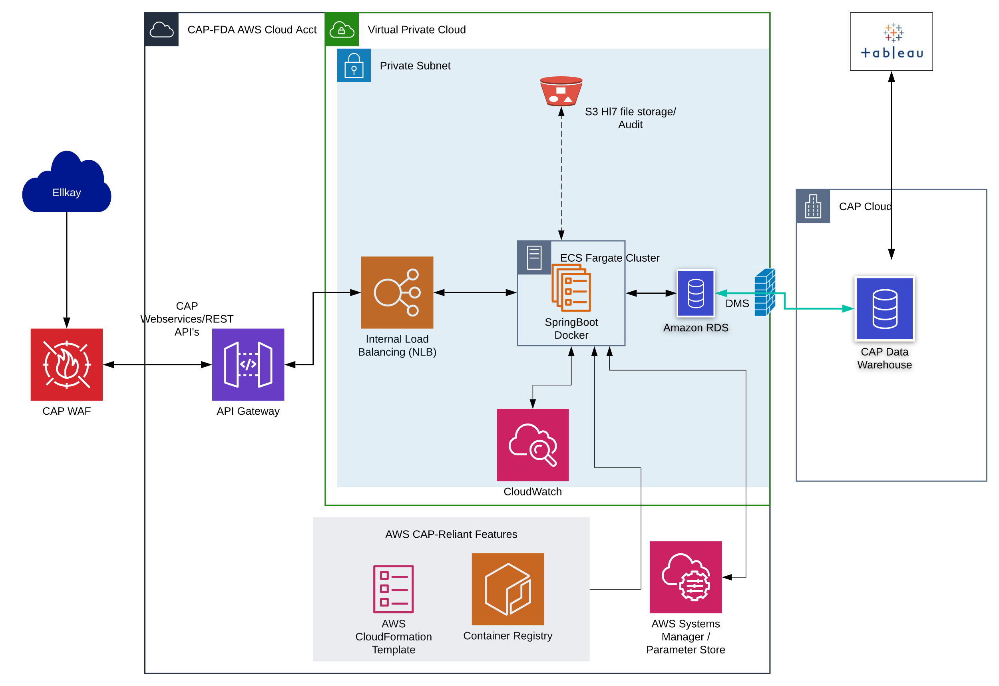
- The CAP deploys all the entities for this POC into a dedicated Amazon Web Services account, ensuring that only resources pertinent to this project are configured in the FDA-POC cloud environment.
- The architecture adheres to the CAP’s approved principles and guidelines.
- All infrastructure resources are placed in a secured virtual-private-cloud.
- Databases are placed in a dedicated virtual-private-cloud with no public internet access.
- VPN access has been granted from specific CAP resources to the FDA-POC cloud environment.
- The design adopts high availability design patterns and follows the CAP’s standard architectural patterns and libraries.
- The model was designed for flexibility, understandability, ease of use, and performance.
- The POC environment is self-healing and resilient with proper monitoring for all deployable components. The environment can handle varying levels of traffic and recover quickly from failures by leveraging elastic load balancing, autoscaling, and proactive monitoring.
Table 29: Intake Interface (CAP) - Description of Design Components
Component | Provider | Purpose
AWS API Gateway | AWS | API Management solution  Used to publish web service/REST APIs
CloudFormation | AWS | A solution to define and provision infrastructure as code
Load Balancers | AWS | Elastic load balancing for Spring Boot gateways
Amazon S3 | AWS | Cloud storage service for static contents, HL7 files
AWS Container Registry | AWS | Container registry for Docker images
VPC, Subnets, ACL & Other network components | AWS | Network components
AWS CloudWatch (alarms, logs, matrices) | AWS | Monitoring service for logs and infrastructure
AWS Redshift | AWS | Data warehouse
Tableau | CAP & Third party | Data visualization reports and dashboards
WAF | CAP | Web application firewall solution
AWS Systems Manager | AWS | Security management framework to store keys and secret data to access secure resources
AWS CloudTrail | AWS | AWS logging service that services and infrastructure related to the project will use to log
RDS Postgres SQL | AWS | AWS managed relational database
DMS | AWS | Data migration service from relational database to the data warehouse
Intake Interface (CAP)-Security
- Basic HTTPS REST API authentication configured. Leveraged Token-based authentication for REST API security.
- Spring Boot Security layer (Gateway) will enforce external user authentication.
- Other Infrastructure, AWS-Fargate clusters placed inside Private Subnet.
- AWS Security groups ensure the appropriate access
- Data in transit
  - No PII and PHI data are involved.
  - HTTPS
- Data in rest
  - No PII and PHI data are involved.
  - Data encrypted at rest

Figure 29: Intake Interface (CAP)- Sequence Diagram
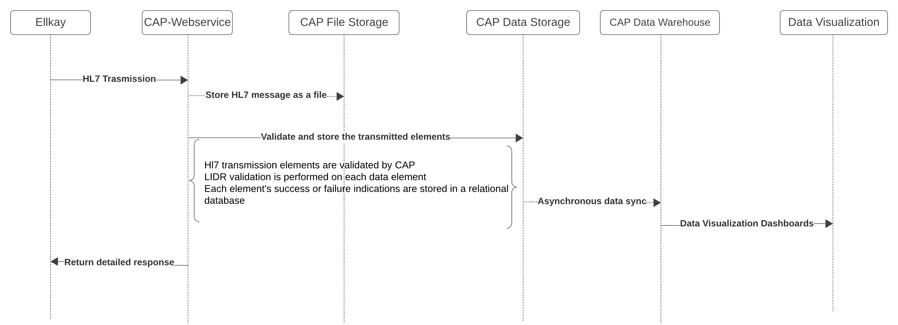
Full Interface Specifications Document
The CAP has provided comprehensive documentation of the interface specifications with this deliverable submission. For complete details, please refer to the Excel file that was submitted alongside the Environment Creation document titled ‘Interface Specifications’.

7.3.1.2 Coding Feedback and Vendor Collaboration Survey
Coding Feedback Survey
The following questions were provided to Duke though a Microsoft Forms survey.
Question number | Question text | Answers
3 | Please indicate your job title | Laboratory Manager/Supervisor/Director
 |  | IT Analyst
 |  | Other
4 | Who determines if the correct LIDR code has been assigned to the tests in your Laboratory Information System (LIS)? | Laboratory Director (Medical)
 |  | Pathologist
 |  | Administrative Laboratory Director
 |  | Lab Manager/Supervisor
 |  | Medical Technologist
 |  | Information Technology (IT) Staff
 |  | Vendor (or 3rd Party)
 |  | Unsure
 |  | Other
5 | What do you do when you are unsure which LIDR code to select for a test or its result? | I make my best guess
 |  | I ask the lab manager/supervisor or a laboratory technologist
 |  | I ask an IT professional
 |  | I ask a PhD laboratorian or a pathologist (and/or the medical director of the laboratory)
 |  | Search in LIDR
 |  | Search in search.loinc.org
 |  | Other
6 | How often are LIDR codes assessed at your workplace to ensure they remain the best test codes? | Rarely or never
 |  | Every year
 |  | Every 6 months
 |  | Any time a new instrument is added
 |  | Any time a test is modified by the vendor
 |  | Any time the medical director of the laboratory changes
 |  | Every time a new version of LIDR is released (every 6 months)
 |  | When the IVD Vendor provides and updates LIDR for my tests/methods
 |  | When requested (by clinicians, other laboratories, clinical research staff or IT staff, etc.)
7 | What technological challenges do you face when using LIDR? | The LIS/LIMS is not able to store or send LIDR codes (for orders of single analytes, orders that are panels, results or observations)
 |  | Laboratory instruments that generate the test result cannot store LIDR codes
 |  | Laboratory instruments cannot transmit LIDR codes for their test results
 |  | EHR systems are not able to send or receive LIDR codes
 |  | Public health reporting systems are not able to send or receive LIDR codes
 |  | The test requires multiple LIDR codes per result and the LIS/LIMS is only able to store one LIDR code per test
 |  | The test requires multiple LIDR codes per result, and the EHR is not able to send or receive more than one LIDR code per test
8 | Please rate the level of difficulty your laboratory has with encoding the correct LIDR codes for its specific test compendium in the LIS/EHR. 1 being "Least Difficult", 5 being Most Difficult | 1= Least Difficult
 |  | 2= Slightly Difficult
 |  | 3= Moderately Difficult
 |  | 4= Very Difficult
 |  | 5= Most Difficult
 |  | If not applicable, please leave blank
9 | Please rate the level of difficulty your lab has with transmitting the correct LIDR codes for patient laboratory test results | 1= Least Difficult
 |  | 2= Slightly Difficult
 |  | 3= Moderately Difficult
 |  | 4= Very Difficult
 |  | 5= Most Difficult
 |  | If not applicable, please leave blank
10 | How many IVD Vendors are utilized in your laboratory? (include all methods, instruments, and kit tests) | Open-ended question
11 | Please list the LIS and version used in your laboratory for Clinical Lab: | Open-ended question
12 | Please list the LIS and version used in your laboratory for Anatomic Pathology Lab: | Open-ended question
13 | Please list the EMR/EHR used in your healthcare organization: | Open-ended question
14 | How many FTEs are dedicated to building and maintaining the LIS? | Open-ended question
15 | How long did it take the LIS analyst(s) to set up the testing environment, including interface setup, configuration, and implementing the LIDR subset in Beaker? (Please specify the time in weeks) | Open-ended question
16 | How much time was involved for the interface analyst(s) in the technical build (developing interface engine, duplicating and creating new test builds, etc.)? (Please specify the time in weeks) | Open-ended question
17 | How long did it take to test the transmission of the LIDR Test Compendium Report? (Please specify the time in weeks) | Open-ended question
18 | How much time was involved in testing the transmission of HL7 messages? (Please specify the time in weeks) | Open-ended question
19 | How much time was involved in general project tasks and collaboration? (Please specify the time in weeks) | Open-ended question
20 | Please describe any challenges or constraints that impacted the time or resources required throughout the project: | Open-ended question
21 | How many personnel were involved in the testing environment set-up and technical build phase? | 1-2
 |  | 3-5
 |  | 6-10
 |  | More than 10
22 | How many personnel were involved in the testing phase? | 1-2
 |  | 3-5
 |  | 6-10
 |  | More than 10
23 | Provide feedback as to what worked well. Some topics to consider are:  - What should we make sure we do again in the future?  - What tools or techniques proved to be useful? | Open-ended question
24 | Provide feedback for challenges faced. Some topics to consider are:  - What was unexpected? What tools or techniques were not useful?  - What was the biggest impediment?  - Which of our methods or processes were difficult or frustrating to use? | Open-ended question
25. | Rate how well you agree or disagree with the following statements:
25.1 | I clearly understood the project’s objectives and scope | Strongly Agree
 |  | Agree
 |  | Neutral
 |  | Disagree
 |  | Strongly Disagree
25.2 | Changes to the objectives and scope were clearly communicated and understood | Strongly Agree
 |  | Agree
 |  | Neutral
 |  | Disagree
 |  | Strongly Disagree
25.3 | Communication was effective where I was adequately informed of project status, milestones, and decisions | Strongly Agree
 |  | Agree
 |  | Neutral
 |  | Disagree
 |  | Strongly Disagree
25.4 | My allocated time commitment was adequate for the project and the scheduling realistic for the work that had to be completed | Strongly Agree
 |  | Agree
 |  | Neutral
 |  | Disagree
 |  | Strongly Disagree
25.5 | I am satisfied with what I delivered with my scheduling and time commitments | Strongly Agree
 |  | Agree
 |  | Neutral
 |  | Disagree
 |  | Strongly Disagree
25.6 | I am satisfied with the overall project delivered | Strongly Agree
 |  | Agree
 |  | Neutral
 |  | Disagree
 |  | Strongly Disagree

Vendor Collaboration Feedback Survey
The following questions were provided to ELLKAY though a Microsoft Forms survey.
Question number | Question text | Answers
3 | Please indicate your job title | Laboratory Manager/Supervisor/Director
 |  | IT Analyst
 |  | Other
4 | How much time was involved in environment creation and set-up? (Please specify the time in weeks) | Open-ended question
5 | How much time was involved in testing the transmission of HL7 messages? (Please specify the time in weeks) | Open-ended question
6 | How much time was involved in general project tasks and collaboration? (Please specify the time in weeks) | Open-ended question
7 | Please describe any challenges or constraints that impacted the time or resources required throughout the project | Open-ended question
8 | How many personnel were involved in the environment set-up and technical build phase? | 1-2
 |  | 3-5
 |  | 6-10
 |  | More than 10
9 | How many personnel were involved in the testing phase? | 1-2
 |  | 3-5
 |  | 6-10
 |  | More than 10
10 | Provide feedback as to what worked well. Some topics to consider are:  - What should we make sure we do again in the future?  - What tools or techniques proved to be useful? | Open-ended question
11 | Provide feedback for challenges faced. Some topics to consider are:  - What was unexpected?  - What tools or techniques were not useful?  - What was the biggest impediment?  - Which of our methods or processes were difficult or frustrating to use? | Open-ended question
12. | Rate how well you agree or disagree with the following statements:
12.1 | I clearly understood the project’s objectives and scope | Strongly Agree
 |  | Agree
 |  | Neutral
 |  | Disagree
 |  | Strongly Disagree
12.2 | Changes to the objectives and scope were clearly communicated and understood | Strongly Agree
 |  | Agree
 |  | Neutral
 |  | Disagree
 |  | Strongly Disagree
12.3 | Communication was effective where I was adequately informed of project status, milestones, and decisions | Strongly Agree
 |  | Agree
 |  | Neutral
 |  | Disagree
 |  | Strongly Disagree
12.4 | My allocated time commitment was adequate for the project and the scheduling realistic for the work that had to be completed | Strongly Agree
 |  | Agree
 |  | Neutral
 |  | Disagree
 |  | Strongly Disagree
12.5 | I am satisfied with what I delivered with my scheduling and time commitments | Strongly Agree
 |  | Agree
 |  | Neutral
 |  | Disagree
 |  | Strongly Disagree
12.6 | I am satisfied with the overall project delivered | Strongly Agree
 |  | Agree
 |  | Neutral
 |  | Disagree
 |  | Strongly Disagree

7.3.2 Training and Education Supplemental Materials
The following supplementary materials related to training and education are included as separate files, accompanying the submission of this document:
# | Name | Description
12.0 | Video Introduction Script | Word document containing the script and screenplay used in the final video introduction.

7.3.3 ANF Supplemental Materials
The following supplementary materials related to ANF are included as separate files, accompanying the submission of this document:
# | Name | Description
13.0 | ANF Use Cases Master List | An Excel document containing the detailed use cases and illustrating the process of aligning them with ANF elements.
14.0 | ANF Use Case and Circumstance Figures (Figures 24, 25, and 26) | Figures 24, 25, and 26 are provided as individual PDFs for user convenience.
15.0 | ANF UML Model | Figure 27 is provided as an individual PDF for convenience.
16.0 | Clinical Narratives | The clinical narratives described in Table 13 are included as individual Word documents for convenience.

* Note: Relevant terminologies and acronyms are listed in the Terminology Glossary at the end of the document.

